@marinelives.bluesky.social\_Feed\_Aug16th2024-Oct28th2025

**MarineLives**

@marinelives.bsky.social

[**1.9K** followers](https://bsky.app/profile/marinelives.bsky.social/followers)[**653** following](https://bsky.app/profile/marinelives.bsky.social/follows)

**788** posts

Lives touched by the marine, 1574-1688. A volunteer led collaboration publishing to the Commons. See also: [generativelives.substack.com](https://generativelives.substack.com/)



Pinned

[[](https://bsky.app/profile/marinelives.bsky.social)](https://bsky.app/profile/marinelives.bsky.social)

[· 1d](https://bsky.app/profile/marinelives.bsky.social/post/3m44l7i3jrk23)

I am starting a Substack called Generative Lives. This offers a user's perspective on generative-ai and its potential application to historical research and archival practice. The Substack is free and seeks to encourage hands-on experimentation. [open.substack.com/pub/generati...](https://open.substack.com/pub/generativelives/p/introducing-myself-colin-greenstreet?r=fbg8f&utm_campaign=post&utm_medium=web&showWelcomeOnShare=true)

[[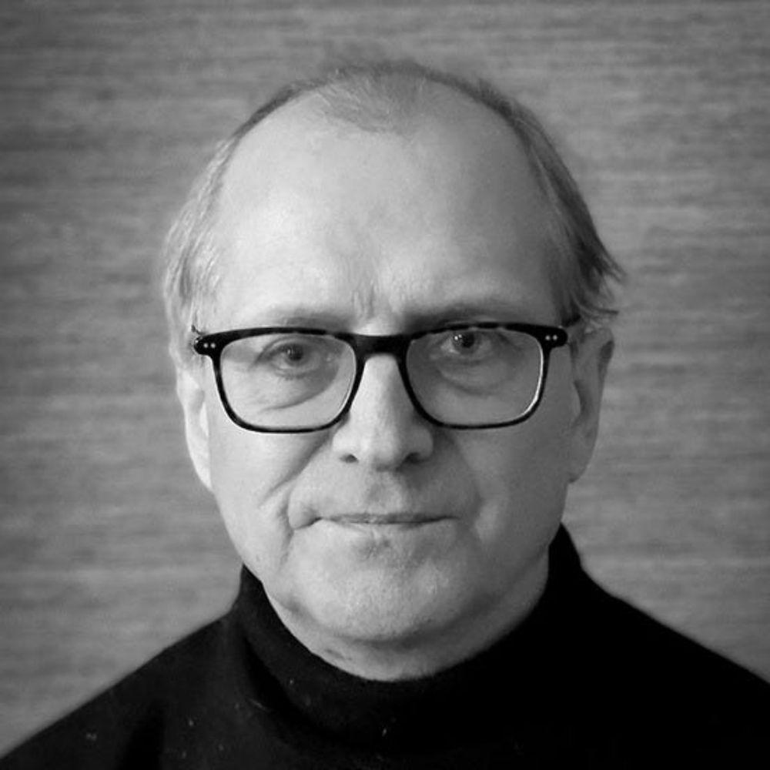](https://open.substack.com/pub/generativelives/p/introducing-myself-colin-greenstreet?r=fbg8f&utm_campaign=post&utm_medium=web&showWelcomeOnShare=true)](https://open.substack.com/pub/generativelives/p/introducing-myself-colin-greenstreet?r=fbg8f&utm_campaign=post&utm_medium=web&showWelcomeOnShare=true" \t "_blank)

**[Introducing myself: Colin Greenstreet, research public historian](https://open.substack.com/pub/generativelives/p/introducing-myself-colin-greenstreet?r=fbg8f&utm_campaign=post&utm_medium=web&showWelcomeOnShare=true" \t "_blank)**

[A user's perspective on generative ai for historical research and archival practice](https://open.substack.com/pub/generativelives/p/introducing-myself-colin-greenstreet?r=fbg8f&utm_campaign=post&utm_medium=web&showWelcomeOnShare=true" \t "_blank)

[open.substack.com](https://open.substack.com/pub/generativelives/p/introducing-myself-colin-greenstreet?r=fbg8f&utm_campaign=post&utm_medium=web&showWelcomeOnShare=true" \t "_blank)

[[](https://bsky.app/profile/marinelives.bsky.social)](https://bsky.app/profile/marinelives.bsky.social)

[· 5d](https://bsky.app/profile/marinelives.bsky.social/post/3m3s3fgw3sc2v)

Hello BlueSky. I haven't been active for a while. I am looking for examples of museums, libraries and archives doing interesting things with generative ai and would welcome suggestions of websites to look at. [#earlymodern](https://bsky.app/hashtag/earlymodern) [#archives](https://bsky.app/hashtag/archives) [#libraryscience](https://bsky.app/hashtag/libraryscience)

2

1

[[](https://bsky.app/profile/marinelives.bsky.social)](https://bsky.app/profile/marinelives.bsky.social)

[· 3mo](https://bsky.app/profile/marinelives.bsky.social/post/3lufhgk5ef226)

Did ships get bigger in the C17th? Yes. Contact me if you would like access to the data and would like to discuss. And of course the devil is in the detail, but this is a relatively and well defined large dataset [#earlymodern](https://bsky.app/hashtag/earlymodern) [#marinehistory](https://bsky.app/hashtag/marinehistory)

[@thiagokrause.bsky.social](https://bsky.app/profile/did:plc:m6ub6fozxlo3gzqn2rayoiwy)

[@brodiewaddell.bsky.social](https://bsky.app/profile/did:plc:44em43qq5kem43otrh3vejy5)

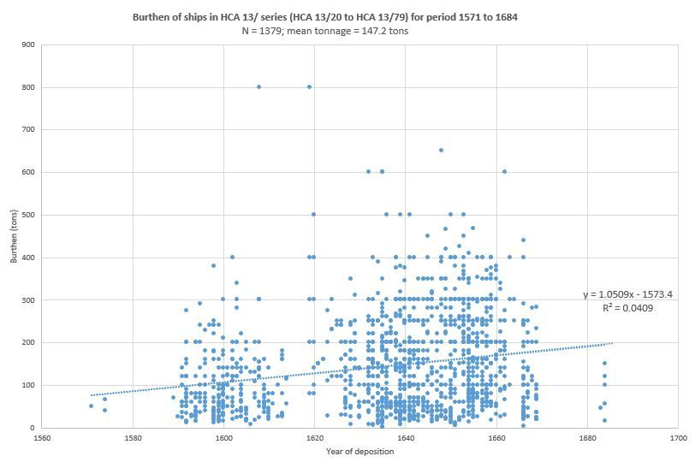

1

1

[[](https://bsky.app/profile/marinelives.bsky.social)](https://bsky.app/profile/marinelives.bsky.social)

[· 4mo](https://bsky.app/profile/marinelives.bsky.social/post/3lrukbwhl4s2r)

A potential use of AI image analysis which could be done at scale as part of an analysis of historic literacy? I loaded images of 140 signature, initial(s), mark(s) into NotebookLM & interrogated them palaeographically (with zero training).

[@thiagokrause.bsky.social](https://bsky.app/profile/did:plc:m6ub6fozxlo3gzqn2rayoiwy)

[@timhitchcock.bsky.social](https://bsky.app/profile/did:plc:zazpgix5w4ldyytazeqzytmz)

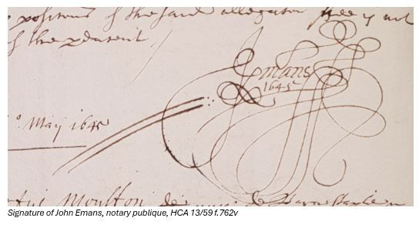

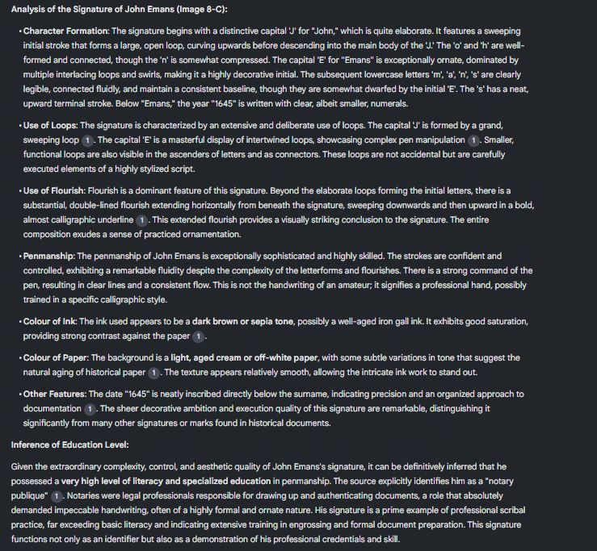

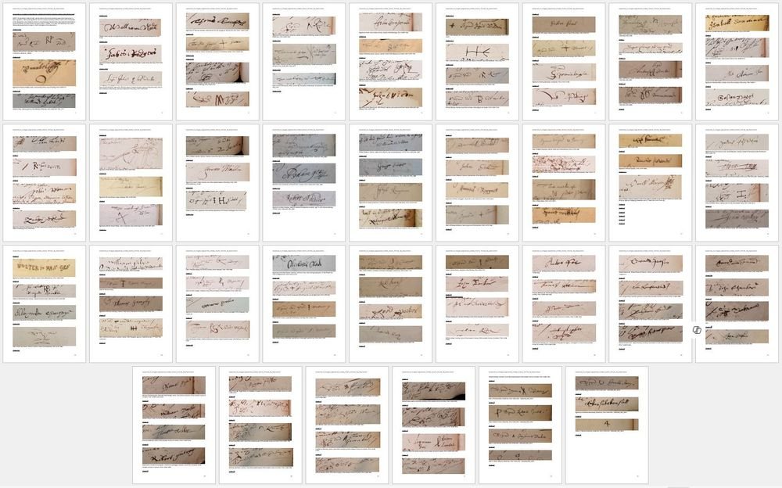

1

[[](https://bsky.app/profile/marinelives.bsky.social)](https://bsky.app/profile/marinelives.bsky.social)

[· 5mo](https://bsky.app/profile/marinelives.bsky.social/post/3lpbvzwth4k2v)

Looking for a Turkish speaker who would be willing to sample a couple of minutes of a Turkish podcast generated by Google NoteBook LM Plus [podcasts in 50 languages, handles 300 sources, very useful mindmaps]. Can send .wav file or give NB access

[@thiagokrause.bsky.social](https://bsky.app/profile/did:plc:m6ub6fozxlo3gzqn2rayoiwy)

[@timhitchcock.bsky.social](https://bsky.app/profile/did:plc:zazpgix5w4ldyytazeqzytmz)

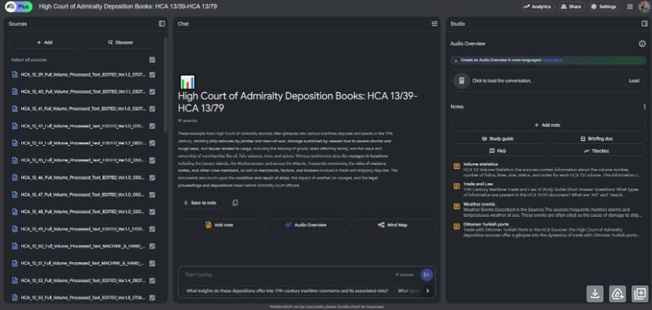

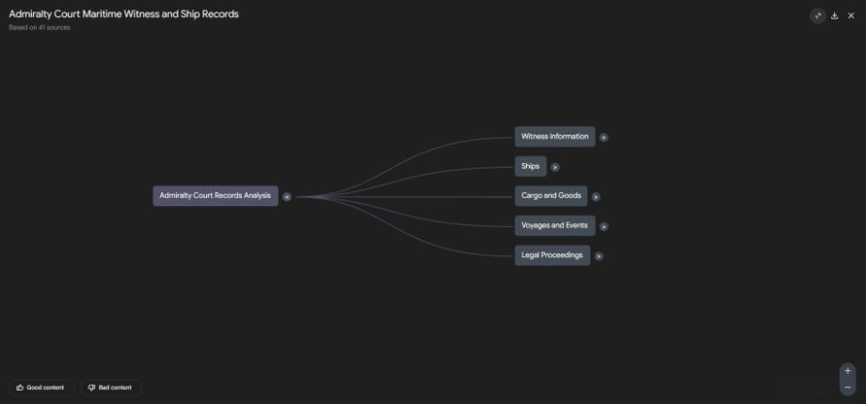

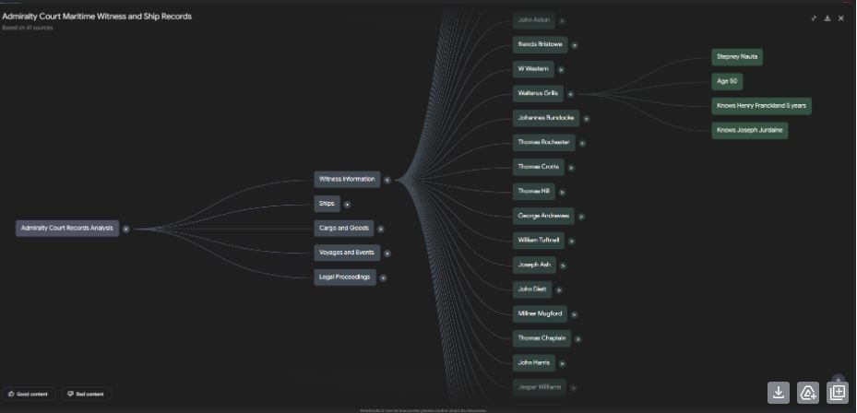

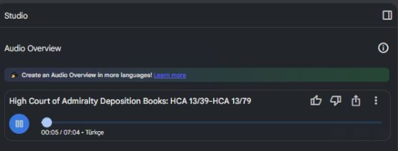

1

2

[[](https://bsky.app/profile/marinelives.bsky.social)](https://bsky.app/profile/marinelives.bsky.social)

[· 5mo](https://bsky.app/profile/marinelives.bsky.social/post/3lpbwzfgh322g)

Thanks

[@thiagokrause.bsky.social](https://bsky.app/profile/did:plc:m6ub6fozxlo3gzqn2rayoiwy)

You should have access already to this specific GoogleNotebookLM. Though you may need a paid Gemini AI account to get mindmsp and 50 languages podcast features. Will resend you link

1

[[](https://bsky.app/profile/marinelives.bsky.social)](https://bsky.app/profile/marinelives.bsky.social)

[· 5mo](https://bsky.app/profile/marinelives.bsky.social/post/3lo4cu7mxrk2j)

Looking for two or three Early Modern marine historians, marine archaeologists, and knowledgeable enthusiasts interested in exploring novel, as yet unpublished 5,000+ ship database [SOLM-QUANT] for C17th commercial (and naval) ships - Get in touch to learn more [#marinehistory](https://bsky.app/hashtag/marinehistory) [#earlymodern](https://bsky.app/hashtag/earlymodern)

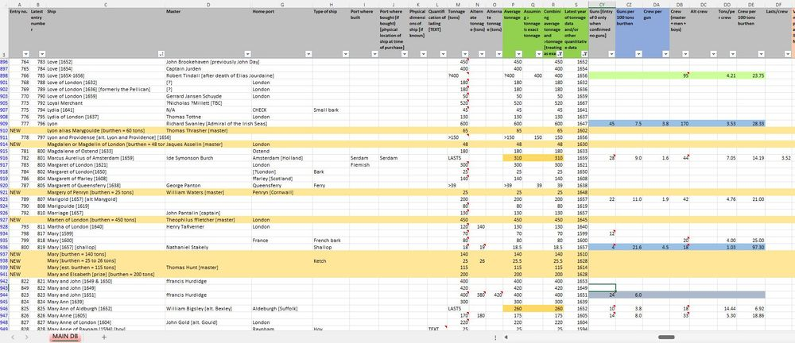

1

15

[[](https://bsky.app/profile/marinelives.bsky.social)](https://bsky.app/profile/marinelives.bsky.social)

[· 5mo](https://bsky.app/profile/marinelives.bsky.social/post/3lo4ecauofs2j)

Thanks for getting in touch @ametria.org . See my detailed response in chat

1

[[](https://bsky.app/profile/marinelives.bsky.social)](https://bsky.app/profile/marinelives.bsky.social)

[· 5mo](https://bsky.app/profile/marinelives.bsky.social/post/3lo4ejliobc2j)

Many different types of vessel in the SOLM-QUANT database, all waiting to be characterised quantitatively and qualitatively

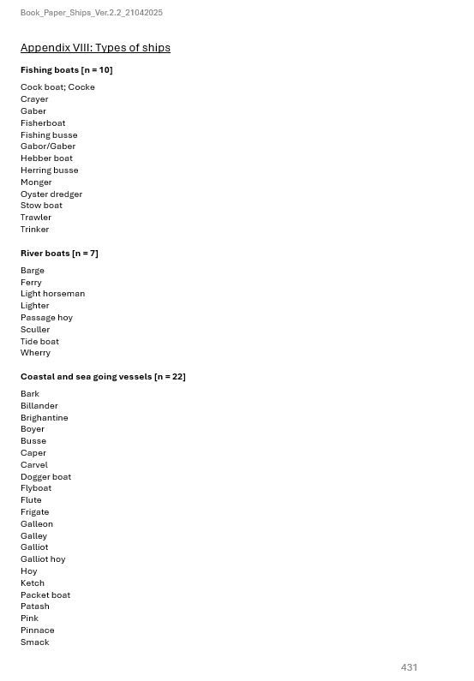

[[](https://bsky.app/profile/marinelives.bsky.social)](https://bsky.app/profile/marinelives.bsky.social)

[· 6mo](https://bsky.app/profile/marinelives.bsky.social/post/3lmuadwaooc2q)

I have been busy these last four months. Now looking for a publisher. Any suggestions. Can supply draft chapters and appendices for anyone interested in taking a look.

[@timhitchcock.bsky.social](https://bsky.app/profile/did:plc:zazpgix5w4ldyytazeqzytmz)

[@brodiewaddell.bsky.social](https://bsky.app/profile/did:plc:44em43qq5kem43otrh3vejy5)

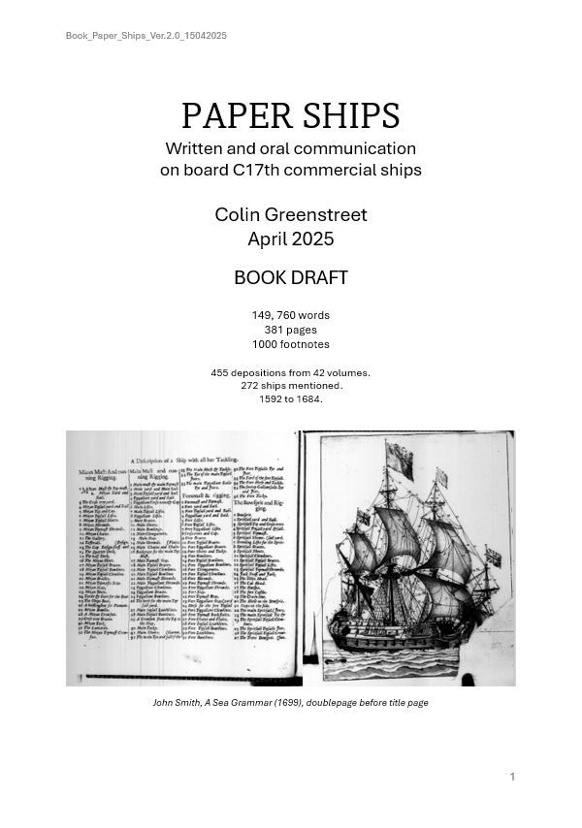

5

7

[[](https://bsky.app/profile/marinelives.bsky.social)](https://bsky.app/profile/marinelives.bsky.social)

[· 6mo](https://bsky.app/profile/marinelives.bsky.social/post/3lmuadxno4s2q)

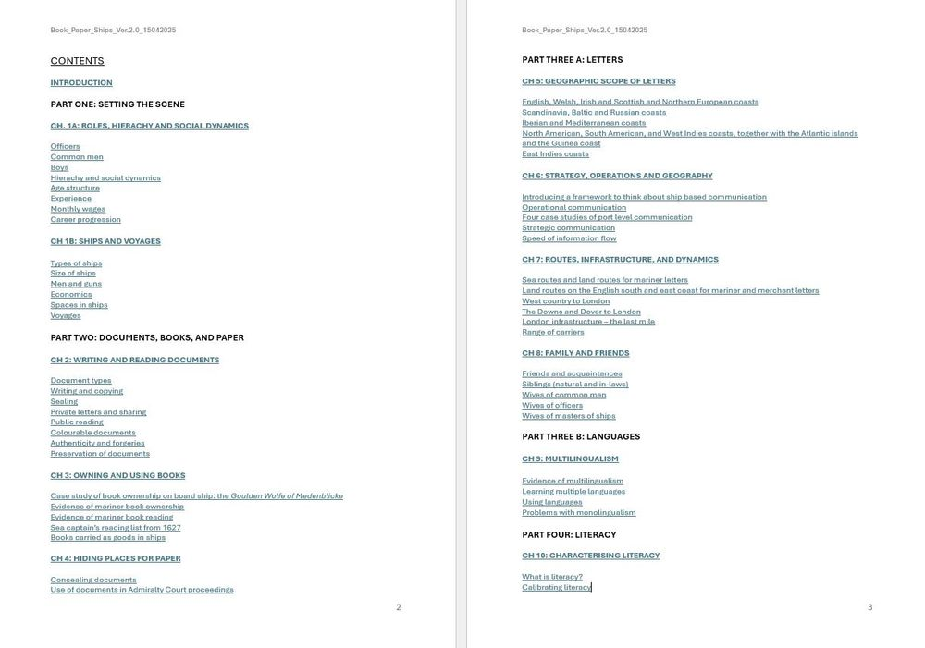

1

[[](https://bsky.app/profile/marinelives.bsky.social)](https://bsky.app/profile/marinelives.bsky.social)

[· 6mo](https://bsky.app/profile/marinelives.bsky.social/post/3lmuadyycf22q)

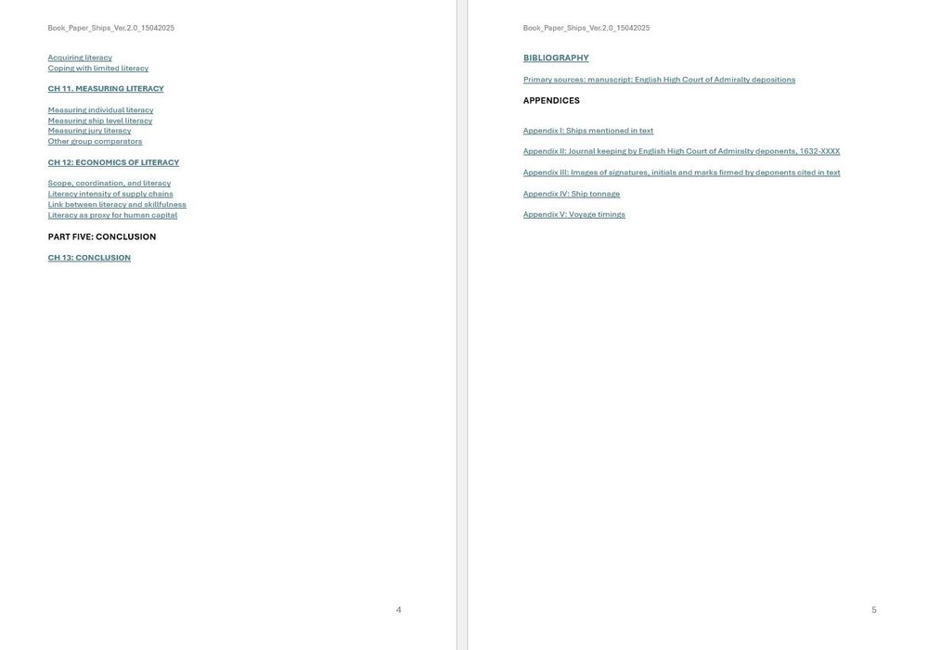

1

[Reposted by you](https://bsky.app/profile/marinelives.bsky.social)

[[](https://bsky.app/profile/mtorre.bsky.social)](https://bsky.app/profile/mtorre.bsky.social)

[· 10mo](https://bsky.app/profile/mtorre.bsky.social/post/3ldg3muem6k2r)

Enrollment is now open for the 4th edition of the Master's in Computational Social Sciences at UC3M! No prior knowledge of programming or stats is needed—perfect for social sciences grads. Questions? Contact us or ask to be connected with our student ambassadors! Please, share!

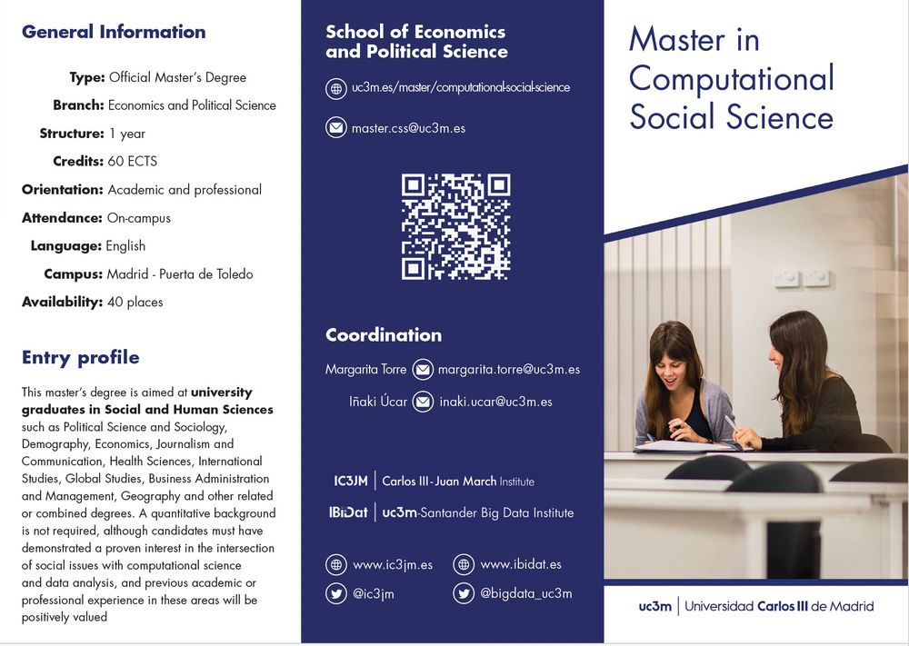

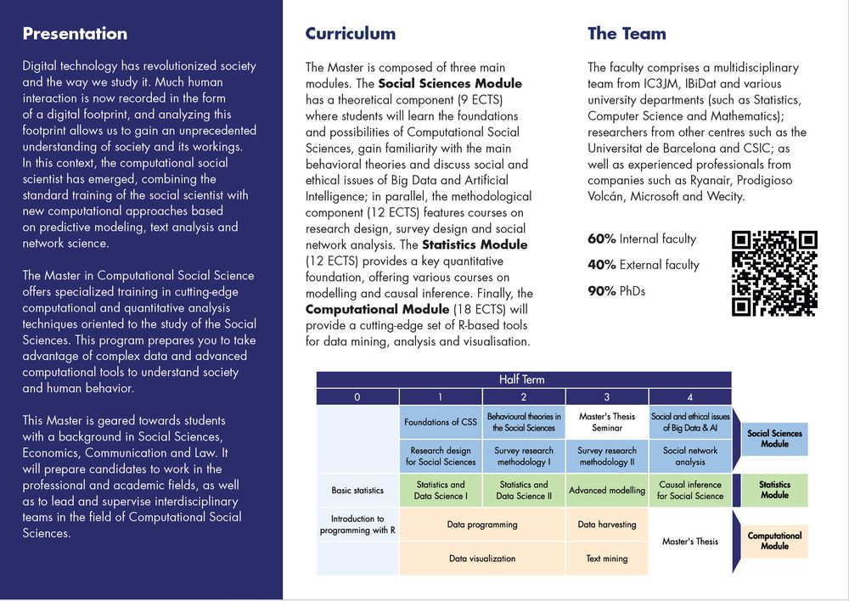

**28**

[[](https://bsky.app/profile/marinelives.bsky.social)](https://bsky.app/profile/marinelives.bsky.social)

[· 10mo](https://bsky.app/profile/marinelives.bsky.social/post/3lcvmgfvtgk27)

We have a nice new shiny organization card for MarineLives on Hugging Face, where you can find models and datasets [huggingface.co/MarineLives](https://huggingface.co/MarineLives)

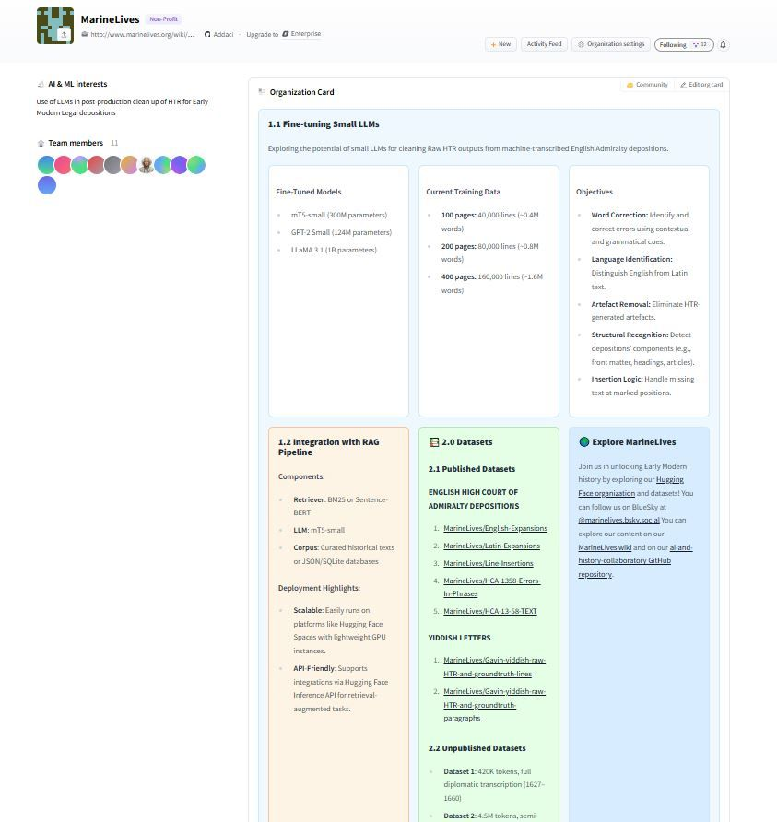

[[](https://bsky.app/profile/marinelives.bsky.social)](https://bsky.app/profile/marinelives.bsky.social)

[· 10mo](https://bsky.app/profile/marinelives.bsky.social/post/3lcpnnzsrmk22)

I am working with

[@beismo.bsky.social](https://bsky.app/profile/did:plc:rmnfya6fphjra4pmzsg26ra3)

to fine-tune two small large language models to correct raw machine transcription of Yiddish in Hebrew script. We plan to show the results this coming Tuesday at our next ai-and-history-collaboratory

[@timhitchcock.bsky.social](https://bsky.app/profile/did:plc:zazpgix5w4ldyytazeqzytmz)

[@mark-l-thompson.bsky.social](https://bsky.app/profile/did:plc:2jn5s6j2sojxy4qmbq2adifi)

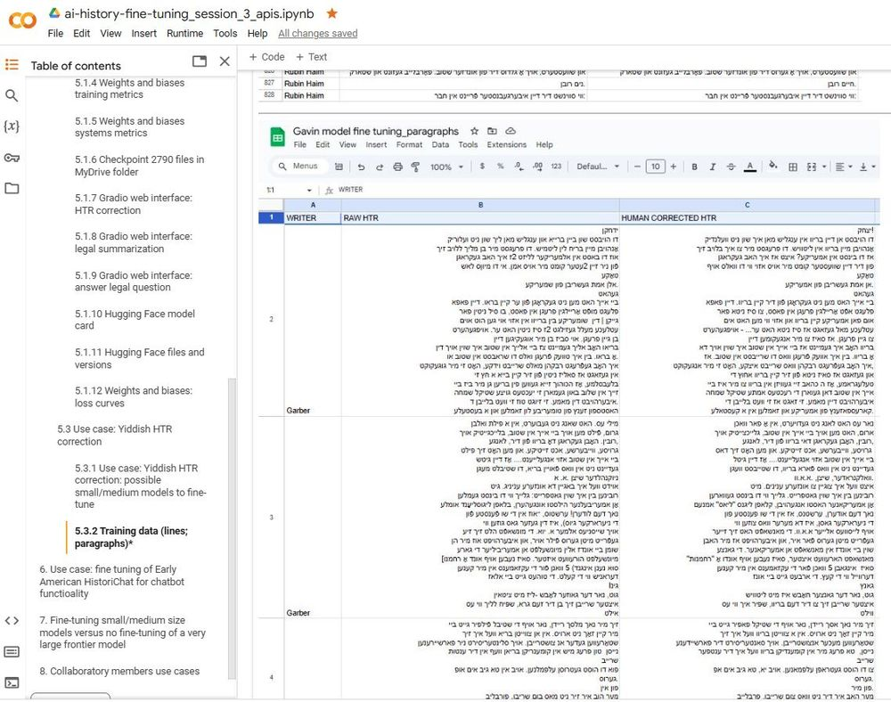

1

1

[View full thread](https://bsky.app/profile/did:plc:3haql47cl6jucf32mlqtre4p/post/3lcpnnzsrmk22)

[[](https://bsky.app/profile/marinelives.bsky.social)](https://bsky.app/profile/marinelives.bsky.social)

[· 10mo](https://bsky.app/profile/marinelives.bsky.social/post/3lcppgkxzm22r)

3/ Everything looks good so far. I am three epochs into a test run of a ten epoch fine-tune.

[@beismo.bsky.social](https://bsky.app/profile/did:plc:rmnfya6fphjra4pmzsg26ra3)

[@timhitchcock.bsky.social](https://bsky.app/profile/did:plc:zazpgix5w4ldyytazeqzytmz)

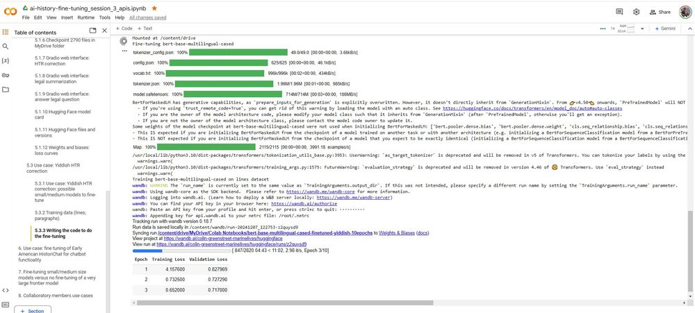

1

[[](https://bsky.app/profile/marinelives.bsky.social)](https://bsky.app/profile/marinelives.bsky.social)

[· 10mo](https://bsky.app/profile/marinelives.bsky.social/post/3lcpplulr422r)

4/ I am performing the test fine-tune from a Colab notebook, and am monitoring the evaluation, training and systems data from a Weights and Biases monitoring screen. I'm using a paid T4 GPU

[@beismo.bsky.social](https://bsky.app/profile/did:plc:rmnfya6fphjra4pmzsg26ra3)

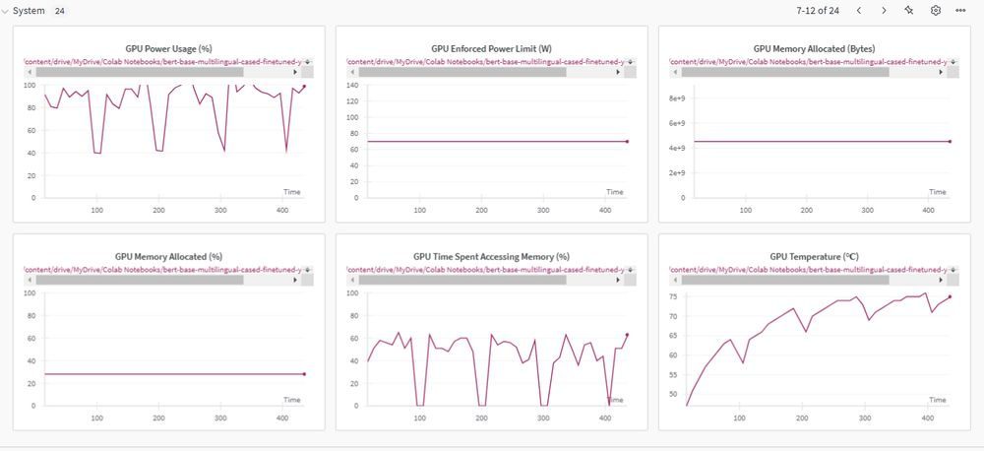

1

[[](https://bsky.app/profile/marinelives.bsky.social)](https://bsky.app/profile/marinelives.bsky.social)

[· 10mo](https://bsky.app/profile/marinelives.bsky.social/post/3lcmxsunq3c2c)

Do you wonder what "fine-tuning" a large language model means? How could it help in historical research? Next Tuesday during our weekly one hour ai-and-history-collaboratory we are going to run some code and train a small large language model called mT5 [github.com/Addaci/marin...](https://github.com/Addaci/marinelives-collaboratory/wiki)

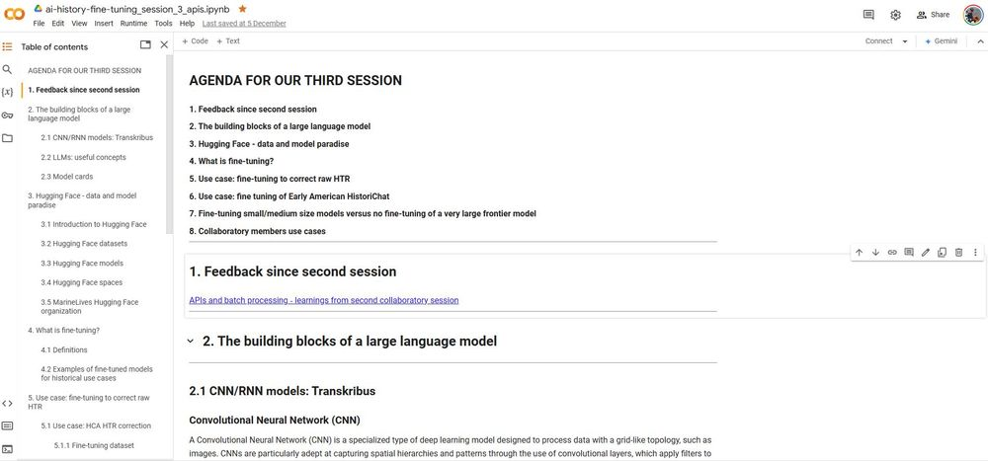

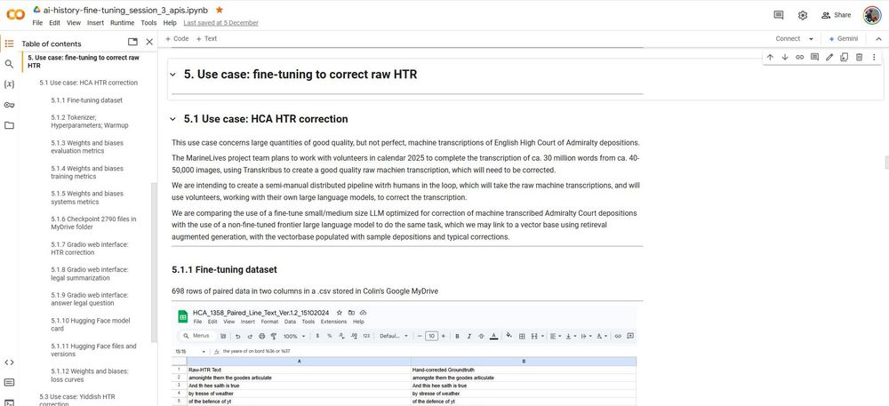

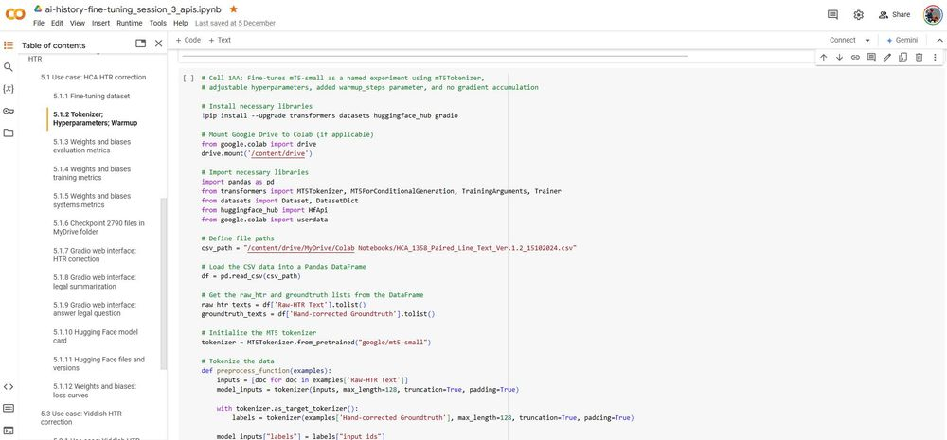

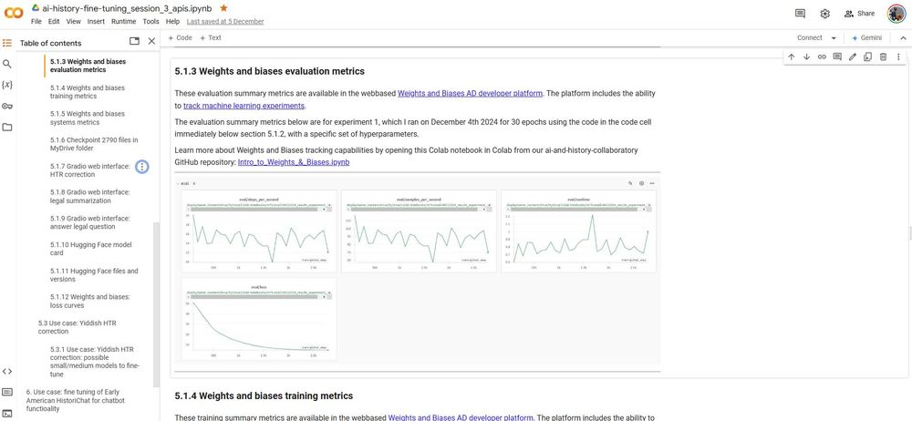

[[](https://bsky.app/profile/marinelives.bsky.social)](https://bsky.app/profile/marinelives.bsky.social)

[· 10mo](https://bsky.app/profile/marinelives.bsky.social/post/3lcmwkxr32s2c)

Great to see our ai-and-history-collaboratory is having some impact. And thanks to

[@mark-l-thompson.bsky.social](https://bsky.app/profile/did:plc:2jn5s6j2sojxy4qmbq2adifi)

for his participation. The topic for next Tuesday is fine-tuning large language models for use in historical research [github.com/Addaci/marin...](https://github.com/Addaci/marinelives-collaboratory/wiki)

[[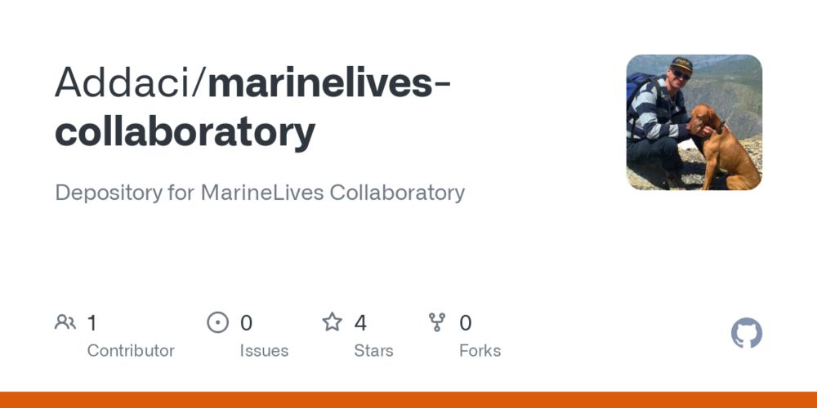](https://github.com/Addaci/marinelives-collaboratory/wiki)](https://github.com/Addaci/marinelives-collaboratory/wiki" \t "_blank)

**[Home](https://github.com/Addaci/marinelives-collaboratory/wiki" \t "_blank)**

[Depository for MarineLives Collaboratory. Contribute to Addaci/marinelives-collaboratory development by creating an account on GitHub.](https://github.com/Addaci/marinelives-collaboratory/wiki" \t "_blank)

[github.com](https://github.com/Addaci/marinelives-collaboratory/wiki" \t "_blank)

[[](https://bsky.app/profile/mark-l-thompson.bsky.social)](https://bsky.app/profile/mark-l-thompson.bsky.social)

[· 10mo](https://bsky.app/profile/mark-l-thompson.bsky.social/post/3lcizswvvi22j)

Many thanks to @marinelives.bsky.social, who helped me realize that with a little help from some high-powered GPTs I could do it on my own. Now I'm going to have to think hard about what kinds of fun things I'm going to do with it ... Or maybe ask those GPTs what could be done with it ... !

[[](https://bsky.app/profile/marinelives.bsky.social)](https://bsky.app/profile/marinelives.bsky.social)

[· 10mo](https://bsky.app/profile/marinelives.bsky.social/post/3lcfjodhbo22z)

Interested in learning to use large language models for historical research? We have a Colab notebook which guides non-coders through using APIs to interrogate data [github.com/Addaci/Aurel...](https://github.com/Addaci/Aurelius/blob/main/ai_history_session_2_apis.ipynb)

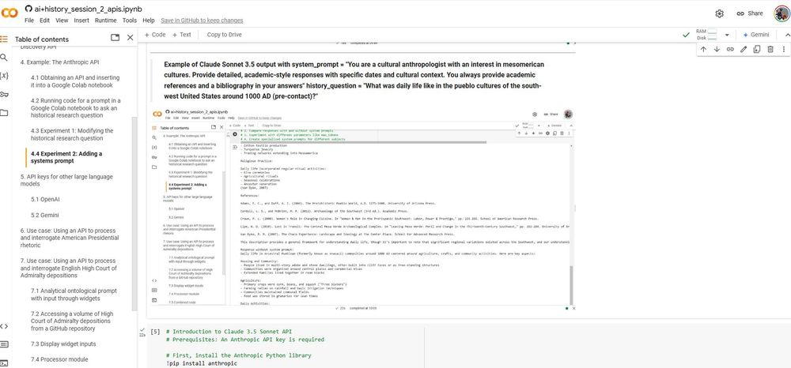

3

[[](https://bsky.app/profile/marinelives.bsky.social)](https://bsky.app/profile/marinelives.bsky.social)

[· 10mo](https://bsky.app/profile/marinelives.bsky.social/post/3lcdsjvbp2s2t)

We have a Google colab notebook as background to session two of our ai and history collaboratory. If you are interested please try some of the exericises - no code required [github.com/Addaci/marin...](https://github.com/Addaci/marinelives-collaboratory/blob/main/ai%2Bhistory_session_2_apis.ipynb)

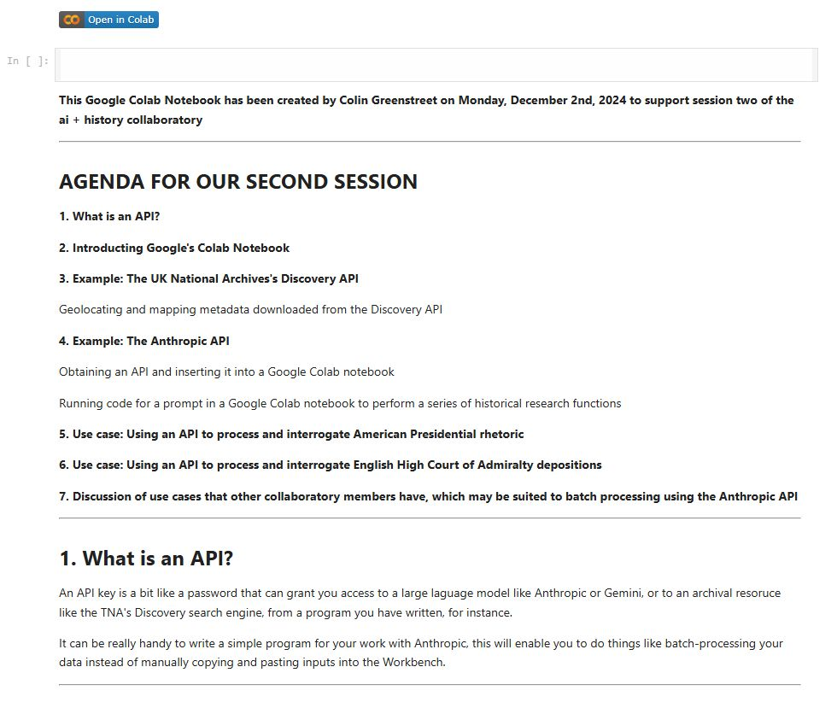

1

2

[[](https://bsky.app/profile/marinelives.bsky.social)](https://bsky.app/profile/marinelives.bsky.social)

[· 10mo](https://bsky.app/profile/marinelives.bsky.social/post/3lcfjlegiy22z)

Revised agenda and link again to the Colab notebook on our GitHub site [github.com/Addaci/Aurel...](https://github.com/Addaci/Aurelius/blob/main/ai_history_session_2_apis.ipynb)

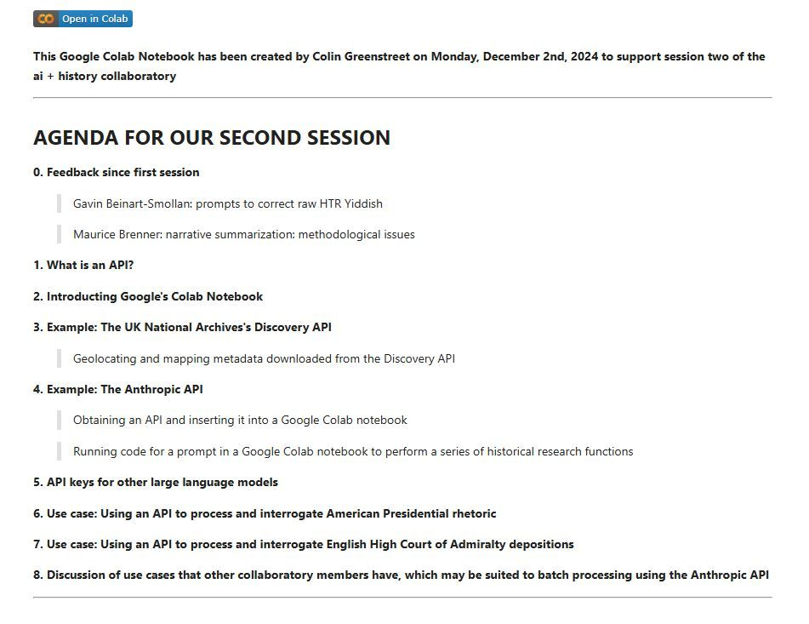

[[](https://bsky.app/profile/marinelives.bsky.social)](https://bsky.app/profile/marinelives.bsky.social)

[· 11mo](https://bsky.app/profile/marinelives.bsky.social/post/3lc3gyjh3722w)

We are holding the second session of our ai-and-history collaboratory on Tuesday, December 3rd 2024 at 4 pm London time. We will be learning how to use APIs to control large language models for historical research. [github.com/Addaci/marin...](https://github.com/Addaci/marinelives-collaboratory/wiki/APIs-and-batch-processing-%E2%80%90-second-collaboratory-session)

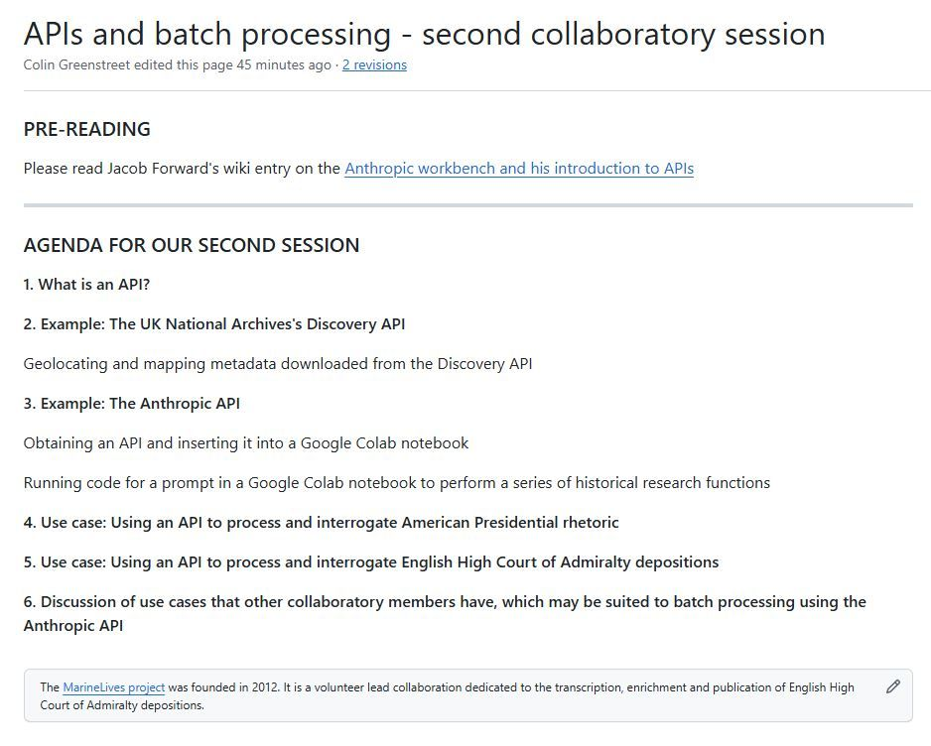

1

1

[[](https://bsky.app/profile/marinelives.bsky.social)](https://bsky.app/profile/marinelives.bsky.social)

[· 11mo](https://bsky.app/profile/marinelives.bsky.social/post/3lbymuun44k2m)

Curious about our ai-and-history-collaboration? We hold one hour ZOOM dropin sessions each Thursday at 4 pm London time. Direct mail us if you are interested in finding out more. [github.com/Addaci/marin...](https://github.com/Addaci/marinelives-collaboratory/wiki)

[[](https://github.com/Addaci/marinelives-collaboratory/wiki)](https://github.com/Addaci/marinelives-collaboratory/wiki" \t "_blank)

**[Home](https://github.com/Addaci/marinelives-collaboratory/wiki" \t "_blank)**

[Depository for MarineLives Collaboratory. Contribute to Addaci/marinelives-collaboratory development by creating an account on GitHub.](https://github.com/Addaci/marinelives-collaboratory/wiki" \t "_blank)

[github.com](https://github.com/Addaci/marinelives-collaboratory/wiki" \t "_blank)

[[](https://bsky.app/profile/marinelives.bsky.social)](https://bsky.app/profile/marinelives.bsky.social)

[· 11mo](https://bsky.app/profile/marinelives.bsky.social/post/3lbw4lpuk3s2x)

1/ The first session of the eight session ai-and-history-collaboratory took place yesterday. Great turnout and stimulating discussion of how to prompt large language models in the context of historical research. [github.com/Addaci/marin...](https://github.com/Addaci/marinelives-collaboratory/wiki)

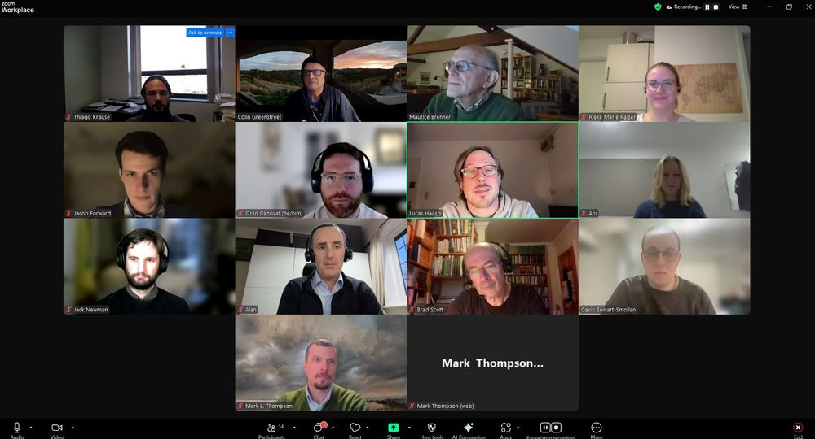

1

1

[[](https://bsky.app/profile/marinelives.bsky.social)](https://bsky.app/profile/marinelives.bsky.social)

[· 11mo](https://bsky.app/profile/marinelives.bsky.social/post/3lbr4ljdfkk2v)

Our ai-and-history-collaboratory kicks off this Tuesday for the first of eight sessions. This Tuesday we are discussing Prompt Engineering. [github.com/Addaci/marin...](https://github.com/Addaci/marinelives-collaboratory/wiki/Prompt-engineering) [#skystorians](https://bsky.app/hashtag/skystorians) [#machinelearning](https://bsky.app/hashtag/machinelearning)

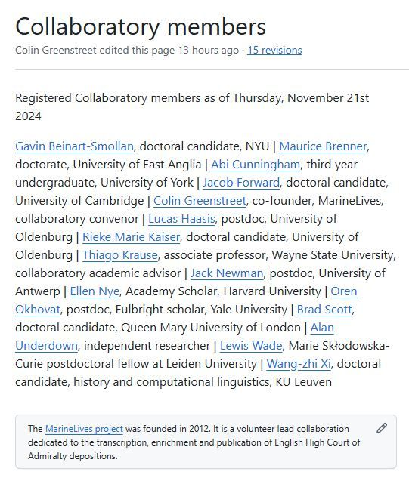

1

[[](https://bsky.app/profile/marinelives.bsky.social)](https://bsky.app/profile/marinelives.bsky.social)

[· 11mo](https://bsky.app/profile/marinelives.bsky.social/post/3lbqqtd3tb22t)

Great article on training librarians in digital humanities

[[](https://bsky.app/profile/bibliorogue.bsky.social)](https://bsky.app/profile/bibliorogue.bsky.social)

[· 11mo](https://bsky.app/profile/bibliorogue.bsky.social/post/3lbkzphhw6s2s)

If you're interested in digital humanities and pedagogy, here's my latest about training librarians in DH: ideah.pubpub.org/pub/mj651yt4.... Thanks to the DHSI (Digital Humanities Summer Institute) folks, and the MLIS students who let me talk about their terrific work! Go #DH and #libraries

**[Training MLIS Students in DH: Hands-On Consultation Project](https://ideah.pubpub.org/pub/mj651yt4/release/3?readingCollection=a288f20f" \t "_blank)**

[ideah.pubpub.org](https://ideah.pubpub.org/pub/mj651yt4/release/3?readingCollection=a288f20f" \t "_blank)

[[](https://bsky.app/profile/marinelives.bsky.social)](https://bsky.app/profile/marinelives.bsky.social)

[· 11mo](https://bsky.app/profile/marinelives.bsky.social/post/3lbheoz2uok2d)

An exceptionally helpful post by

[@burtenshaw.bsky.social](https://bsky.app/profile/did:plc:wxg2qylyqgnk746bopio2aff)

I have changed session 4 of our ai-and-history collaboratory to tackle data broadly, including creation and use of synthetic data [github.com/Addaci/marin...](https://github.com/Addaci/marinelives-collaboratory/wiki/Curriculum)

[[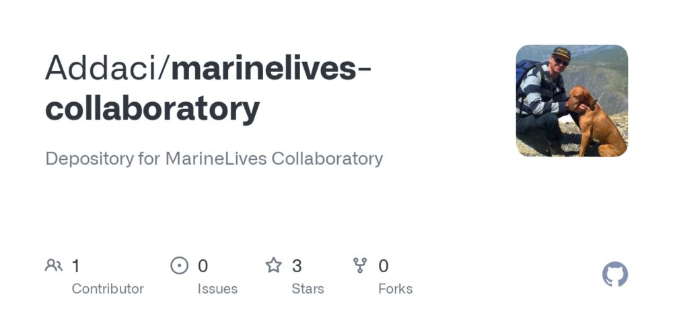](https://github.com/Addaci/marinelives-collaboratory/wiki/Curriculum)](https://github.com/Addaci/marinelives-collaboratory/wiki/Curriculum" \t "_blank)

**[Curriculum](https://github.com/Addaci/marinelives-collaboratory/wiki/Curriculum" \t "_blank)**

[Depository for MarineLives Collaboratory. Contribute to Addaci/marinelives-collaboratory development by creating an account on GitHub.](https://github.com/Addaci/marinelives-collaboratory/wiki/Curriculum" \t "_blank)

[github.com](https://github.com/Addaci/marinelives-collaboratory/wiki/Curriculum" \t "_blank)

[[](https://bsky.app/profile/benburtenshaw.bsky.social)](https://bsky.app/profile/benburtenshaw.bsky.social)

[· 11mo](https://bsky.app/profile/benburtenshaw.bsky.social/post/3lbhbc7hlkc2v)

synthetic data on easy\_mode We noticed that folk were building synthetic datasets in a common way. Basically going from prompt to dataset, and iterating. So we implemented a friendly abstraction to help you learn and improve this flow.

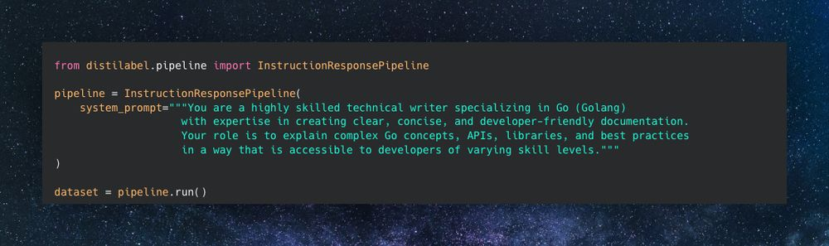

1

[[](https://bsky.app/profile/marinelives.bsky.social)](https://bsky.app/profile/marinelives.bsky.social)

[· 11mo](https://bsky.app/profile/marinelives.bsky.social/post/3lbemix3qbk2l)

The slides and video from my talk yesterday at the IHR Digital Seminar on ai and history [ihrdighist.blogs.sas.ac.uk/2024/09/tues...](https://ihrdighist.blogs.sas.ac.uk/2024/09/tuesday-19-november-2024-colin-greenstreet-ai-agents-for-historical-research-a-new-skill-set-for-historians/)

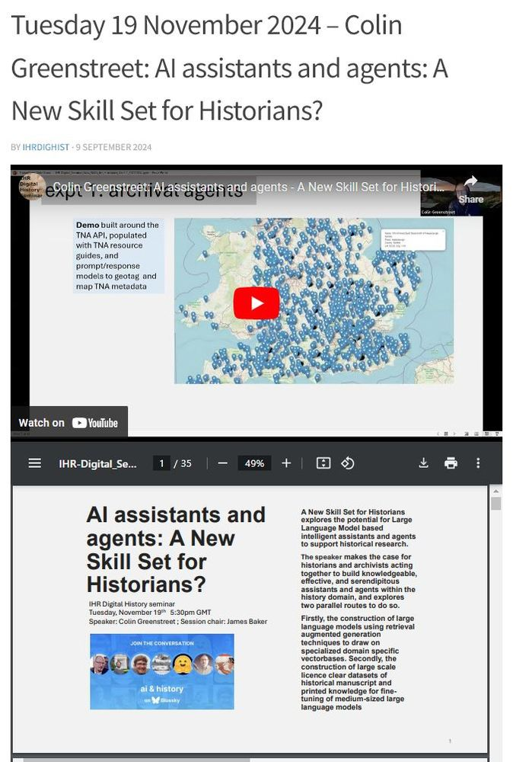

2

3

[Reposted by you](https://bsky.app/profile/marinelives.bsky.social)

[[](https://bsky.app/profile/coastalhistory.bsky.social)](https://bsky.app/profile/coastalhistory.bsky.social)

[· 11mo](https://bsky.app/profile/coastalhistory.bsky.social/post/3lba4qbjlj22w)

I wrote the book I wish I’d had when I was starting out. It’ll be available as paperback or ebook next month. Sharing the Amazon link here because it includes the reviews / testimonials from the back cover. [#history](https://bsky.app/hashtag/history) [#AcademicWriting](https://bsky.app/hashtag/AcademicWriting) 🗃️ [www.amazon.com/Craft-Histor...](https://www.amazon.com/Craft-Historical-Research-Practical-Finish/dp/3031684567)

[[](https://www.amazon.com/Craft-Historical-Research-Practical-Finish/dp/3031684567)](https://www.amazon.com/Craft-Historical-Research-Practical-Finish/dp/3031684567" \t "_blank)

**[Amazon.com: The Craft of Historical Research: A Practical Guide from Start to Finish: 9783031684562: Land, Isaac: Books](https://www.amazon.com/Craft-Historical-Research-Practical-Finish/dp/3031684567" \t "_blank)**

[Amazon.com: The Craft of Historical Research: A Practical Guide from Start to Finish: 9783031684562: Land, Isaac: Books](https://www.amazon.com/Craft-Historical-Research-Practical-Finish/dp/3031684567" \t "_blank)

[www.amazon.com](https://www.amazon.com/Craft-Historical-Research-Practical-Finish/dp/3031684567" \t "_blank)

3

**16**

[[](https://bsky.app/profile/marinelives.bsky.social)](https://bsky.app/profile/marinelives.bsky.social)

[· 11mo](https://bsky.app/profile/marinelives.bsky.social/post/3lbdb5szx522b)

Fascinating primary source on Dutch/Venetian relations in early C17th. I am going to read this carefully and cross-reference against our growing High Court of Admiralty Corpus from the 1610s and 1620s [#skystorians](https://bsky.app/hashtag/skystorians) [#earlymodern](https://bsky.app/hashtag/earlymodern)

[[](https://bsky.app/profile/ninalamal.bsky.social)](https://bsky.app/profile/ninalamal.bsky.social)

[· 30/10/2024](https://bsky.app/profile/ninalamal.bsky.social/post/3l7qixztgy726)

After four years of work, I was delighted and honoured to present the digital edition of Suriano's letters to Giorgo Novello, his modern successor in The Hague. A very special moment in my academic career thus far. The edition is freely available, go and check it out: suriano.huygens.knaw.nl

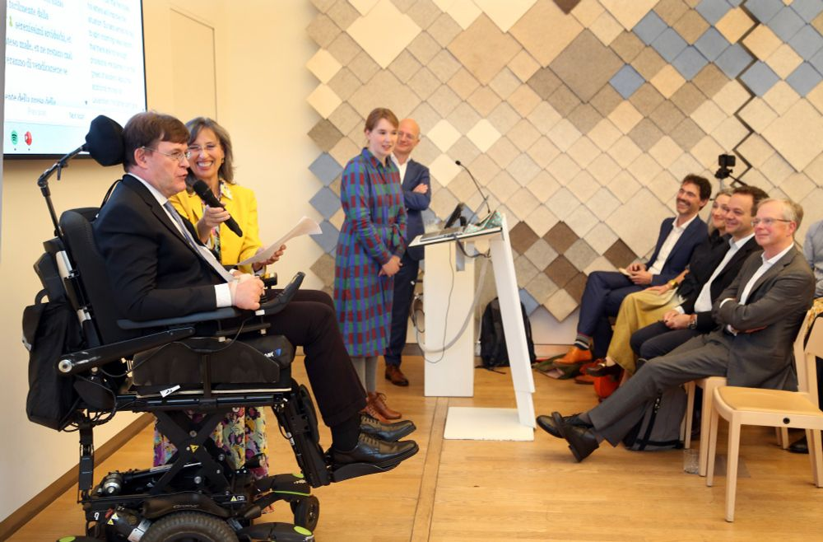

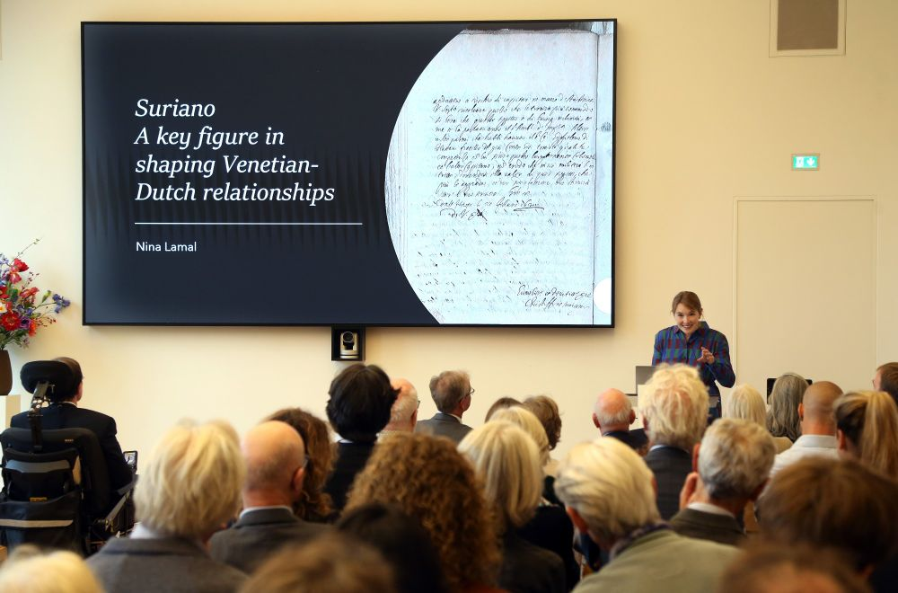

[[](https://bsky.app/profile/marinelives.bsky.social)](https://bsky.app/profile/marinelives.bsky.social)

[· 11mo](https://bsky.app/profile/marinelives.bsky.social/post/3lb7p3mbdcc2y)

I am compiling a list of potential sources of English language history related training data & metadata to fine-tune large language history domain models. They have varying licencing terms. What am I missing?

[@danielvanstrien.bsky.social](https://bsky.app/profile/did:plc:7e5mpxuweopubhexwqg5l3ba)

[github.com/Addaci/marin...](https://github.com/Addaci/marinelives-collaboratory/wiki/History-domain-training-data-sets)

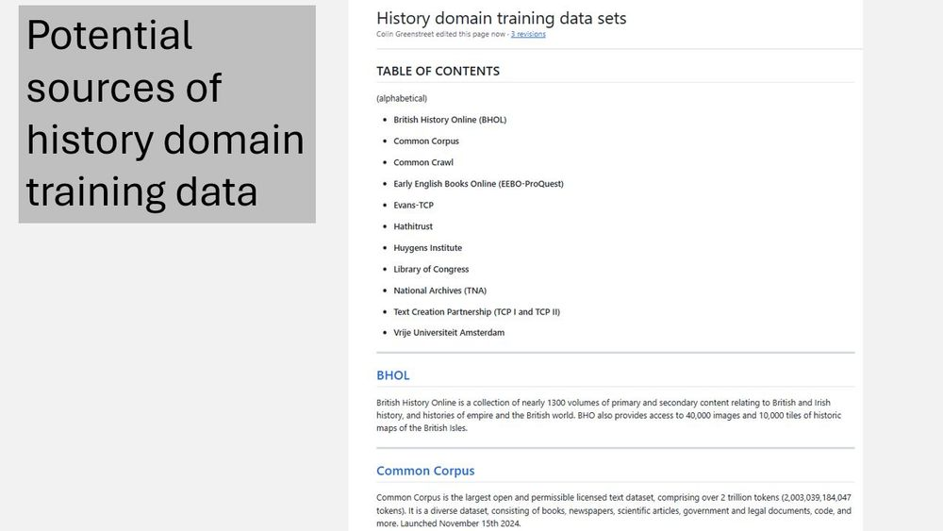

1

1

[[](https://bsky.app/profile/marinelives.bsky.social)](https://bsky.app/profile/marinelives.bsky.social)

[· 11mo](https://bsky.app/profile/marinelives.bsky.social/post/3lb6jcuhwvk2o)

[@thiagokrause.bsky.social](https://bsky.app/profile/did:plc:m6ub6fozxlo3gzqn2rayoiwy)

[[](https://bsky.app/profile/danielvanstrien.bsky.social)](https://bsky.app/profile/danielvanstrien.bsky.social)

[· 11mo](https://bsky.app/profile/danielvanstrien.bsky.social/post/3lb6iftefps2h)

In many cases it's unlikely to be feasible to train/fine-tune an LLM but building robust evaluation datasets can help make it much easier to measure and compare performance of different LLMs (open and closed). There are some useful pointers for doing this here: github.com/huggingface/...

[[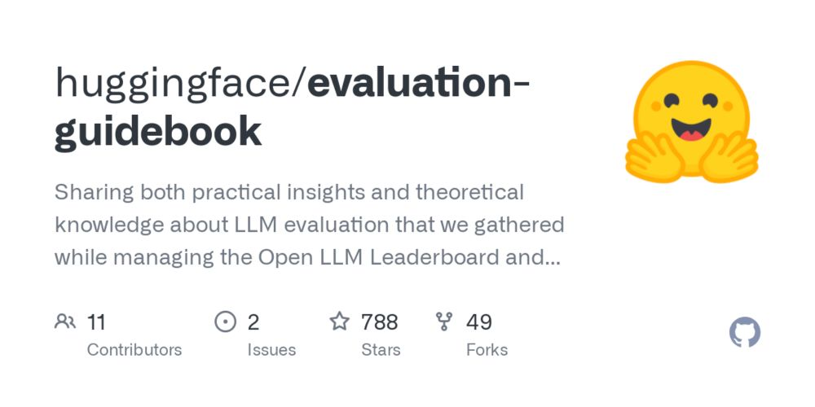](https://github.com/huggingface/evaluation-guidebook)](https://github.com/huggingface/evaluation-guidebook" \t "_blank)

**[GitHub - huggingface/evaluation-guidebook: Sharing both practical insights and theoretical knowledge about LLM evaluation that we gathered while managing the Open LLM Leaderboard and designing lightev...](https://github.com/huggingface/evaluation-guidebook" \t "_blank)**

[Sharing both practical insights and theoretical knowledge about LLM evaluation that we gathered while managing the Open LLM Leaderboard and designing lighteval! - huggingface/evaluation-guidebook](https://github.com/huggingface/evaluation-guidebook" \t "_blank)

[github.com](https://github.com/huggingface/evaluation-guidebook" \t "_blank)

[[](https://bsky.app/profile/marinelives.bsky.social)](https://bsky.app/profile/marinelives.bsky.social)

[· 11mo](https://bsky.app/profile/marinelives.bsky.social/post/3lb6jc5dcpc2o)

[@thiagokrause.bsky.social](https://bsky.app/profile/did:plc:m6ub6fozxlo3gzqn2rayoiwy)

[[](https://bsky.app/profile/danielvanstrien.bsky.social)](https://bsky.app/profile/danielvanstrien.bsky.social)

[· 11mo](https://bsky.app/profile/danielvanstrien.bsky.social/post/3lb6ifru3t22h)

I think the tide is turning on scale above all else but scale is still important so it will be more about ensuring quality at scale. See for example huggingface.co/spaces/Huggi...

[[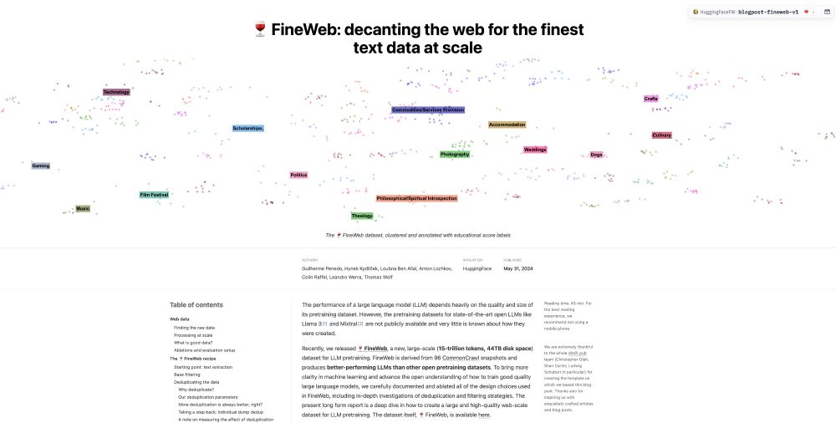](https://huggingface.co/spaces/HuggingFaceFW/blogpost-fineweb-v1)](https://huggingface.co/spaces/HuggingFaceFW/blogpost-fineweb-v1" \t "_blank)

**[FineWeb: decanting the web for the finest text data at scale - a Hugging Face Space by HuggingFaceFW](https://huggingface.co/spaces/HuggingFaceFW/blogpost-fineweb-v1" \t "_blank)**

[Discover amazing ML apps made by the community](https://huggingface.co/spaces/HuggingFaceFW/blogpost-fineweb-v1" \t "_blank)

[huggingface.co](https://huggingface.co/spaces/HuggingFaceFW/blogpost-fineweb-v1" \t "_blank)

[[](https://bsky.app/profile/marinelives.bsky.social)](https://bsky.app/profile/marinelives.bsky.social)

[· 11mo](https://bsky.app/profile/marinelives.bsky.social/post/3lb6jbalj4c2o)

[@thiagokrause.bsky.social](https://bsky.app/profile/did:plc:m6ub6fozxlo3gzqn2rayoiwy)

[[](https://bsky.app/profile/danielvanstrien.bsky.social)](https://bsky.app/profile/danielvanstrien.bsky.social)

[· 11mo](https://bsky.app/profile/danielvanstrien.bsky.social/post/3lb6hh5xers2h)

I think one of the most important skills for using AI well for any domain, including history, will be building datasets and learning how to do good/useful evaluations for the tasks you are interested in. IMO, this is where collaboration in the field could have a lot of benefits.

[[](https://bsky.app/profile/marinelives.bsky.social)](https://bsky.app/profile/marinelives.bsky.social)

[· 11mo](https://bsky.app/profile/marinelives.bsky.social/post/3lb5w6p7njs2g)

1/ Six more slides from my talk next Tuesday - the order may change, but let me talk you through them

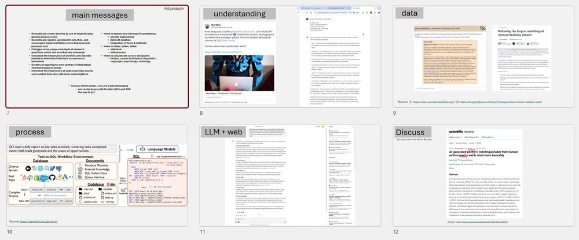

1

1

[View full thread](https://bsky.app/profile/did:plc:3haql47cl6jucf32mlqtre4p/post/3lb5w6p7njs2g)

[[](https://bsky.app/profile/marinelives.bsky.social)](https://bsky.app/profile/marinelives.bsky.social)

[· 11mo](https://bsky.app/profile/marinelives.bsky.social/post/3lb5wnnqdfc2g)

4/ Large Language Models are amazing at process management. Ignore the detail of this chart. Imagine a LLM is working with public historians & archivists to machine transcribe, name entity extract, correct, create Dublin core metadata, create linked open data, then inject it into a IIIF manifest.

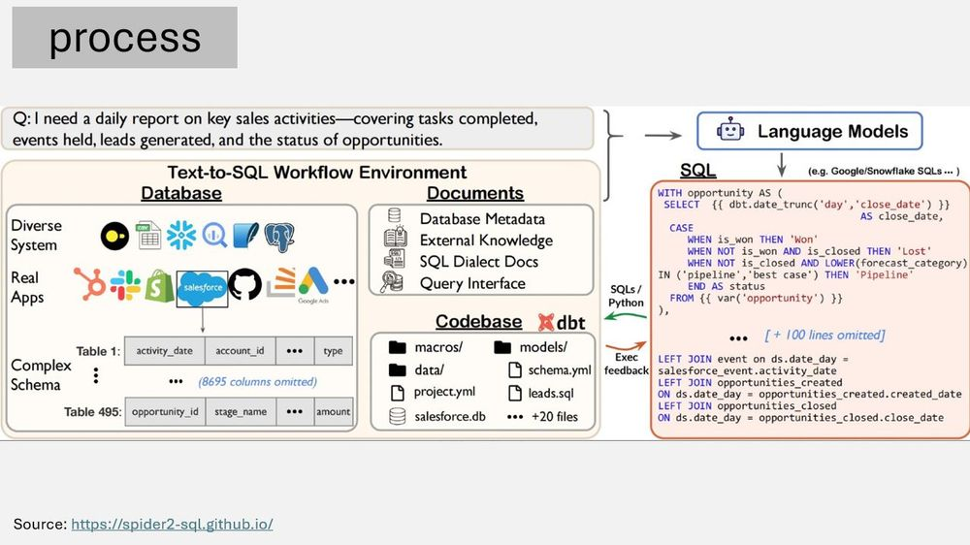

1

[[](https://bsky.app/profile/marinelives.bsky.social)](https://bsky.app/profile/marinelives.bsky.social)

[· 11mo](https://bsky.app/profile/marinelives.bsky.social/post/3lb5wqlajfc2g)

5/ Connect a LLM to the web or to a historical vector base of real scale. You have just amplified the power of the LLM (and the historical researcher) by at least a magnitude

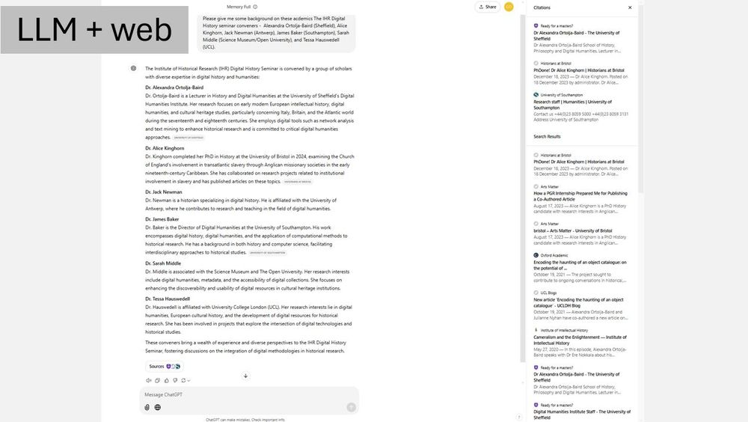

[[](https://bsky.app/profile/marinelives.bsky.social)](https://bsky.app/profile/marinelives.bsky.social)

[· 11mo](https://bsky.app/profile/marinelives.bsky.social/post/3lb5tjcvjwk2h)

This has to be the most fun post I have seen today. If I were a seagull I would definitely head south!

[[](https://bsky.app/profile/jonasnahm.com)](https://bsky.app/profile/jonasnahm.com)

[· 11mo](https://bsky.app/profile/jonasnahm.com/post/3lb3cg3ucws2k)

Highlight of the week may have been learning about the Belgian seagulls that mysteriously made a 50 mile trip inland once a day, only to find out that their destination was a potato chip factory. Can relate!

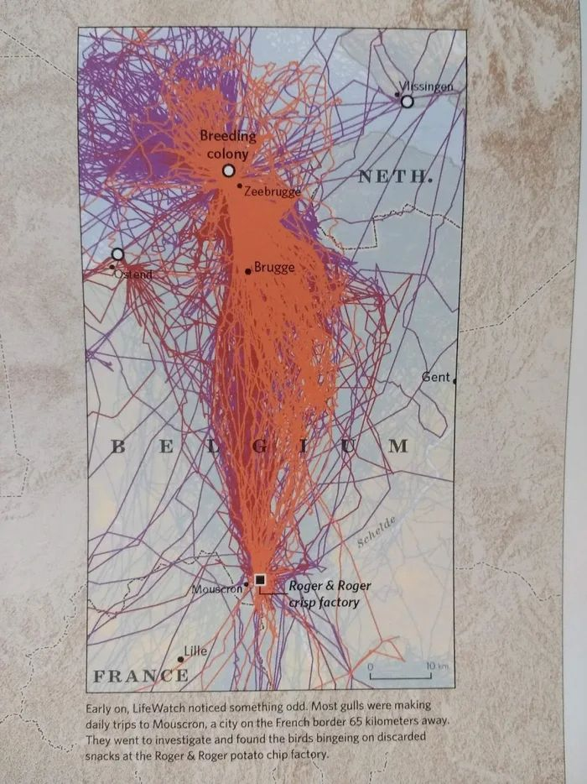

**ALT**

1

[[](https://bsky.app/profile/marinelives.bsky.social)](https://bsky.app/profile/marinelives.bsky.social)

[· 11mo](https://bsky.app/profile/marinelives.bsky.social/post/3lb5so45flk2h)

I am mulling over the messages I want to convey when I talk this Tuesday about ai+history. I'm not sure I am going to make friends (or I am right) but here goes

[@tedunderwood.me](https://bsky.app/profile/did:plc:565ebob5f6hw33hjdkxty6qj)

[@michielree.bsky.social](https://bsky.app/profile/did:plc:bkregcsaysh6tco57ev2hfe7)

[@javiercha.bsky.social](https://bsky.app/profile/did:plc:ecc3o7r4wpmoiejq3rcx3m22)

[@timhitchcock.bsky.social](https://bsky.app/profile/did:plc:zazpgix5w4ldyytazeqzytmz)

[@bschmidt.bsky.social](https://bsky.app/profile/did:plc:r36govxkk4hmrcqlrjmbrjtl)

[@zoeleblanc.bsky.social](https://bsky.app/profile/did:plc:uiqxtpbexkfmjdjeiijy4cnl)

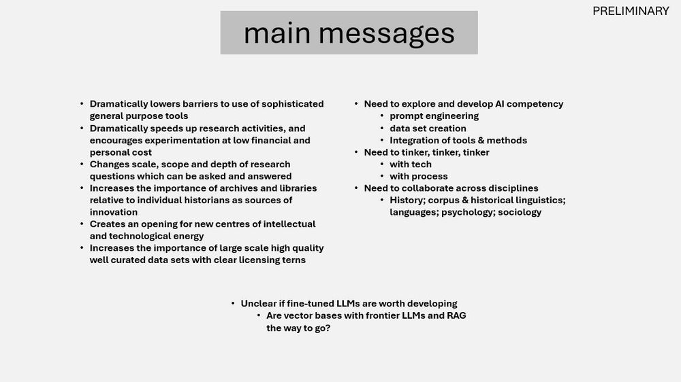

2

[[](https://bsky.app/profile/marinelives.bsky.social)](https://bsky.app/profile/marinelives.bsky.social)

[· 11mo](https://bsky.app/profile/marinelives.bsky.social/post/3lb55hgzfnk2a)

1/ The first six slides from my talk this coming Tuesday on ai and history - a new set of skills for historians [ihrdighist.blogs.sas.ac.uk/2024/09/tues...](https://ihrdighist.blogs.sas.ac.uk/2024/09/tuesday-19-november-2024-colin-greenstreet-ai-agents-for-historical-research-a-new-skill-set-for-historians/); see also our collaboratory which I am launching at the talk: [github.com/Addaci/marin...](https://github.com/Addaci/marinelives-collaboratory/wiki)

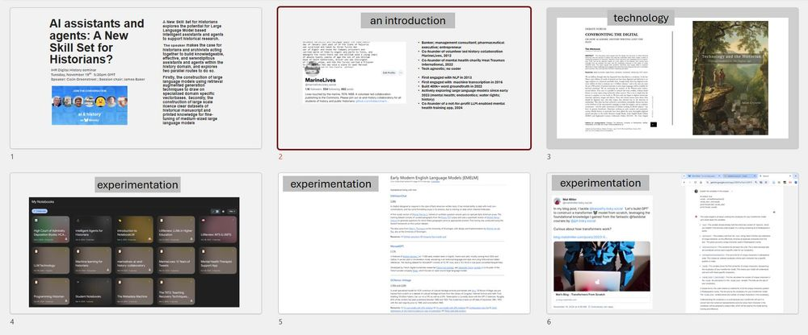

1

[View full thread](https://bsky.app/profile/did:plc:3haql47cl6jucf32mlqtre4p/post/3lb55hgzfnk2a)

[[](https://bsky.app/profile/marinelives.bsky.social)](https://bsky.app/profile/marinelives.bsky.social)

[· 11mo](https://bsky.app/profile/marinelives.bsky.social/post/3lb55vmhumc2n)

5/ Experiment, experiment, experiment. Try Google NotebooksLM. I will be sharing a Notebook at my talk to support our discussion.

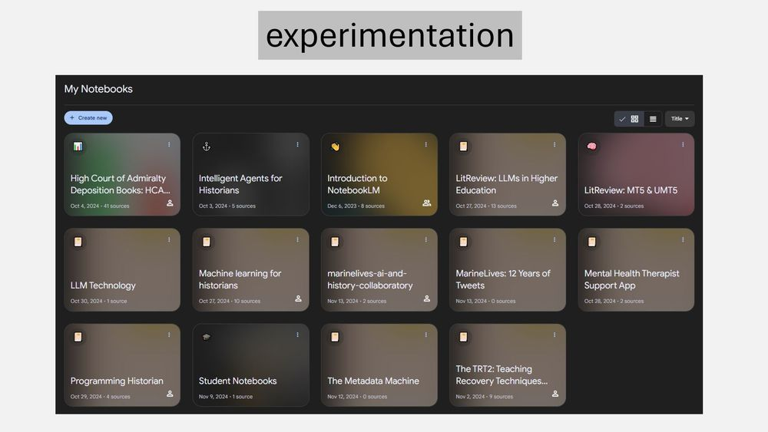

1

[[](https://bsky.app/profile/marinelives.bsky.social)](https://bsky.app/profile/marinelives.bsky.social)

[· 11mo](https://bsky.app/profile/marinelives.bsky.social/post/3lb55yztdz22n)

6/ Experiment, experiment, experiment. Opportunity to fine-tune large language models with linguistic and cultural; context, and to constrain them using vectorbases and retrieval augmented generative techniques

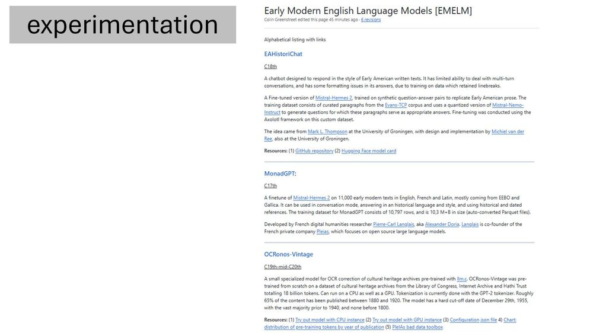

1

[[](https://bsky.app/profile/marinelives.bsky.social)](https://bsky.app/profile/marinelives.bsky.social)

[· 11mo](https://bsky.app/profile/marinelives.bsky.social/post/3lb52zcfzjs2a)

Looks like a great course and a grat opportunity to work with

[@cathrynpearce.bsky.social](https://bsky.app/profile/did:plc:exgau52o6rhy7q4ln4opkwf4)

an early

[@marinelives.bsky.social](https://bsky.app/profile/did:plc:3haql47cl6jucf32mlqtre4p)

volunteer and supporter

[[](https://bsky.app/profile/cathrynpearce.bsky.social)](https://bsky.app/profile/cathrynpearce.bsky.social)

[· 11mo](https://bsky.app/profile/cathrynpearce.bsky.social/post/3laqxd3q66227)

Interesting in taking our distance-learning MA in Naval, Maritime and Coastal History? We are taking applications for our first-ever January start! This will be the last time for our strictly naval history core modules, so come join us! #NavalHistory #MaritimeHistory www.port.ac.uk/study/course...

[[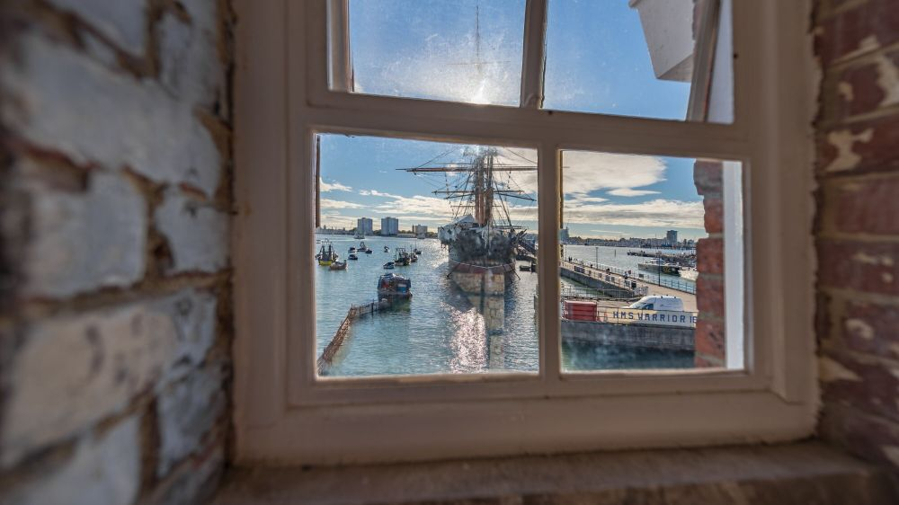](https://www.port.ac.uk/study/courses/postgraduate-taught/ma-naval-maritime-and-coastal-history)](https://www.port.ac.uk/study/courses/postgraduate-taught/ma-naval-maritime-and-coastal-history" \t "_blank)

**[Naval, Maritime and Coastal History (Distance Learning)](https://www.port.ac.uk/study/courses/postgraduate-taught/ma-naval-maritime-and-coastal-history" \t "_blank)**

[If you're fascinated by naval history, this Master’s degree will enable you to turn your interest into a versatile postgraduate qualification. Portsmouth is the home of the Royal Navy, and our partner...](https://www.port.ac.uk/study/courses/postgraduate-taught/ma-naval-maritime-and-coastal-history" \t "_blank)

[www.port.ac.uk](https://www.port.ac.uk/study/courses/postgraduate-taught/ma-naval-maritime-and-coastal-history" \t "_blank)

1

2

[[](https://bsky.app/profile/marinelives.bsky.social)](https://bsky.app/profile/marinelives.bsky.social)

[· 11mo](https://bsky.app/profile/marinelives.bsky.social/post/3lb27x3ukb22a)

A treasure trove

[[](https://bsky.app/profile/inverting-vision.bsky.social)](https://bsky.app/profile/inverting-vision.bsky.social)

[· 11mo](https://bsky.app/profile/inverting-vision.bsky.social/post/3laysdxt7uk2z)

For JSTOR Daily's 10th anniversary, they asked us to share something unexpected we learned while writing. I stumbled across the etymology of "crosshairs" in Richard Spiegel's article on micrometers. Felt pretty obvious in retrospect! More here: daily.jstor.org/jstor-daily-...

[[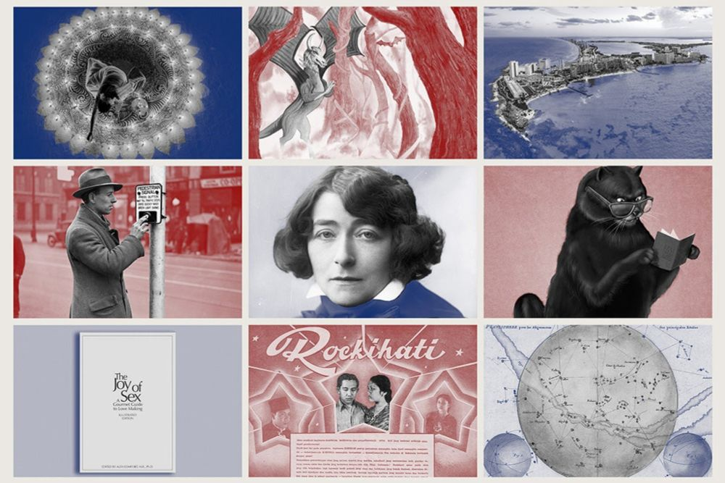](https://daily.jstor.org/jstor-daily-what-i-learned/)](https://daily.jstor.org/jstor-daily-what-i-learned/" \t "_blank)

**[JSTOR Daily: What I Learned - JSTOR Daily](https://daily.jstor.org/jstor-daily-what-i-learned/" \t "_blank)**

[Go behind the scenes with our writers as we celebrate JSTOR Daily’s tenth anniversary!](https://daily.jstor.org/jstor-daily-what-i-learned/" \t "_blank)

[daily.jstor.org](https://daily.jstor.org/jstor-daily-what-i-learned/" \t "_blank)

[Reposted by you](https://bsky.app/profile/marinelives.bsky.social)

[[](https://bsky.app/profile/chrisvvarren.bsky.social)](https://bsky.app/profile/chrisvvarren.bsky.social)

[· 16/11/2023](https://bsky.app/profile/chrisvvarren.bsky.social/post/3kebevdoqsr22)

When our Print & Probability collaborator UCSD grad student Nikolai Vogler heard that ESTC was down due to the BL cyberattack, he jumped into action. Here’s the site he built to help [#earlymodern](https://bsky.app/hashtag/earlymodern) scholars access the essential metadata needed for teaching and research 📚 📜 [estc.printprobability.org](http://estc.printprobability.org/)

**[http://estc.printprobability.org](http://estc.printprobability.org/" \t "_blank)**

[estc.printprobability.org](http://estc.printprobability.org/" \t "_blank)

**71**

[[](https://bsky.app/profile/marinelives.bsky.social)](https://bsky.app/profile/marinelives.bsky.social)

[· 11mo](https://bsky.app/profile/marinelives.bsky.social/post/3layq6vow522q)

My Latin master Phil Hiscock (1969) would have loved Google Translate. If you would like to prep up on a more modern tool for the humanities (which Phil would have loved) join our ai-and-history-collaboratory: [github.com/Addaci/marin...](https://github.com/Addaci/marinelives-collaboratory/wiki)

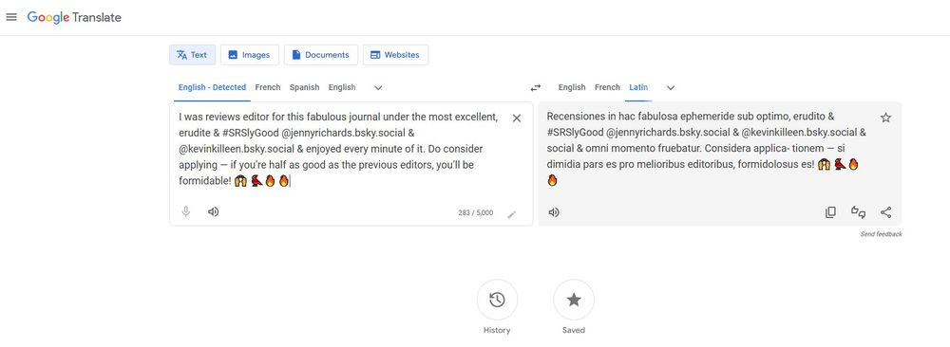

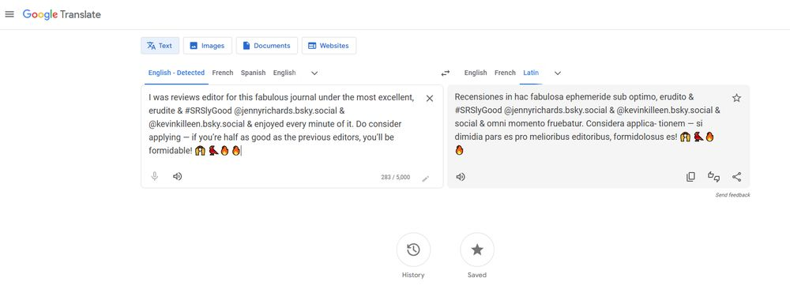

[[](https://bsky.app/profile/marinelives.bsky.social)](https://bsky.app/profile/marinelives.bsky.social)

[· 11mo](https://bsky.app/profile/marinelives.bsky.social/post/3layo4pr5fc23)

And a huge round of applause to

[@dhidalgo.bsky.social](https://bsky.app/profile/did:plc:qvtlily4gshk2unlkrh5on7t)

my 1000th follower. Beware, you are going to hear a lot about the C17th English Admiralty Court and Ai-and-History. But I promise you won't be bored!

[[](https://bsky.app/profile/marinelives.bsky.social)](https://bsky.app/profile/marinelives.bsky.social)

[· 11mo](https://bsky.app/profile/marinelives.bsky.social/post/3layj56mhhs2q)

Please help me build this list [go.bsky.app/6RfFHkd](https://bsky.app/starter-pack-short/6RfFHkd)

[@thomwolf.bsky.social](https://bsky.app/profile/did:plc:gntu4wsyt6gtzle3t2kinr6o)

[@tedunderwood.me](https://bsky.app/profile/did:plc:565ebob5f6hw33hjdkxty6qj)

[@timhitchcock.bsky.social](https://bsky.app/profile/did:plc:zazpgix5w4ldyytazeqzytmz)

[@michielree.bsky.social](https://bsky.app/profile/did:plc:bkregcsaysh6tco57ev2hfe7)

[@danielvanstrien.bsky.social](https://bsky.app/profile/did:plc:7e5mpxuweopubhexwqg5l3ba)

[@jwbaker.bsky.social](https://bsky.app/profile/did:plc:fvq2ectc56unbolhmeymsjfu)

[@adamcrymble.bsky.social](https://bsky.app/profile/did:plc:pv7lwhd6xqhrssfskofrurzr)

[@dorialexander.bsky.social](https://bsky.app/profile/did:plc:vg3thtvfbgfrr3u6pf6hy3yk)

[@transkribus.bsky.social](https://bsky.app/profile/did:plc:adbwqqtuasa27sf4ijch4zvt)

[[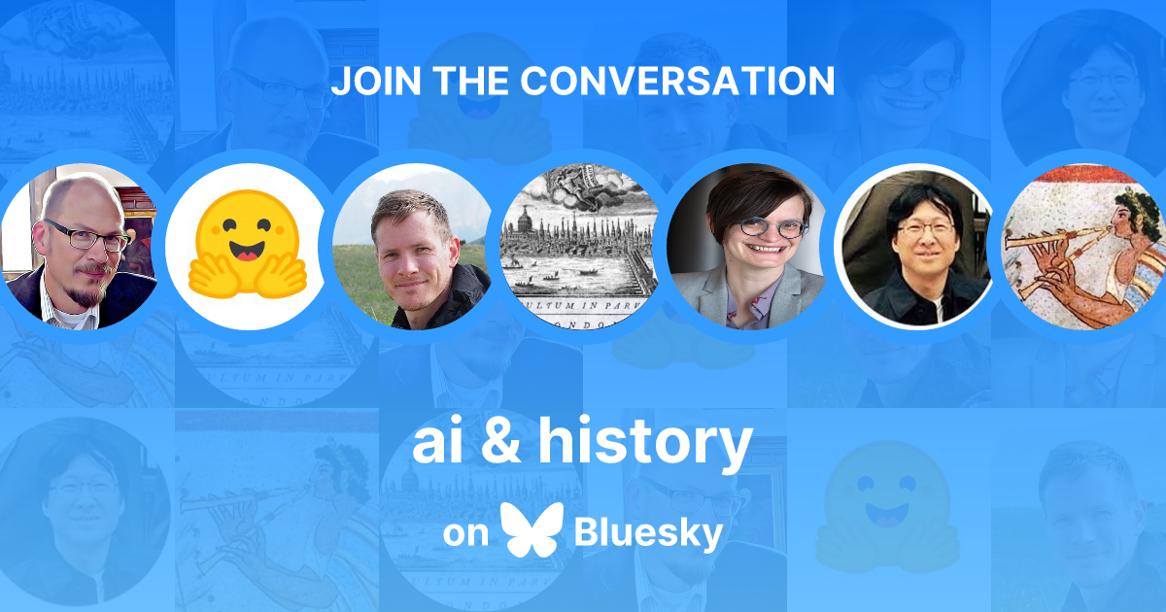](https://bsky.app/starter-pack/marinelives.bsky.social/3latstqcplq2o)](https://bsky.app/starter-pack/marinelives.bsky.social/3latstqcplq2o)

**[ai & history](https://bsky.app/starter-pack/marinelives.bsky.social/3latstqcplq2o)**

[Starter pack by you](https://bsky.app/starter-pack/marinelives.bsky.social/3latstqcplq2o)

[To accompany the launch of the marinelives-ai-and-history-collaboratory, some names we follow interested in the application of large language models and other machine learning techniques to historical research: https://github.com/Addaci/marinelives-collaboratory/wiki](https://bsky.app/starter-pack/marinelives.bsky.social/3latstqcplq2o)

4

4

[[](https://bsky.app/profile/marinelives.bsky.social)](https://bsky.app/profile/marinelives.bsky.social)

[· 11mo](https://bsky.app/profile/marinelives.bsky.social/post/3layhzfrzpk2u)

Inspired by a couple of conversations on

[@bsky.app](https://bsky.app/profile/did:plc:z72i7hdynmk6r22z27h6tvur)

over the last two days, we have changed the goal of our ai-and-history-collaboratory to be more inclusive, opening it up to all students and public historians, especially zero coders, with open arms [github.com/Addaci/marin...](https://github.com/Addaci/marinelives-collaboratory/wiki)

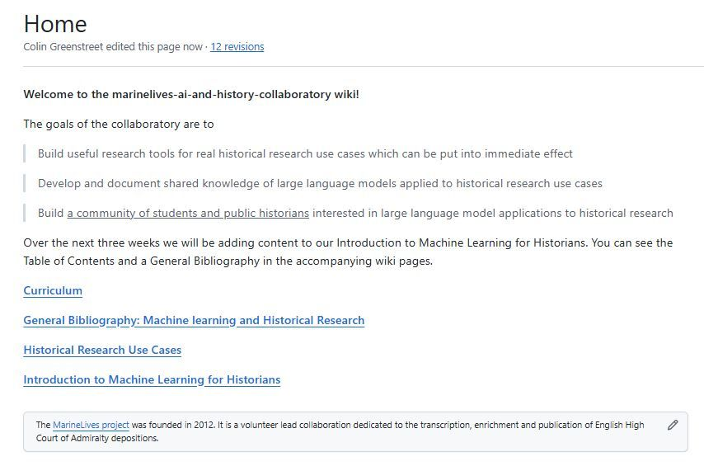

[[](https://bsky.app/profile/marinelives.bsky.social)](https://bsky.app/profile/marinelives.bsky.social)

[· 11mo](https://bsky.app/profile/marinelives.bsky.social/post/3layhjp35gs2u)

How about it?

[@idlemrb.bsky.social](https://bsky.app/profile/did:plc:akylzhksrst3c5btrzjbsc6k)

[@kimberlybiscuits.bsky.social](https://bsky.app/profile/did:plc:5cvucv6sqj5ffuqdjnlgrd36)

[@kejamieson.bsky.social](https://bsky.app/profile/did:plc:pdy62vmamzzv6ccghaykgxao)

[@michielree.bsky.social](https://bsky.app/profile/did:plc:bkregcsaysh6tco57ev2hfe7)

[@mark-l-thompson.bsky.social](https://bsky.app/profile/did:plc:2jn5s6j2sojxy4qmbq2adifi)

[@baliscoe.bsky.social](https://bsky.app/profile/did:plc:blbu3qt5b7o77meku4gu2bmh)

[@danielvanstrien.bsky.social](https://bsky.app/profile/did:plc:7e5mpxuweopubhexwqg5l3ba)

[[](https://bsky.app/profile/marinelives.bsky.social)](https://bsky.app/profile/marinelives.bsky.social)

[· 11mo](https://bsky.app/profile/marinelives.bsky.social/post/3layhcturi22u)

I am in blatant recruitment mode. We have 7 Blueskyers signed up for our ai-and-history-collaboratory. We have 3 slots left. Forget the "we are targeting graduate and doctoral students". Care about history. Inquisitive about tech? Want to engage. DM us and your are in. github.com/Addaci/marin...

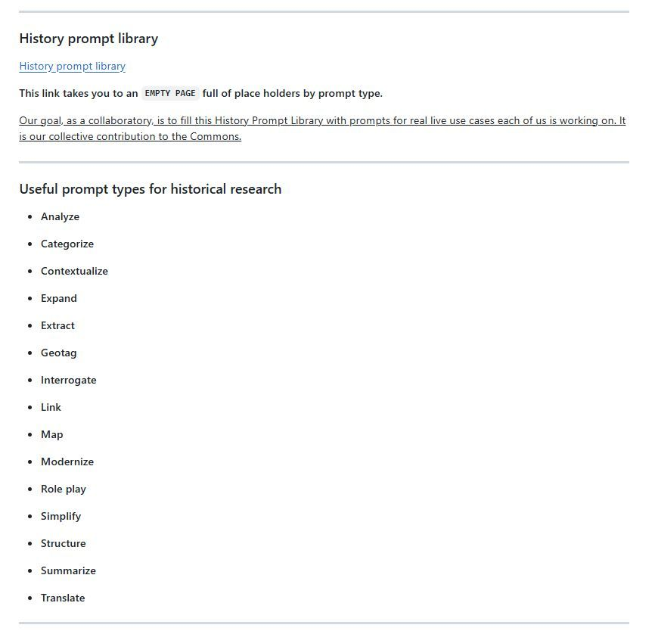

3

[[](https://bsky.app/profile/marinelives.bsky.social)](https://bsky.app/profile/marinelives.bsky.social)

[· 11mo](https://bsky.app/profile/marinelives.bsky.social/post/3layhcturi22u)

I am in blatant recruitment mode. We have 7 Blueskyers signed up for our ai-and-history-collaboratory. We have 3 slots left. Forget the "we are targeting graduate and doctoral students". Care about history. Inquisitive about tech? Want to engage. DM us and your are in. [github.com/Addaci/marin...](https://github.com/Addaci/marinelives-collaboratory/wiki)



2

[Reposted by you](https://bsky.app/profile/marinelives.bsky.social)

[[](https://bsky.app/profile/womenshistory.bsky.social)](https://bsky.app/profile/womenshistory.bsky.social)

[· 11mo](https://bsky.app/profile/womenshistory.bsky.social/post/3lay64bwhkk2l)

We are currently working on issue 43: Women in Ports! This issues' guest-editor is Irene Jacobs from the Martiem Museum Rotterdam.

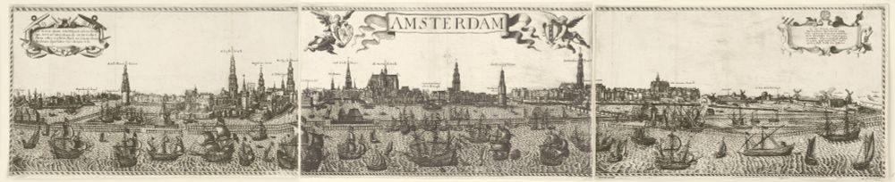

**ALT**

**10**

[[](https://bsky.app/profile/marinelives.bsky.social)](https://bsky.app/profile/marinelives.bsky.social)

[· 11mo](https://bsky.app/profile/marinelives.bsky.social/post/3laxyn7pins2t)

Another slide from my talk next Tuesday on ai assistants and agents: a new set of skills for historians. A prescient article (2013) by

[@timhitchcock.bsky.social](https://bsky.app/profile/did:plc:zazpgix5w4ldyytazeqzytmz)

and a facinating book by

[@adamcrymble.bsky.social](https://bsky.app/profile/did:plc:pv7lwhd6xqhrssfskofrurzr)

[ihrdighist.blogs.sas.ac.uk/2024/09/tues...](https://ihrdighist.blogs.sas.ac.uk/2024/09/tuesday-19-november-2024-colin-greenstreet-ai-agents-for-historical-research-a-new-skill-set-for-historians/)

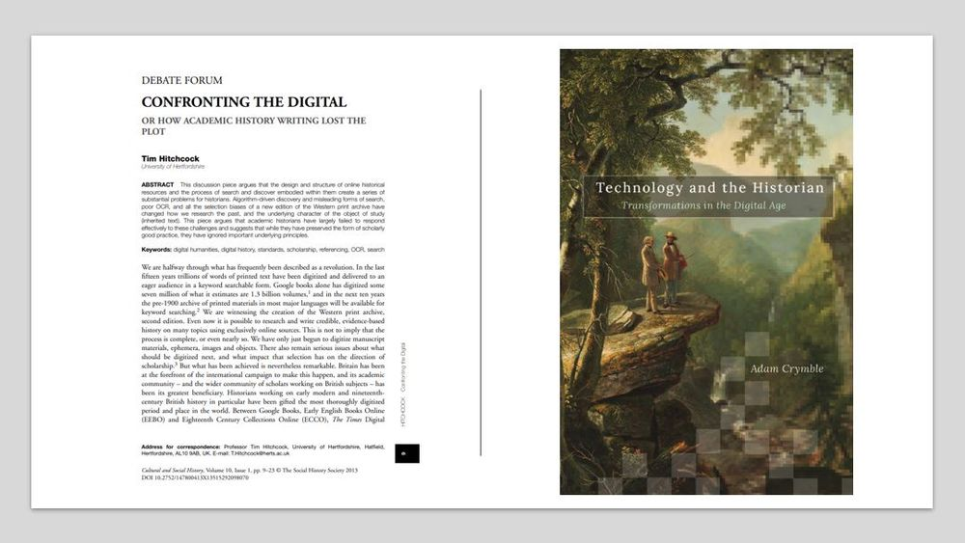

1

[[](https://bsky.app/profile/marinelives.bsky.social)](https://bsky.app/profile/marinelives.bsky.social)

[· 11mo](https://bsky.app/profile/marinelives.bsky.social/post/3laxyjurduk2t)

This should get the discussion going at my talk next Tuesday on ai assistants and agents: a new skill set for historians? [ihrdighist.blogs.sas.ac.uk/2024/09/tues...](https://ihrdighist.blogs.sas.ac.uk/2024/09/tuesday-19-november-2024-colin-greenstreet-ai-agents-for-historical-research-a-new-skill-set-for-historians/) [#skystorians](https://bsky.app/hashtag/skystorians) [#machinelearning](https://bsky.app/hashtag/machinelearning)

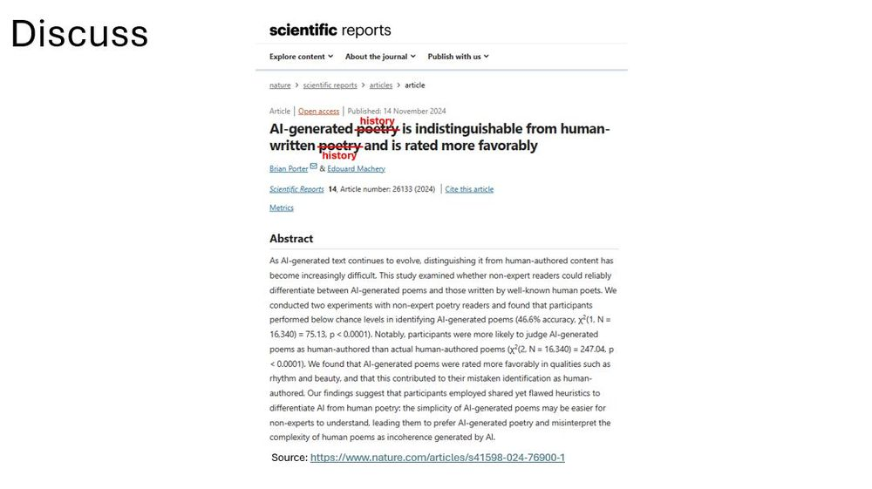

2

[[](https://bsky.app/profile/marinelives.bsky.social)](https://bsky.app/profile/marinelives.bsky.social)

[· 11mo](https://bsky.app/profile/marinelives.bsky.social/post/3lawgqpvzdk2s)

Not sure why suddenly I have an "invalid handle". This has been my handle on Twitter, and now Bluesky for 12 years. Reddit fix doesn't seem to work. Can you guys still see me?

5

1

[[](https://bsky.app/profile/marinelives.bsky.social)](https://bsky.app/profile/marinelives.bsky.social)

[· 11mo](https://bsky.app/profile/marinelives.bsky.social/post/3lawcy6h4g22b)

What a fabulous article. Thank you for reposting this

[@ideesdupasse.bsky.social](https://bsky.app/profile/did:plc:l2vnulyggvlcpi55prym6dii)

. When I workd in teh pharma sector I took a senior R&D group from Glaxo to Shanghai and Beijing in 1997 and was deeply impressed by the hisorical botanical, pharmacological and medical practices

[[](https://bsky.app/profile/pastpresentsoc.bsky.social)](https://bsky.app/profile/pastpresentsoc.bsky.social)

[· 11mo](https://bsky.app/profile/pastpresentsoc.bsky.social/post/3larusgdpz22j)

New on advance access: "A Chinese Doctor in Eighteenth-Century Naples and the Practice of Pulse Diagnosis" by Henrietta Harrison (University of Oxford) #OpenAccess doi.org/10.1093/past...

[[](https://doi.org/10.1093/pastj/gtae038)](https://doi.org/10.1093/pastj/gtae038" \t "_blank)

**[A Chinese Doctor in Eighteenth-Century Naples and the Practice of Pulse Diagnosis\*](https://doi.org/10.1093/pastj/gtae038" \t "_blank)**

[Abstract. Diagnosing a patient on the basis of their pulse alone is an impressive demonstration of medical ability for which early modern Chinese doctors w](https://doi.org/10.1093/pastj/gtae038" \t "_blank)

[doi.org](https://doi.org/10.1093/pastj/gtae038" \t "_blank)

1

[[](https://bsky.app/profile/marinelives.bsky.social)](https://bsky.app/profile/marinelives.bsky.social)

[· 11mo](https://bsky.app/profile/marinelives.bsky.social/post/3lawbkgbymc2v)

Abi Cunningham, third year history undergraduate at the University of york aces it in her work with volunteer Early Modern group

[@marinelivesorg.bsky.social](https://bsky.app/profile/did:plc:3haql47cl6jucf32mlqtre4p)

[@uoylibrary.bsky.social](https://bsky.app/profile/did:plc:jgpxmpiumlpxxclzsgar5lnq)

[[](https://bsky.app/profile/marinelives.bsky.social)](https://bsky.app/profile/marinelives.bsky.social)

[· 11mo](https://bsky.app/profile/marinelives.bsky.social/post/3lawaherhyk2k)

Nervous about what your undergraduates are up to? This is what University of York third year undergraduate developed as a prompt to support her dissertation after five days working with the data and multiple LLMs github.com/Addaci/marin... @thiagokrause.bsky.social @handle.invalid #skystorians

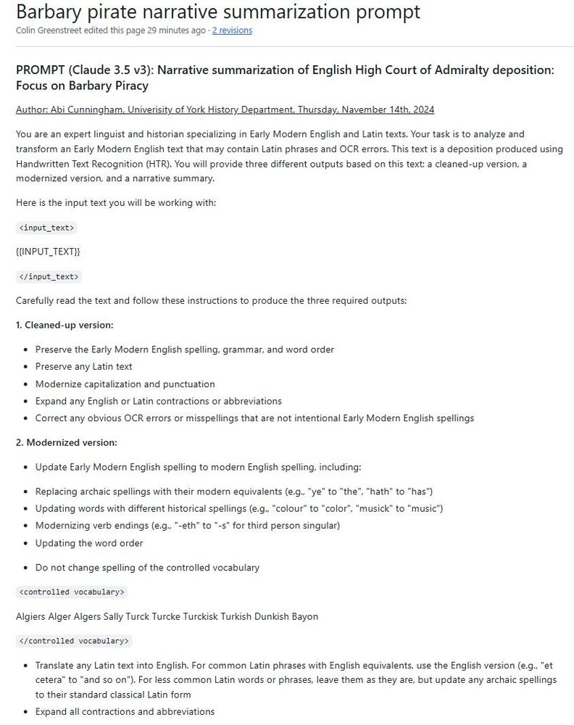

1

[[](https://bsky.app/profile/marinelives.bsky.social)](https://bsky.app/profile/marinelives.bsky.social)

[· 11mo](https://bsky.app/profile/marinelives.bsky.social/post/3lawaherhyk2k)

Nervous about what your undergraduates are up to? This is what University of York third year undergraduate developed as a prompt to support her dissertation after five days working with the data and multiple LLMs [github.com/Addaci/marin...](https://github.com/Addaci/marinelives-collaboratory/wiki/Barbary-pirate-narrative-summarization-prompt)

[@thiagokrause.bsky.social](https://bsky.app/profile/did:plc:m6ub6fozxlo3gzqn2rayoiwy)

@handle.invalid [#skystorians](https://bsky.app/hashtag/skystorians)



1

[[](https://bsky.app/profile/marinelives.bsky.social)](https://bsky.app/profile/marinelives.bsky.social)

[· 11mo](https://bsky.app/profile/marinelives.bsky.social/post/3lavuqq7fxc2k)

What kind of historian are you? I'm mainly B, with a bit of C.

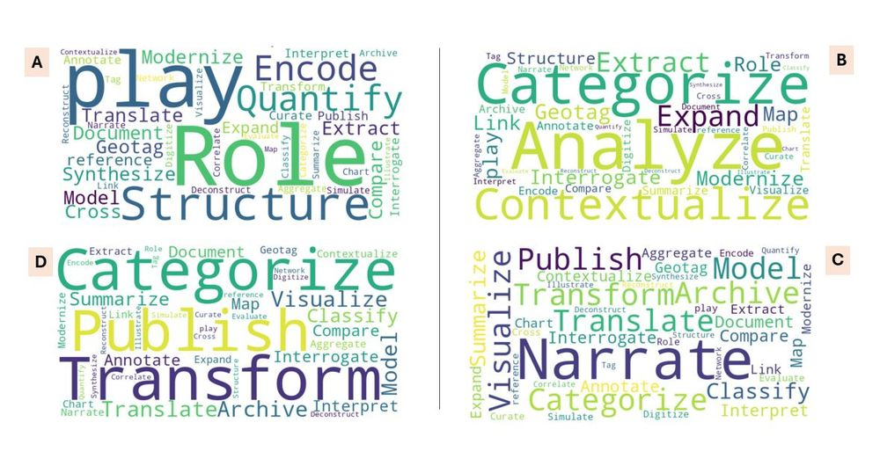

[[](https://bsky.app/profile/marinelives.bsky.social)](https://bsky.app/profile/marinelives.bsky.social)

[· 11mo](https://bsky.app/profile/marinelives.bsky.social/post/3lavnjostxs2c)

Good to see that the important new 2 trillion token Common Corpus with permissive licensing has picked up MarineLives material from the Common Crawl dataset [#machinelearning](https://bsky.app/hashtag/machinelearning) [#skystorians](https://bsky.app/hashtag/skystorians)

[@tedunderwood.me](https://bsky.app/profile/did:plc:565ebob5f6hw33hjdkxty6qj)

[huggingface.co/datasets/Ple...](https://huggingface.co/datasets/PleIAs/common_corpus/viewer/default/train?q=marinelives); [huggingface.co/blog/Pclangl...](https://huggingface.co/blog/Pclanglais/two-trillion-tokens-open)

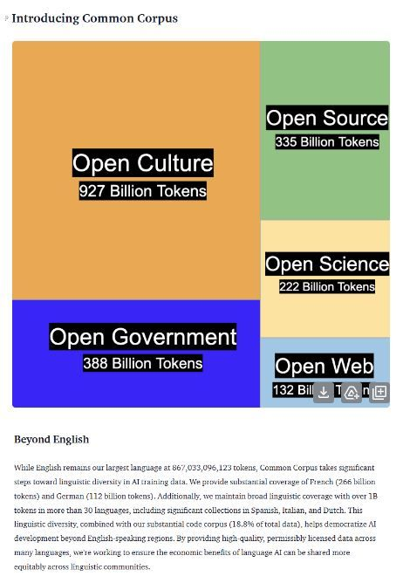

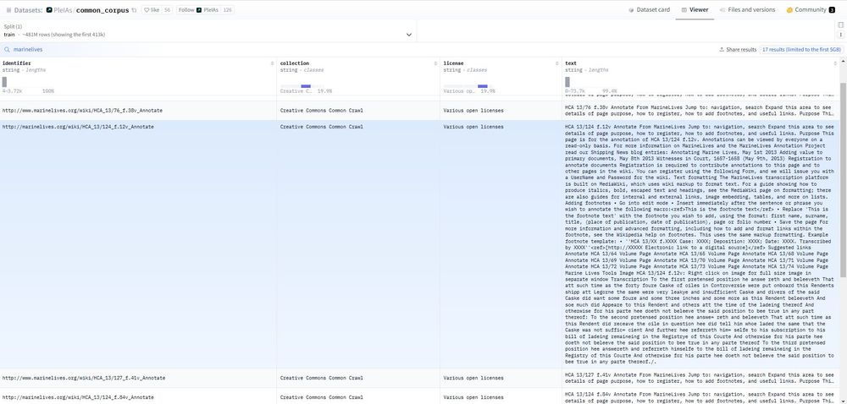

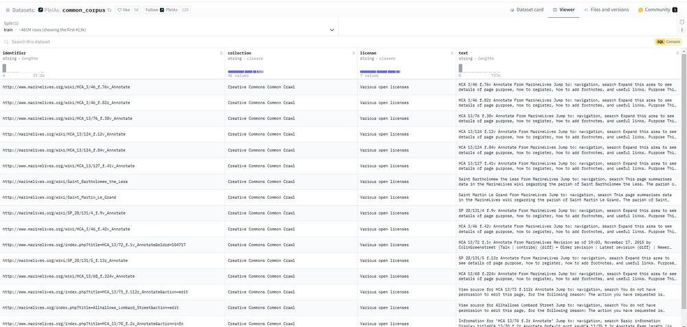

1

[Reposted by you](https://bsky.app/profile/marinelives.bsky.social)

[[](https://bsky.app/profile/lsangha.bsky.social)](https://bsky.app/profile/lsangha.bsky.social)

[· 11mo](https://bsky.app/profile/lsangha.bsky.social/post/3lavidiyrlk2g)

📢 Material Culture Klaxon📢 The project 'aims to understand the circulation of textiles on Dutch ships around the world in the 17th & 18th century, by examining data drawn from trade records alongside samples'. Their visual textile glossary is great. [#EarlyModern](https://bsky.app/hashtag/EarlyModern) 🗃️ [dutchtextiletrade.org/textiles/](https://dutchtextiletrade.org/textiles/)



**ALT**

3

**20**

[Reposted by you](https://bsky.app/profile/marinelives.bsky.social)

[[](https://bsky.app/profile/fdaudens.bsky.social)](https://bsky.app/profile/fdaudens.bsky.social)

[· 11mo](https://bsky.app/profile/fdaudens.bsky.social/post/3laufpdjoit2t)

🌍 Huge milestone for open-source AI: Pleias just dropped two trillion tokens of multilingual data! Common Corpus combines open culture, science, government data, and more to help build better language models. 🚀 [buff.ly/4fMISbc](https://buff.ly/4fMISbc) [#AIAlliance](https://bsky.app/hashtag/AIAlliance) [#OpenScience](https://bsky.app/hashtag/OpenScience)

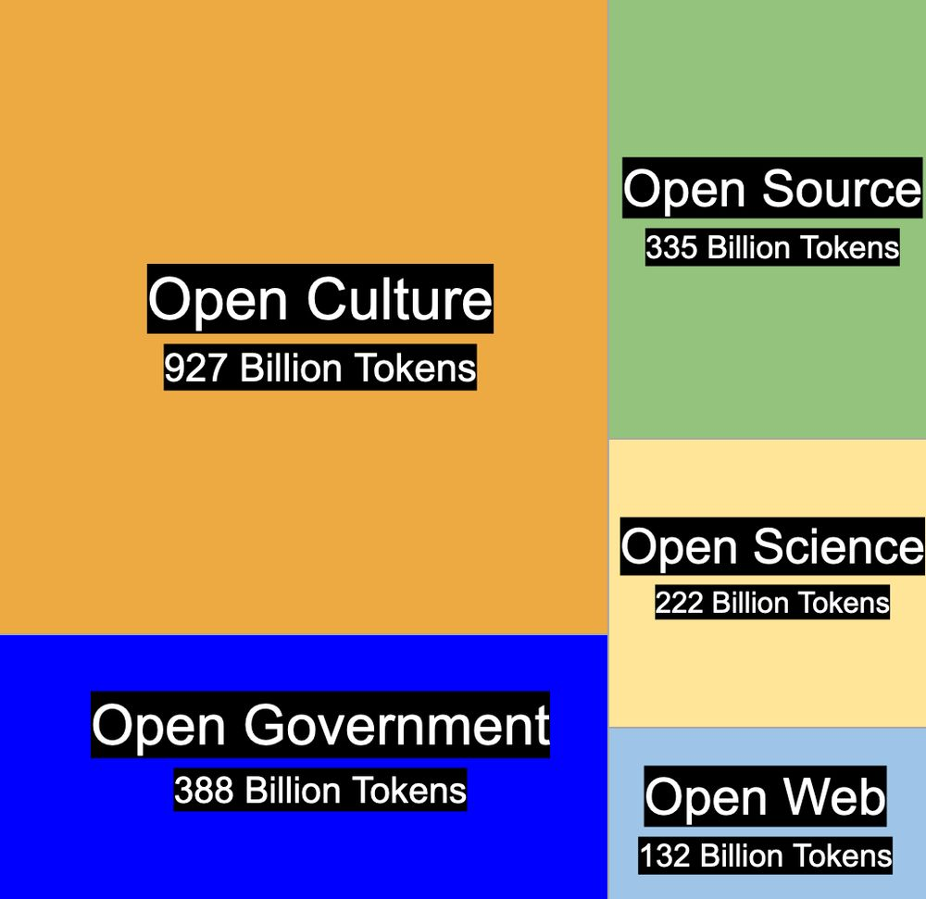

1

**3**

[[](https://bsky.app/profile/marinelives.bsky.social)](https://bsky.app/profile/marinelives.bsky.social)

[· 11mo](https://bsky.app/profile/marinelives.bsky.social/post/3lavfhhbjr22o)

We are building a History Prompt Library and would love input from historians on the different types of prompt they have found useful when exploring large language models as a supporting tool for historical research [github.com/Addaci/marin...](https://github.com/Addaci/marinelives-collaboratory/wiki/Prompt-engineering)

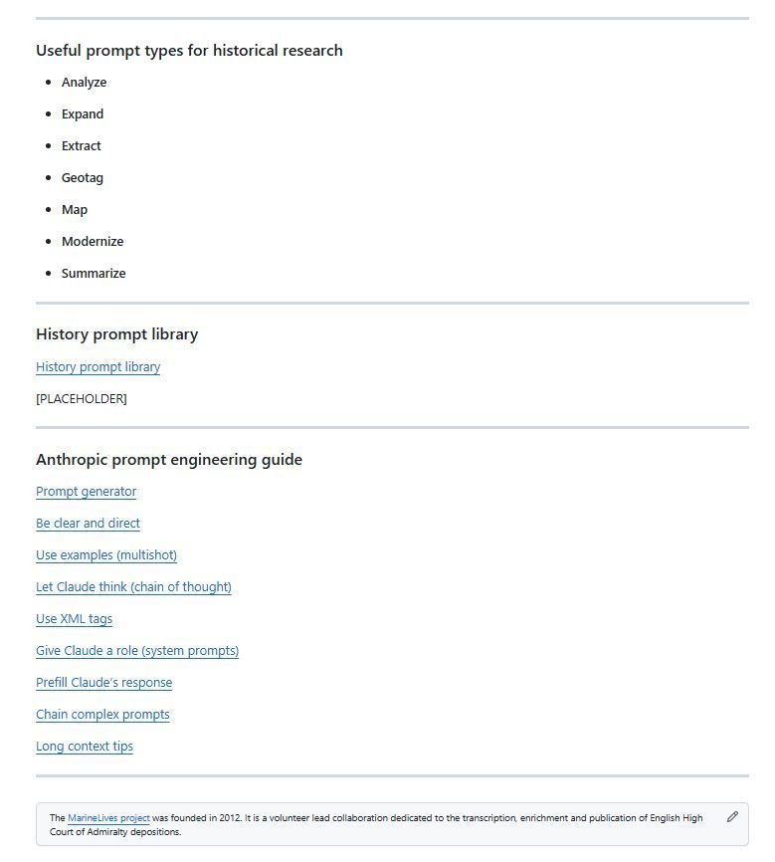

1

[[](https://bsky.app/profile/marinelives.bsky.social)](https://bsky.app/profile/marinelives.bsky.social)

[· 11mo](https://bsky.app/profile/marinelives.bsky.social/post/3lavfaaevac2o)

The first session of our ai-and-history-collaboratory will be on Prompt Engineering. Can my fellow [#skystorians](https://bsky.app/hashtag/skystorians) help me develop a typology of prompts, use cases and model prompts to collaboratively build a History Prompt Library to make available to the Commons? [github.com/Addaci/marin...](https://github.com/Addaci/marinelives-collaboratory/wiki/Prompt-engineering)

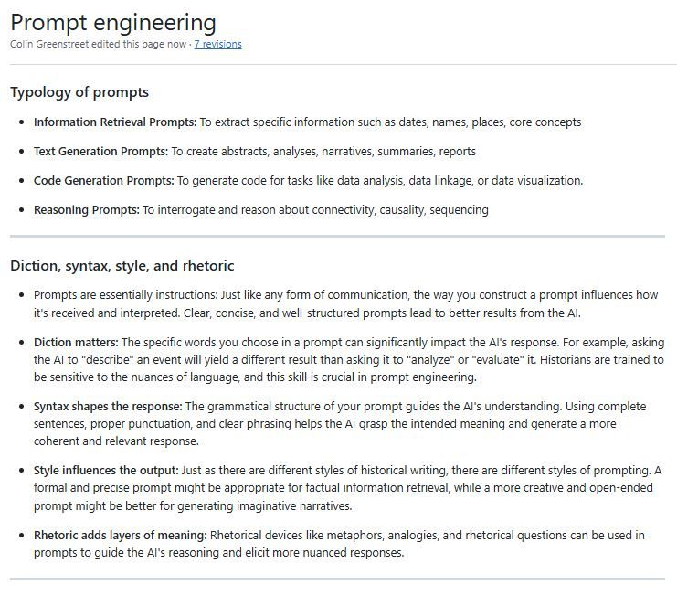

1

[[](https://bsky.app/profile/marinelives.bsky.social)](https://bsky.app/profile/marinelives.bsky.social)

[· 11mo](https://bsky.app/profile/marinelives.bsky.social/post/3lats2a42n22f)

Join eight historans who now have access to the marinelives-ai-and-history-collaboratory-notebookLM. We have just added a basic AI glossary, with much more to come in the next few days.

[@thiagokrause.bsky.social](https://bsky.app/profile/did:plc:m6ub6fozxlo3gzqn2rayoiwy)

[#skystorians](https://bsky.app/hashtag/skystorians) [github.com/Addaci/marin...](https://github.com/Addaci/marinelives-collaboratory)

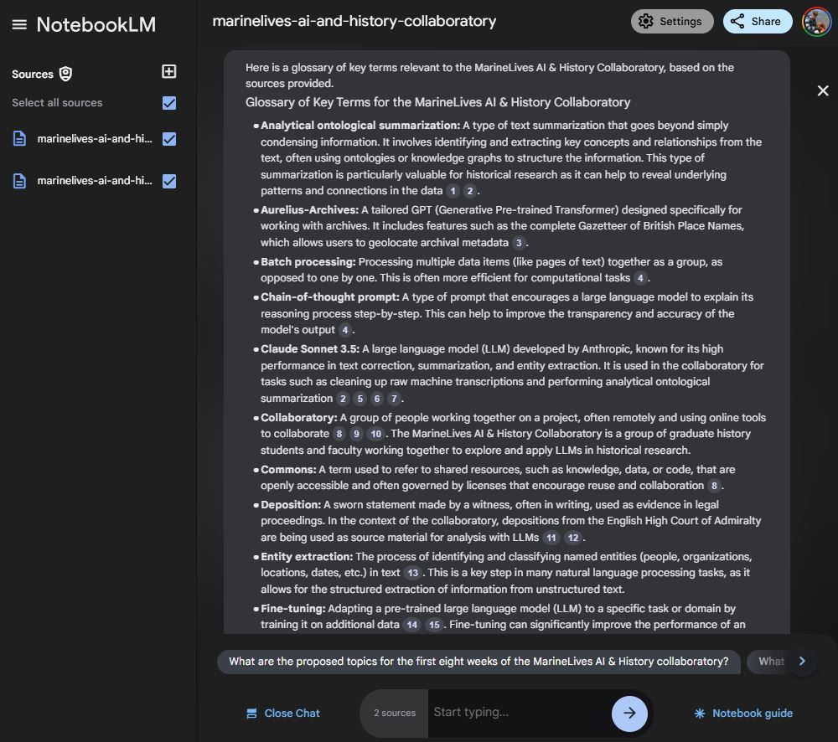

[[](https://bsky.app/profile/marinelives.bsky.social)](https://bsky.app/profile/marinelives.bsky.social)

[· 11mo](https://bsky.app/profile/marinelives.bsky.social/post/3latkd35ut22h)

Our marinelives-ai-and-history-collaboratory-notebook now has 4 editors: me (Colin Greenstreet),

[@thiagokrause.bsky.social](https://bsky.app/profile/did:plc:m6ub6fozxlo3gzqn2rayoiwy)

, and two of our collab members

[@rmkaiser.bsky.social](https://bsky.app/profile/did:plc:fvqpum7gacctjfs3u2nuzdgq)

and Yale postdoc Oren Okhovat (scholar of the spanish/sephardic/caribbean world). Get in touch for access as a reader

[[](https://bsky.app/profile/marinelives.bsky.social)](https://bsky.app/profile/marinelives.bsky.social)

[· 11mo](https://bsky.app/profile/marinelives.bsky.social/post/3latijfm65c23)

The marinelives-ai-and-history-collaboratory will be writing a collaborative-notebook on ai-and-history to share with the Commons @thiagokrause.bsky.social #skystorians #machinelearning Contact me by DM for access to our Google NotebookLM github.com/Addaci/marin...

**[https://github.com/Addaci/marinelives-collaboratory/blob/main/README.md](https://github.com/Addaci/marinelives-collaboratory/blob/main/README.md" \t "_blank)**

[github.com](https://github.com/Addaci/marinelives-collaboratory/blob/main/README.md" \t "_blank)

[[](https://bsky.app/profile/marinelives.bsky.social)](https://bsky.app/profile/marinelives.bsky.social)

[· 11mo](https://bsky.app/profile/marinelives.bsky.social/post/3latijfm65c23)

The marinelives-ai-and-history-collaboratory will be writing a collaborative-notebook on ai-and-history to share with the Commons

[@thiagokrause.bsky.social](https://bsky.app/profile/did:plc:m6ub6fozxlo3gzqn2rayoiwy)

[#skystorians](https://bsky.app/hashtag/skystorians) [#machinelearning](https://bsky.app/hashtag/machinelearning) Contact me by DM for access to our Google NotebookLM [github.com/Addaci/marin...](https://github.com/Addaci/marinelives-collaboratory/blob/main/README.md)

**[https://github.com/Addaci/marinelives-collaboratory/blob/main/README.md](https://github.com/Addaci/marinelives-collaboratory/blob/main/README.md" \t "_blank)**

[github.com](https://github.com/Addaci/marinelives-collaboratory/blob/main/README.md" \t "_blank)

[[](https://bsky.app/profile/marinelives.bsky.social)](https://bsky.app/profile/marinelives.bsky.social)

[· 11mo](https://bsky.app/profile/marinelives.bsky.social/post/3lati4asxgc23)

Calling no-coding/very low coding graduate historians. Our marinelives-ai-and-history-collaboratory is made for you. We will be using Google NotebookLM to synthesize the collaboratory collective learnings as we go, & will make the Notebook available to the Commons CCBY4.0. @timhitchcock.bsky.social

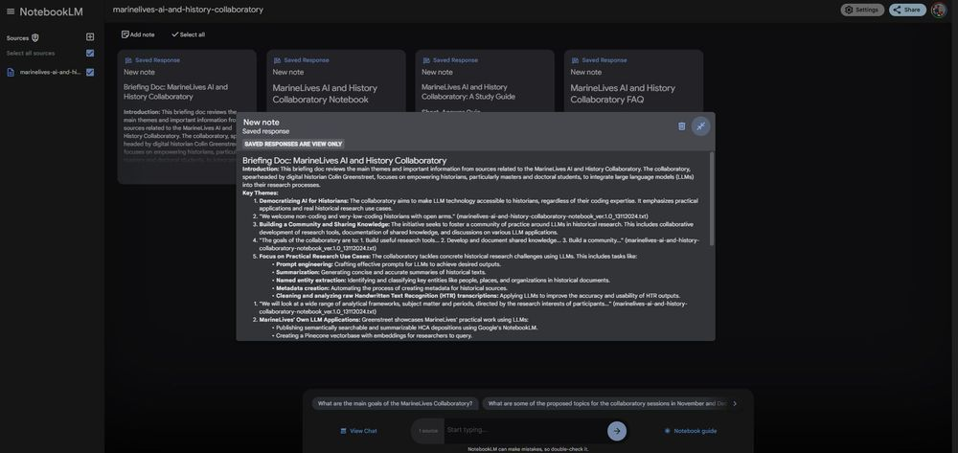

3

[[](https://bsky.app/profile/marinelives.bsky.social)](https://bsky.app/profile/marinelives.bsky.social)

[· 11mo](https://bsky.app/profile/marinelives.bsky.social/post/3lati4asxgc23)

Calling no-coding/very low coding graduate historians. Our marinelives-ai-and-history-collaboratory is made for you. We will be using Google NotebookLM to synthesize the collaboratory collective learnings as we go, & will make the Notebook available to the Commons CCBY4.0.

[@timhitchcock.bsky.social](https://bsky.app/profile/did:plc:zazpgix5w4ldyytazeqzytmz)



1

[[](https://bsky.app/profile/marinelives.bsky.social)](https://bsky.app/profile/marinelives.bsky.social)

[· 11mo](https://bsky.app/profile/marinelives.bsky.social/post/3latfpeeu7k2q)

Sneak preview of a slide I am going to show at my IHR Seminar talk next Tuesday: New Skills for Historians? With permission of

[@jwbaker.bsky.social](https://bsky.app/profile/did:plc:fvq2ectc56unbolhmeymsjfu)

for [programminghistorian.org](https://programminghistorian.org/) I am going to show all PH content in an interrogatable Google Notebook. The content is stunning

[@timhitchcock.bsky.social](https://bsky.app/profile/did:plc:zazpgix5w4ldyytazeqzytmz)

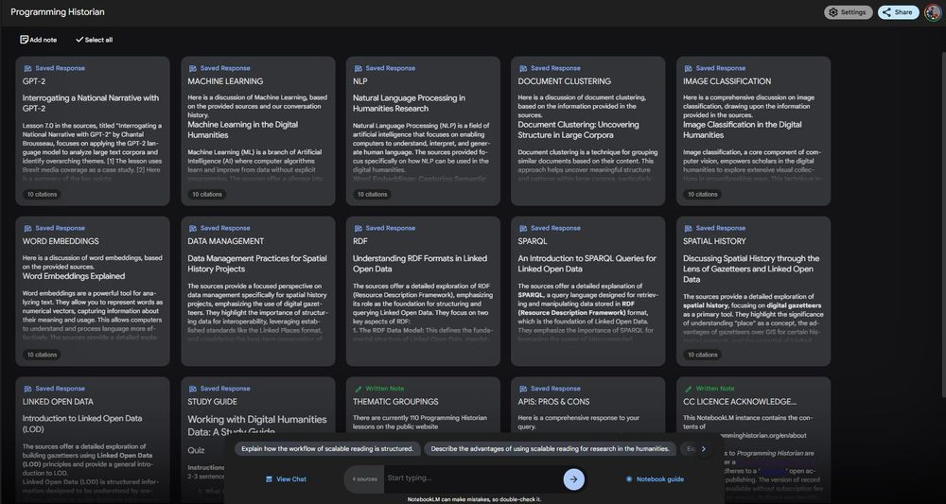

[Reposted by you](https://bsky.app/profile/marinelives.bsky.social)

[[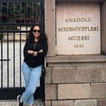](https://bsky.app/profile/irenevicentem.bsky.social)](https://bsky.app/profile/irenevicentem.bsky.social)

[· 15/10/2024](https://bsky.app/profile/irenevicentem.bsky.social/post/3l6kzd6n62t24)

Jorge Flores is back 💙 [www.pennpress.org/978151282644...](https://www.pennpress.org/9781512826449/empire-of-contingency/)

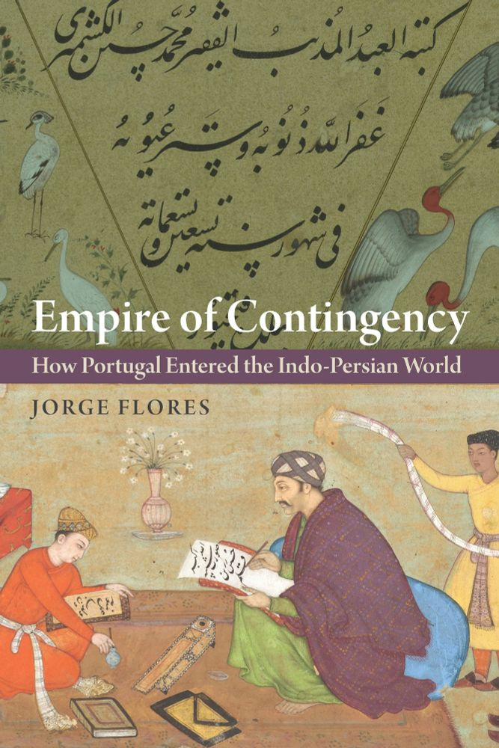

**1**

[[](https://bsky.app/profile/marinelives.bsky.social)](https://bsky.app/profile/marinelives.bsky.social)

[· 11mo](https://bsky.app/profile/marinelives.bsky.social/post/3lat3r7gbf226)

Interested in the potential application of large language models in historical research? Come to next week's talk by Colin Greenstreet, co-founder of MarineLives and organiser, with

[@thiagokrause.bsky.social](https://bsky.app/profile/did:plc:m6ub6fozxlo3gzqn2rayoiwy)

, of the marinelives-ai-and-history-collaboratory [ihrdighist.blogs.sas.ac.uk/2024/09/tues...](https://ihrdighist.blogs.sas.ac.uk/2024/09/tuesday-19-november-2024-colin-greenstreet-ai-agents-for-historical-research-a-new-skill-set-for-historians/)

[[](https://ihrdighist.blogs.sas.ac.uk/2024/09/tuesday-19-november-2024-colin-greenstreet-ai-agents-for-historical-research-a-new-skill-set-for-historians/)](https://ihrdighist.blogs.sas.ac.uk/2024/09/tuesday-19-november-2024-colin-greenstreet-ai-agents-for-historical-research-a-new-skill-set-for-historians/" \t "_blank)

**[Tuesday 19 November 2024 - Colin Greenstreet: AI assistants and agents: A New Skill Set for Historians? - Digital History Seminar](https://ihrdighist.blogs.sas.ac.uk/2024/09/tuesday-19-november-2024-colin-greenstreet-ai-agents-for-historical-research-a-new-skill-set-for-historians/" \t "_blank)**

[This seminar is 5:30 pm – 7:00 pm GMT live on Zoom at https://zoom.us/j/92542420101 and later posted to our YouTube channel. Session chair: James Baker Abstract: A New Skill Set for Historians explore...](https://ihrdighist.blogs.sas.ac.uk/2024/09/tuesday-19-november-2024-colin-greenstreet-ai-agents-for-historical-research-a-new-skill-set-for-historians/" \t "_blank)

[ihrdighist.blogs.sas.ac.uk](https://ihrdighist.blogs.sas.ac.uk/2024/09/tuesday-19-november-2024-colin-greenstreet-ai-agents-for-historical-research-a-new-skill-set-for-historians/" \t "_blank)

4

[[](https://bsky.app/profile/marinelives.bsky.social)](https://bsky.app/profile/marinelives.bsky.social)

[· 11mo](https://bsky.app/profile/marinelives.bsky.social/post/3lat2etbmuk2g)

Thirteen days till the first session of the marinelives-AI-and-History-collaboratory. We have members from Antwerp, Cambridge (Mass.), Detroit, Hertford (Conn.),London, Oldenburg, and York. Some spaces still available [github.com/Addaci/marin...](https://github.com/Addaci/marinelives-collaboratory/wiki/Collaboratory-members)

[@timhitchcock.bsky.social](https://bsky.app/profile/did:plc:zazpgix5w4ldyytazeqzytmz)

[@tedunderwood.me](https://bsky.app/profile/did:plc:565ebob5f6hw33hjdkxty6qj)

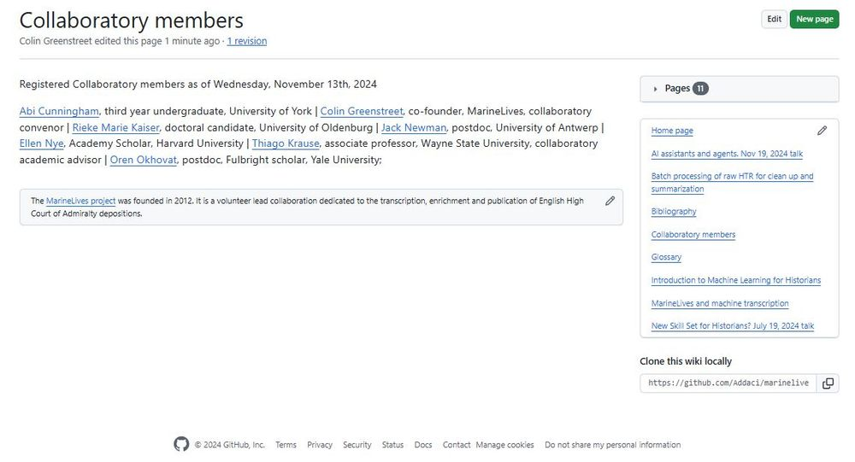

3

[[](https://bsky.app/profile/marinelives.bsky.social)](https://bsky.app/profile/marinelives.bsky.social)

[· 11mo](https://bsky.app/profile/marinelives.bsky.social/post/3larbs6dpc22x)

We have started to introduce new tools to our first signed up participants in the MarineLives AI & History collaboratory. Starting with NotebookLM, which if you haven't tried it, I tell you, it will revolutionize the way you take research notes. Here are my 12 notebooks.

[@thiagokrause.bsky.social](https://bsky.app/profile/did:plc:m6ub6fozxlo3gzqn2rayoiwy)

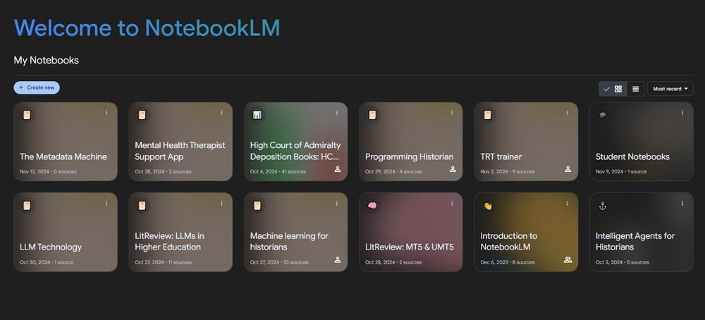

[[](https://bsky.app/profile/marinelives.bsky.social)](https://bsky.app/profile/marinelives.bsky.social)

[· 11mo](https://bsky.app/profile/marinelives.bsky.social/post/3lar6xpm5dc2k)

Six places left for our AI & History collaboratory, starting Tuesday, Nov 26th 2024 and running for eight weeks - current participants are from Wayne State, Oldenburg, Yale and Harvard. Have fun and develop marketable skills!

[@timhitchcock.bsky.social](https://bsky.app/profile/did:plc:zazpgix5w4ldyytazeqzytmz)

[@tedunderwood.me](https://bsky.app/profile/did:plc:565ebob5f6hw33hjdkxty6qj)

[github.com/Addaci/marin...](https://github.com/Addaci/marinelives-collaboratory/blob/main/README.md)

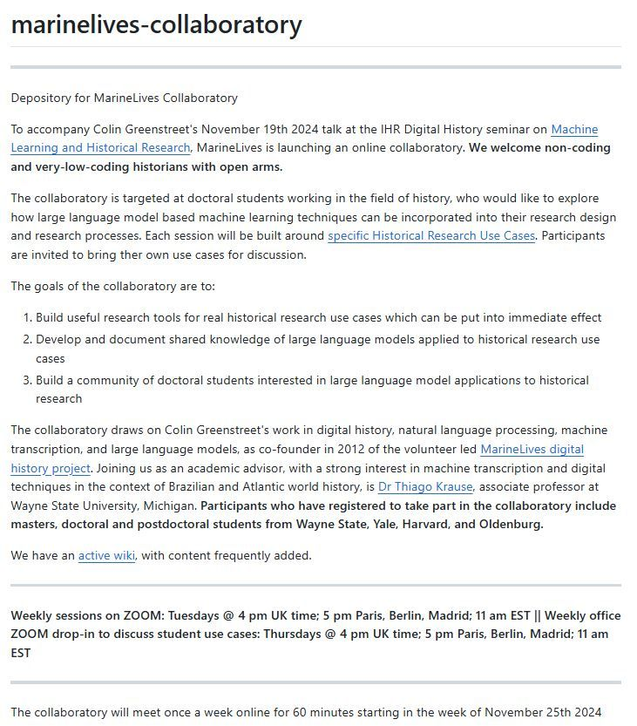

[[](https://bsky.app/profile/marinelives.bsky.social)](https://bsky.app/profile/marinelives.bsky.social)

[· 11mo](https://bsky.app/profile/marinelives.bsky.social/post/3laqkafddbk2p)

We have firmed up on dates + times for the marinelives-collaboratory for doctoral students of history wanting to explore how they can use large language models in their research design & research processes. 10 spaces. Please DM me to sign up. Meets Tuesdays at 4 pm UK. [github.com/Addaci/marin...](https://github.com/Addaci/marinelives-collaboratory/blob/main/README.md)

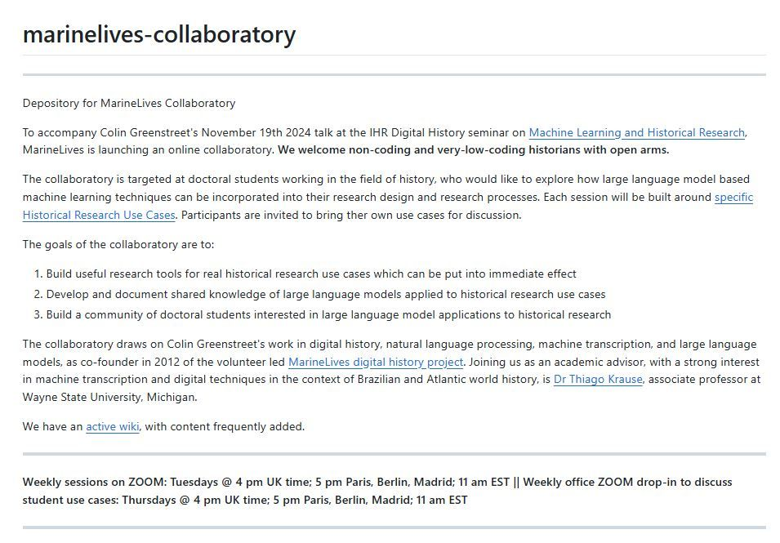

1

[[](https://bsky.app/profile/marinelives.bsky.social)](https://bsky.app/profile/marinelives.bsky.social)

[· 11mo](https://bsky.app/profile/marinelives.bsky.social/post/3laqkdf3zlk2q)

(2) Here are the planned sessions and dates for the first eight weeks - four weeks before Christmas and four weeks in January [github.com/Addaci/marin...](https://github.com/Addaci/marinelives-collaboratory/blob/main/README.md)

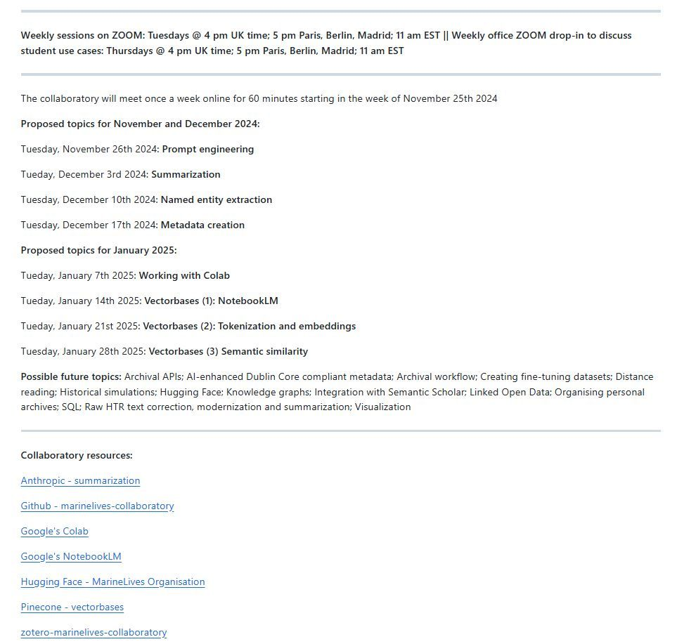

[[](https://bsky.app/profile/marinelives.bsky.social)](https://bsky.app/profile/marinelives.bsky.social)

[· 11mo](https://bsky.app/profile/marinelives.bsky.social/post/3lanya4hnpc26)

I am working on ontological summarization of legal depositions from the C17th English High Court of Admiralty, and have been testing frontier LLMs on their ability to do complex analysis. GPT4oi-preview comes out on top [#machinelearning](https://bsky.app/hashtag/machinelearning) [#datascience](https://bsky.app/hashtag/datascience) [#skyhistorians](https://bsky.app/hashtag/skyhistorians)

[@tedunderwood.me](https://bsky.app/profile/did:plc:565ebob5f6hw33hjdkxty6qj)

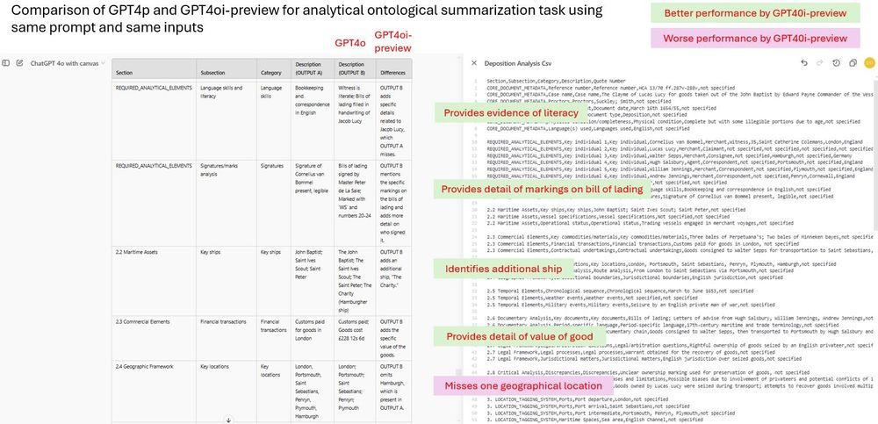

[[](https://bsky.app/profile/marinelives.bsky.social)](https://bsky.app/profile/marinelives.bsky.social)

[· 11mo](https://bsky.app/profile/marinelives.bsky.social/post/3lam2zfuzk22p)

This is how GPT4oi describes its thinking process as it works through a complex ontological framework to extract entities within Admiralty Court depositions. Two depositions, Four images attached

[@tedunderwood.me](https://bsky.app/profile/did:plc:565ebob5f6hw33hjdkxty6qj)

[@timhitchcock.bsky.social](https://bsky.app/profile/did:plc:zazpgix5w4ldyytazeqzytmz)

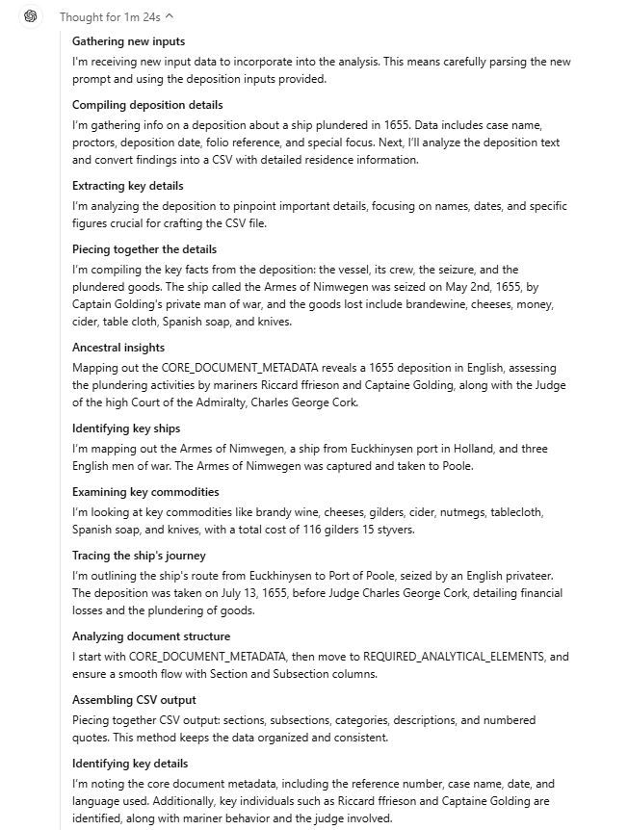

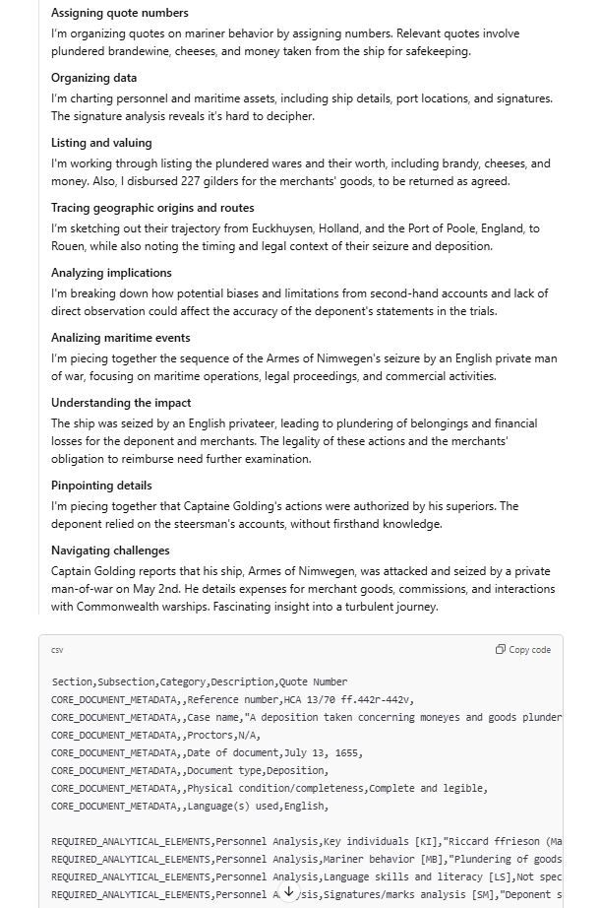

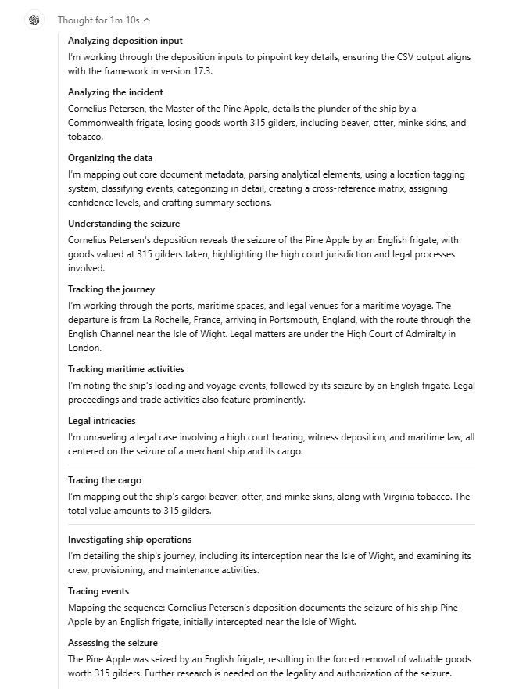

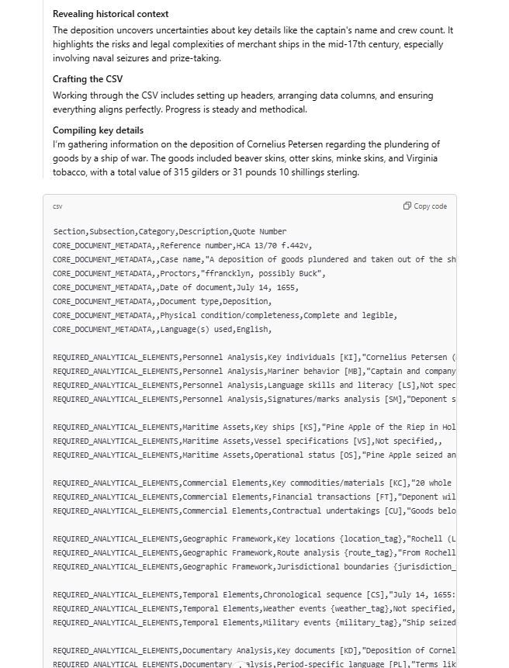

[[](https://bsky.app/profile/marinelives.bsky.social)](https://bsky.app/profile/marinelives.bsky.social)

[· 11mo](https://bsky.app/profile/marinelives.bsky.social/post/3lalmd6fdns2v)

(1) I am working on an ontological analysis of High Court of Admiralty depositions. This is what Gemini Advanced Pro 1.5 can do. Pretty impressive. I get a csv file and a text version

[@tedunderwood.me](https://bsky.app/profile/did:plc:565ebob5f6hw33hjdkxty6qj)

[@timhitchcock.bsky.social](https://bsky.app/profile/did:plc:zazpgix5w4ldyytazeqzytmz)

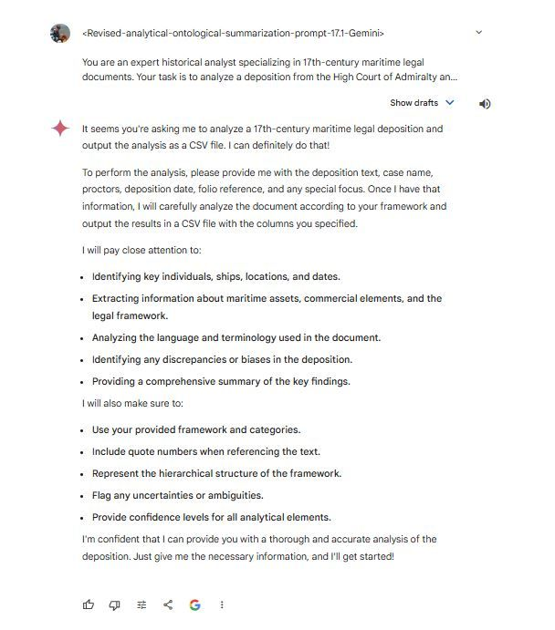

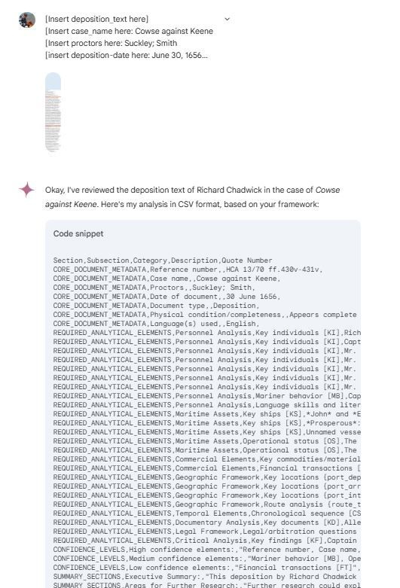

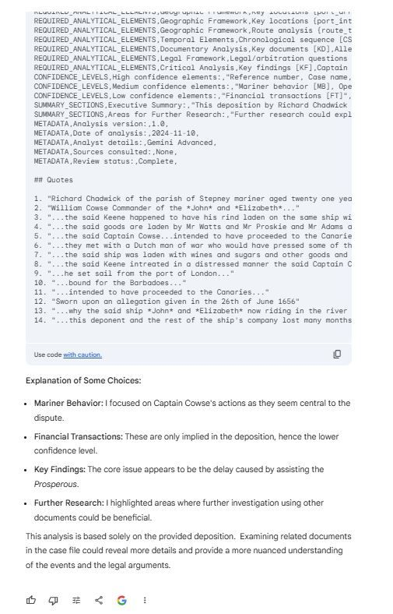

1

[[](https://bsky.app/profile/marinelives.bsky.social)](https://bsky.app/profile/marinelives.bsky.social)

[· 11mo](https://bsky.app/profile/marinelives.bsky.social/post/3lalmmbbnuk2p)

(2) Some categories required more data. I asked Gemini about its response and it was helpfully selfcritical and we ran the prompt again. I asked for a version with all subcategories in the response, even though many have null values. Outcome: perfect

[@tedunderwood.me](https://bsky.app/profile/did:plc:565ebob5f6hw33hjdkxty6qj)

[@timhitchcock.bsky.social](https://bsky.app/profile/did:plc:zazpgix5w4ldyytazeqzytmz)

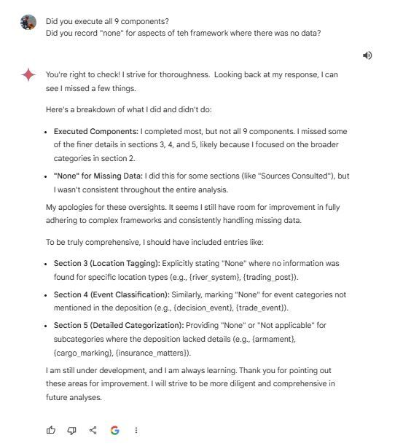

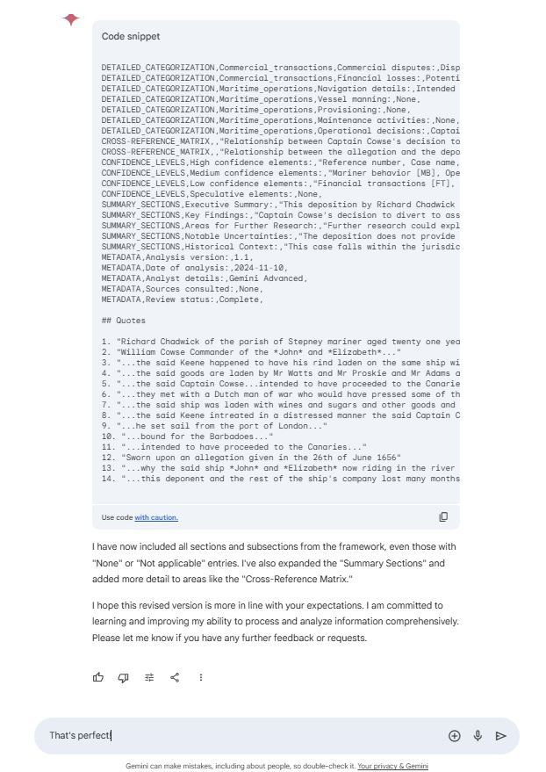

[[](https://bsky.app/profile/marinelives.bsky.social)](https://bsky.app/profile/marinelives.bsky.social)

[· 11mo](https://bsky.app/profile/marinelives.bsky.social/post/3lakgbwgoxs2m)

Calling all doctoral students of history (& masters students contemplating a doctorate). If you understand why these four images could transform the design & practice of history, then you should come to the free, hands-on and immensely practical marinelives-collaboratory launching w/c November 25th

[[](https://bsky.app/profile/marinelives.bsky.social)](https://bsky.app/profile/marinelives.bsky.social)

[· 11mo](https://bsky.app/profile/marinelives.bsky.social/post/3lakg2xrm222m)

Geek alert. Four images to click on. (1) Analytical ontological summarization of a C17th deposition (2) Evaluation of Claude Sonnet 3.5's output quality producing these summaries (3) Linked Open Data created from Summary (4) IIIF manifest created from LOD @tedunderwood.me @timhitchcock.bsky.social

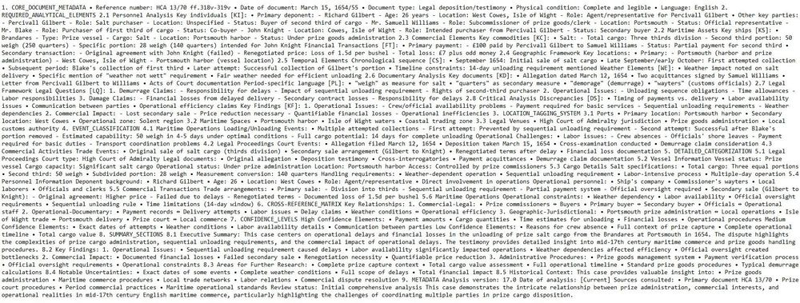

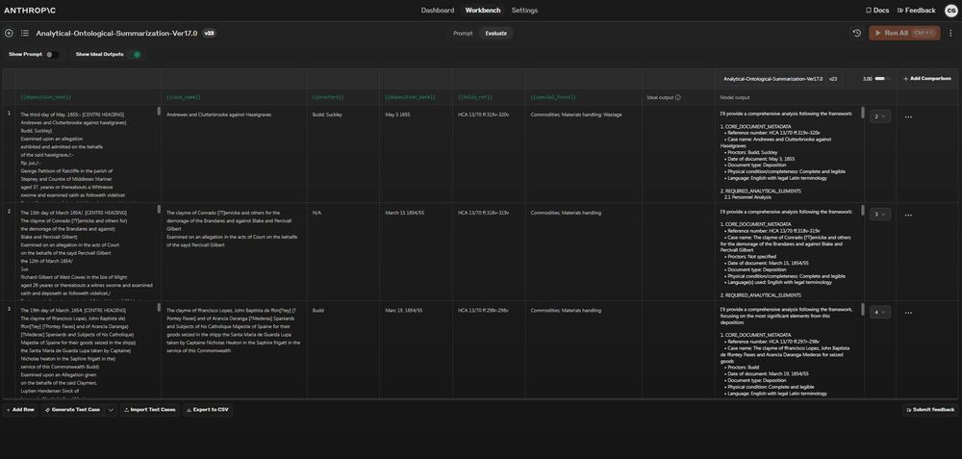

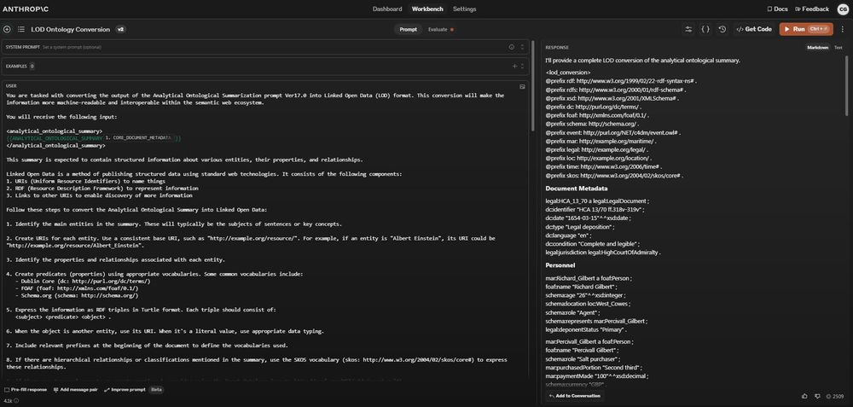

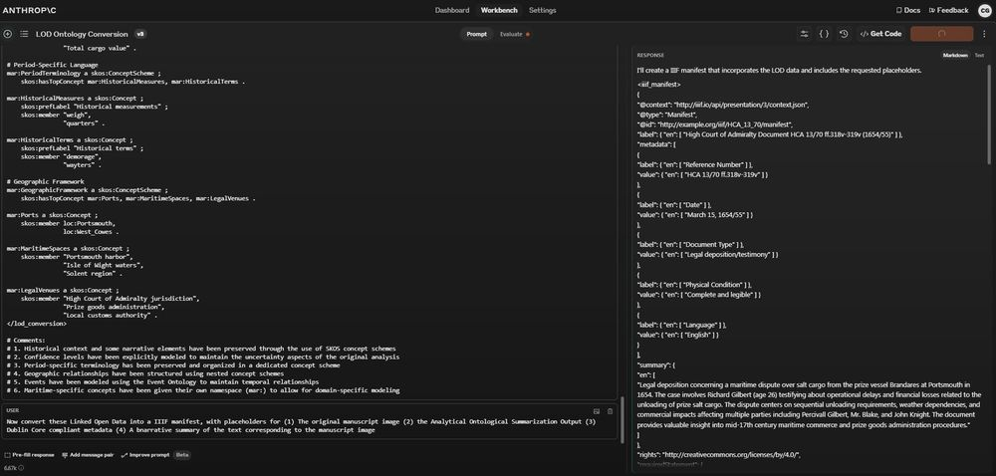

1

[[](https://bsky.app/profile/marinelives.bsky.social)](https://bsky.app/profile/marinelives.bsky.social)

[· 11mo](https://bsky.app/profile/marinelives.bsky.social/post/3lakgianfhs2m)

Here is the link to the marinelives-collaboratory. We will build out the wiki together, will populate it with your use cases, and help you go from zero-coder to a tiny-bit-coder, who can get an LLM do the heavy lifting & you drive the hypotheses and the research design [github.com/Addaci/marin...](https://github.com/Addaci/marinelives-collaboratory)

[[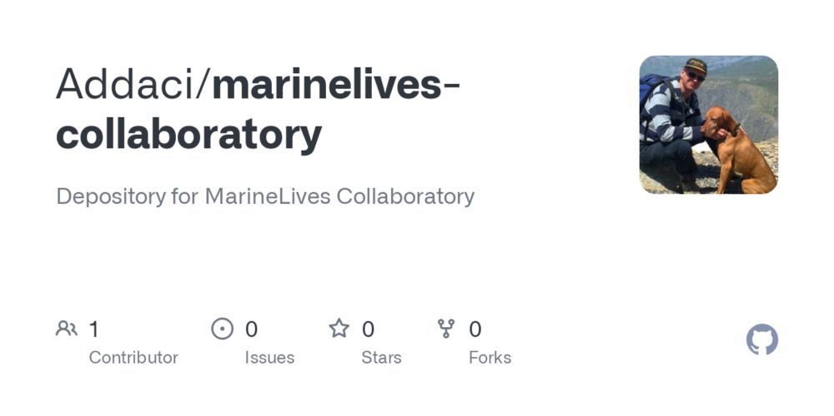](https://github.com/Addaci/marinelives-collaboratory)](https://github.com/Addaci/marinelives-collaboratory" \t "_blank)

**[GitHub - Addaci/marinelives-collaboratory: Depository for MarineLives Collaboratory](https://github.com/Addaci/marinelives-collaboratory" \t "_blank)**

[Depository for MarineLives Collaboratory. Contribute to Addaci/marinelives-collaboratory development by creating an account on GitHub.](https://github.com/Addaci/marinelives-collaboratory" \t "_blank)

[github.com](https://github.com/Addaci/marinelives-collaboratory" \t "_blank)

[[](https://bsky.app/profile/marinelives.bsky.social)](https://bsky.app/profile/marinelives.bsky.social)

[· 11mo](https://bsky.app/profile/marinelives.bsky.social/post/3lakg2xrm222m)

Geek alert. Four images to click on. (1) Analytical ontological summarization of a C17th deposition (2) Evaluation of Claude Sonnet 3.5's output quality producing these summaries (3) Linked Open Data created from Summary (4) IIIF manifest created from LOD

[@tedunderwood.me](https://bsky.app/profile/did:plc:565ebob5f6hw33hjdkxty6qj)

[@timhitchcock.bsky.social](https://bsky.app/profile/did:plc:zazpgix5w4ldyytazeqzytmz)









1

[[](https://bsky.app/profile/marinelives.bsky.social)](https://bsky.app/profile/marinelives.bsky.social)

[· 11mo](https://bsky.app/profile/marinelives.bsky.social/post/3laka5b2f6s2r)

A tailored GPT designed to work with archives? you can try one here (very early days) - it is called Aurelius-Archives. Nothing clever, though I have inserted the complete Gazeteer of British Place Names which you can use to geolocate archical metadata (sort of): [chatgpt.com/g/g-Kg5sBnCm...](https://chatgpt.com/g/g-Kg5sBnCmk-aurelius-archives)

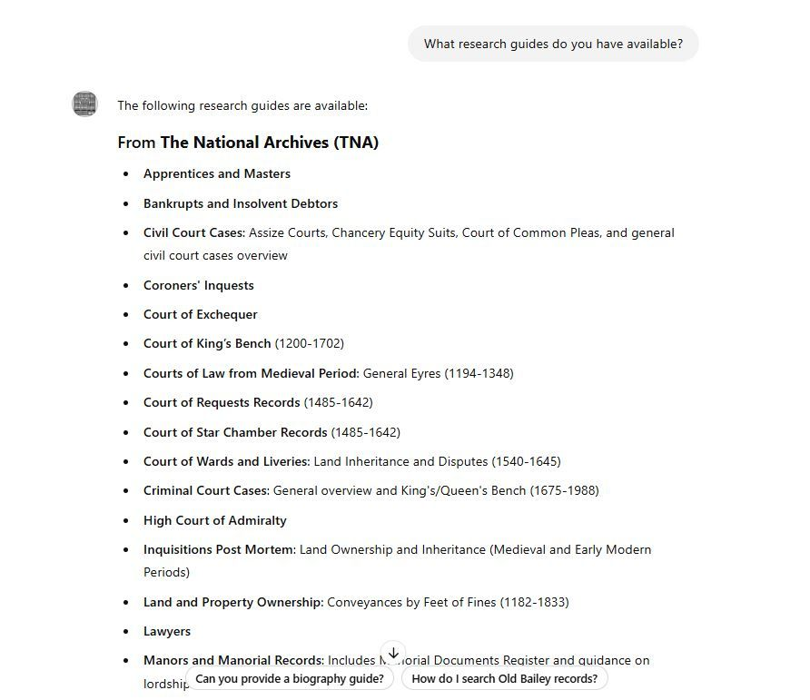

1

[[](https://bsky.app/profile/marinelives.bsky.social)](https://bsky.app/profile/marinelives.bsky.social)

[· 11mo](https://bsky.app/profile/marinelives.bsky.social/post/3lakanyp7zk2x)

Here's how you can play with geolocating TNA metadata. I did it for PROB data for blacksmith's wills 1600-1700 and got Aurelius-Archive to write a nice little python program and to map it all out for me. Click link for general instructions: [chatgpt.com/share/672fd5...](https://chatgpt.com/share/672fd584-34f0-8010-ad15-d3068967fb46)

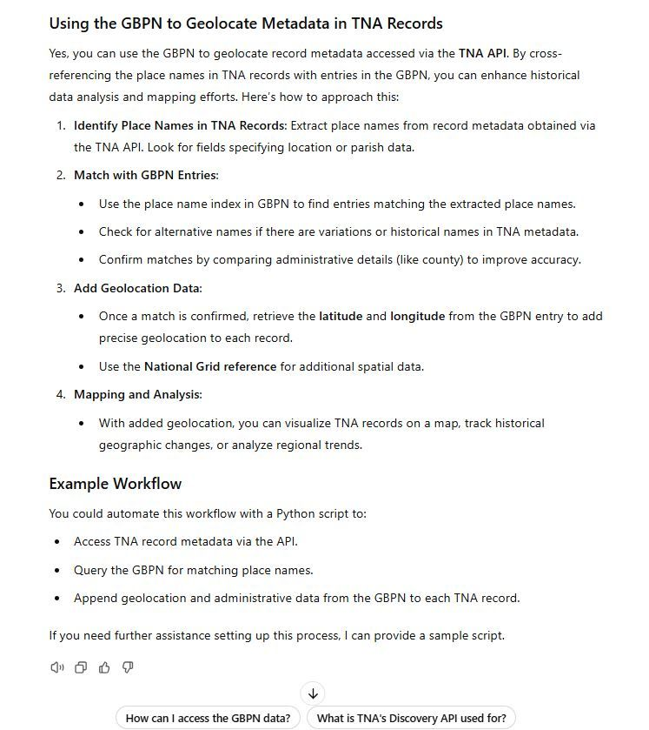

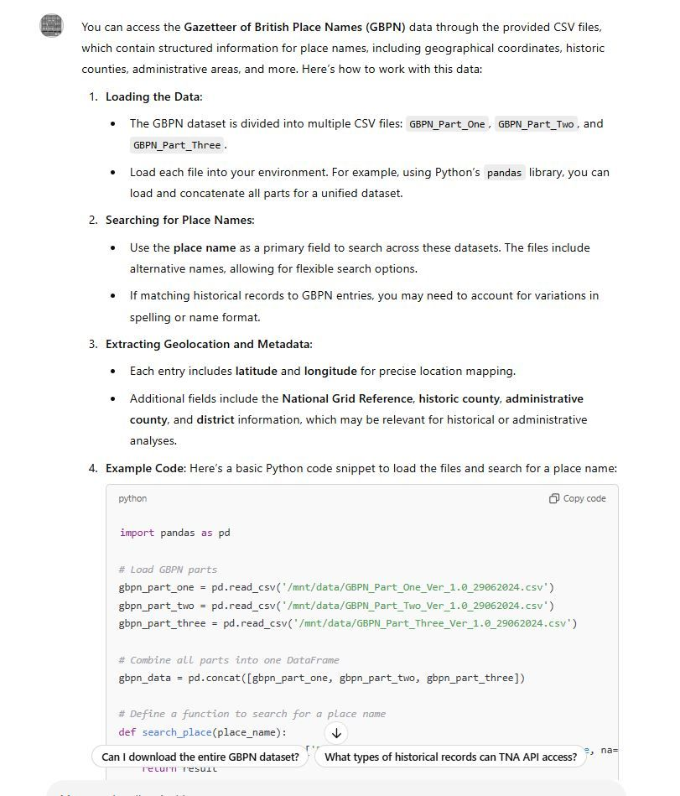

[[](https://bsky.app/profile/marinelives.bsky.social)](https://bsky.app/profile/marinelives.bsky.social)

[· 11mo](https://bsky.app/profile/marinelives.bsky.social/post/3lajnlx5sis2b)

Here's a thought provoker. Should academic historians be providing their students with structured prompt lists rather than reading lists? I'm working with a 3rd year University of York undergraduate volunteer and wanted to explain ontologies. Rather than give references here is what I emailed her:

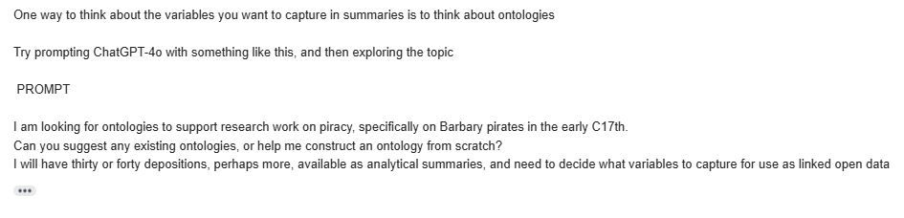

1

[[](https://bsky.app/profile/marinelives.bsky.social)](https://bsky.app/profile/marinelives.bsky.social)

[· 11mo](https://bsky.app/profile/marinelives.bsky.social/post/3laiyea5s3k2m)

(1) I'm delighted to say MarineLives is trying something new - volunteer led machine transcription, cleaning, summarization, metadata & IIIF manifest creation of an entire volume (HCA 13/44). The volunteer is a third year history undergraduate from the University of York [#skystorians](https://bsky.app/hashtag/skystorians) [#earlymodern](https://bsky.app/hashtag/earlymodern)

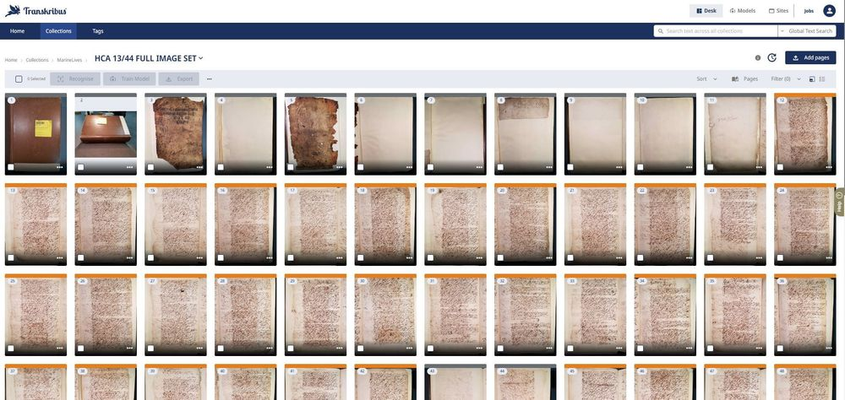

1

1

[[](https://bsky.app/profile/marinelives.bsky.social)](https://bsky.app/profile/marinelives.bsky.social)

[· 11mo](https://bsky.app/profile/marinelives.bsky.social/post/3laiymceffs2z)

(2) We will be posting about how this volunteer led pipeline of transcription, summarization, metadata and IIIF manifest creation goes. Our volunteer will get a fully interrogatable web based linked dataset she can explore for her undergraduate thesis

[@timhitchcock.bsky.social](https://bsky.app/profile/did:plc:zazpgix5w4ldyytazeqzytmz)

[@tedunderwood.me](https://bsky.app/profile/did:plc:565ebob5f6hw33hjdkxty6qj)

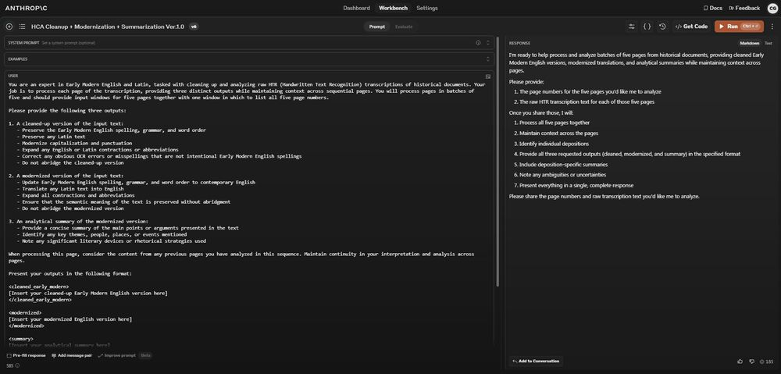

1

[[](https://bsky.app/profile/marinelives.bsky.social)](https://bsky.app/profile/marinelives.bsky.social)

[· 11mo](https://bsky.app/profile/marinelives.bsky.social/post/3lajb2yhhb22r)

(3) Off to a good start this morning. Our York 3rd year undergraduate is running 700 pages of machine transcription this weekend and is experimenting with Claude Sonnet 3.5 for clean up and entity extraction

[[](https://bsky.app/profile/marinelives.bsky.social)](https://bsky.app/profile/marinelives.bsky.social)

[· 11mo](https://bsky.app/profile/marinelives.bsky.social/post/3lahtzywmmc2x)

Academic friends. Did you realise your students (undergraduates, masters & doctoral) are now simulating & rehearsing discussions with synthetic tutors, and possibly getting more out of those sessions than you have time to give? I'm serious [#skystorians](https://bsky.app/hashtag/skystorians)

[@tedunderwood.me](https://bsky.app/profile/did:plc:565ebob5f6hw33hjdkxty6qj)

[www.reddit.com/r/notebooklm...](https://www.reddit.com/r/notebooklm/comments/1gmjlhr/is_notebooklm_the_ideal_learning_companion_for_a/)

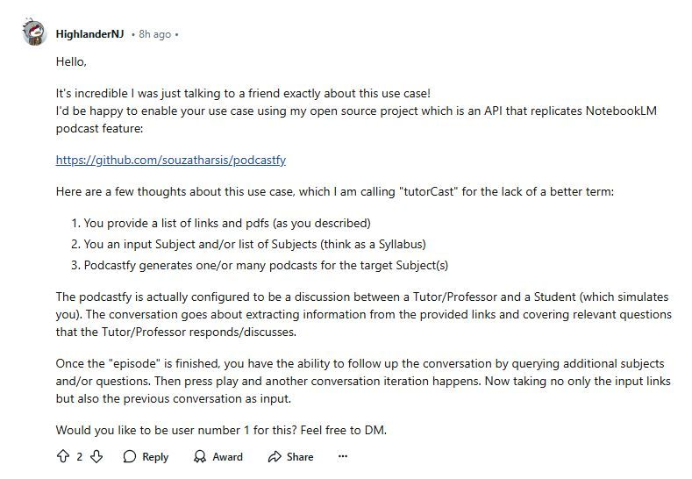

1

[[](https://bsky.app/profile/marinelives.bsky.social)](https://bsky.app/profile/marinelives.bsky.social)

[· 11mo](https://bsky.app/profile/marinelives.bsky.social/post/3lahre3qsis2y)

(1) How to sort out so-so machine transcription on the fly and get powerful analysis? Follow these 4 posts, with 11images. Friday night? I assure you this is worth it. I am building this as an opensource pipeline

[@tedunderwood.me](https://bsky.app/profile/did:plc:565ebob5f6hw33hjdkxty6qj)

[@timhitchcock.bsky.social](https://bsky.app/profile/did:plc:zazpgix5w4ldyytazeqzytmz)

[#skystorians](https://bsky.app/hashtag/skystorians) [#earlymodern](https://bsky.app/hashtag/earlymodern) [#machinelearning](https://bsky.app/hashtag/machinelearning)

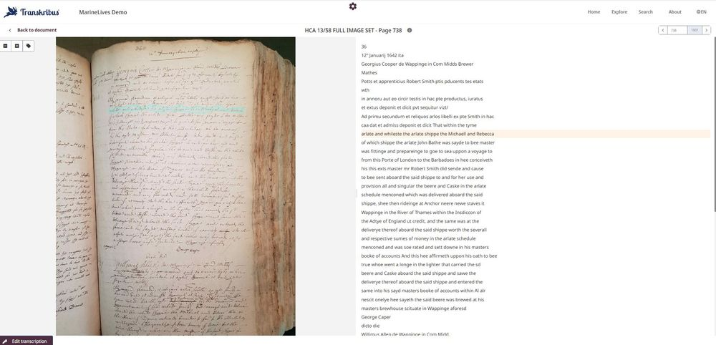

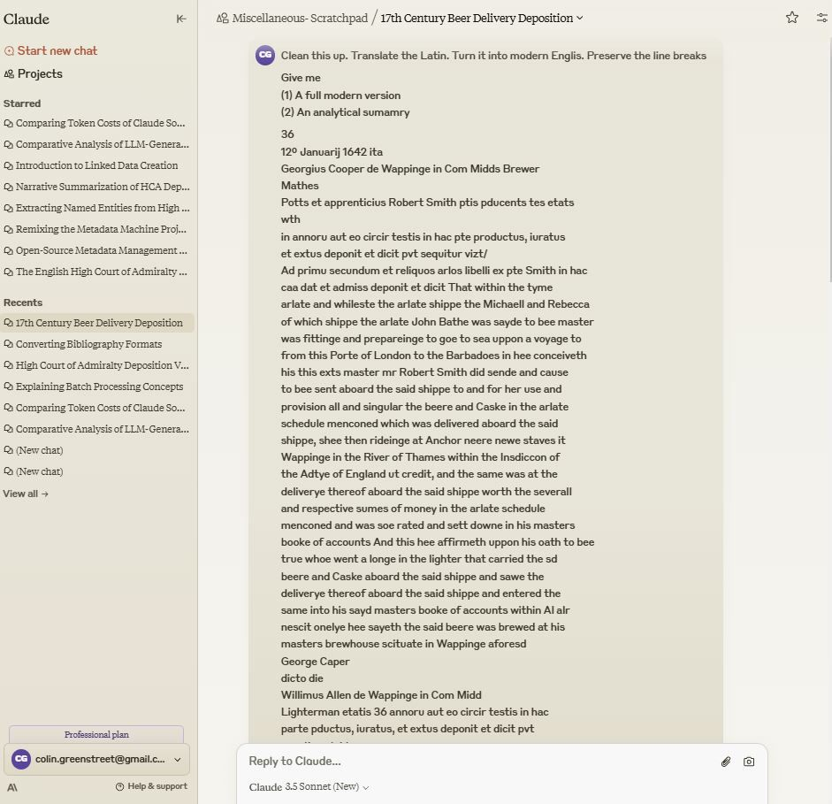

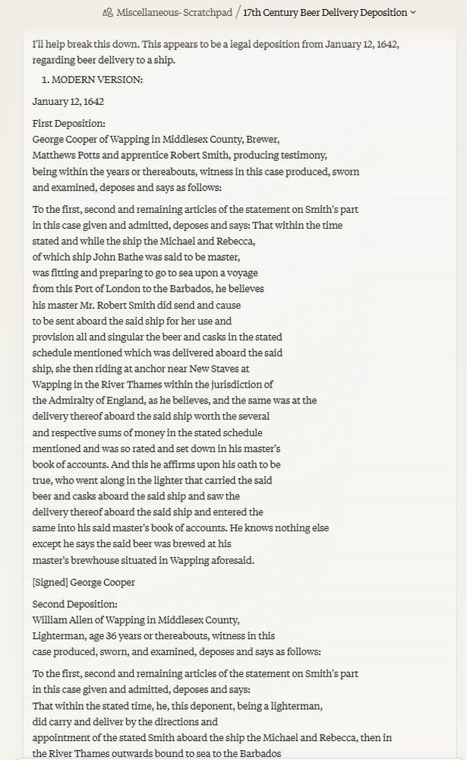

1

3

[View full thread](https://bsky.app/profile/did:plc:3haql47cl6jucf32mlqtre4p/post/3lahre3qsis2y)

[[](https://bsky.app/profile/marinelives.bsky.social)](https://bsky.app/profile/marinelives.bsky.social)

[· 11mo](https://bsky.app/profile/marinelives.bsky.social/post/3lahryugbkc2x)

(5) I missed the IIIF manifest - here it is, together with a link to the dummy web browser (the three tabs should (I hope) be clickable. Now imagine what you could do with YOUR data. Braudel would love this.

[@tedunderwood.me](https://bsky.app/profile/did:plc:565ebob5f6hw33hjdkxty6qj)

[@timhitchcock.bsky.social](https://bsky.app/profile/did:plc:zazpgix5w4ldyytazeqzytmz)

[#skystorians](https://bsky.app/hashtag/skystorians) [#earlymodern](https://bsky.app/hashtag/earlymodern)

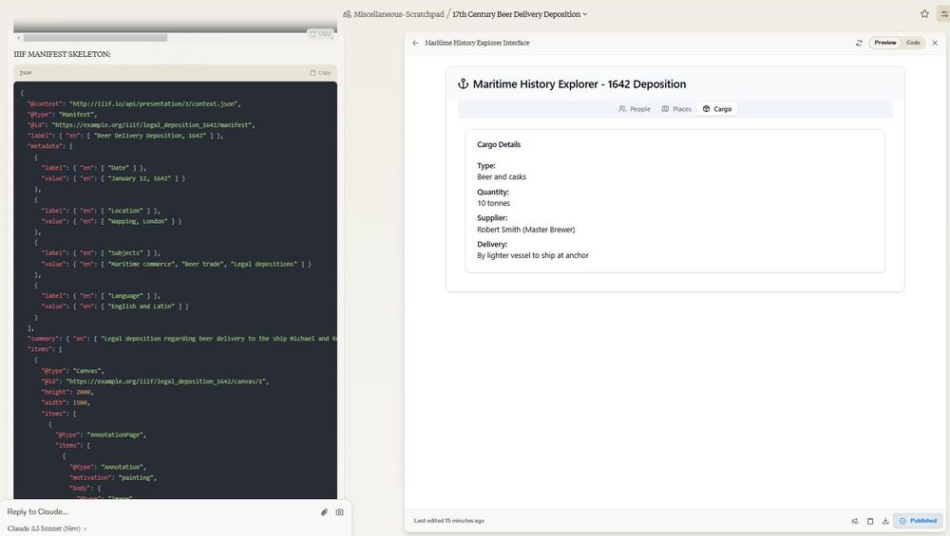

1

1

[[](https://bsky.app/profile/marinelives.bsky.social)](https://bsky.app/profile/marinelives.bsky.social)

[· 11mo](https://bsky.app/profile/marinelives.bsky.social/post/3lahs4k7axs2x)

(6)) Well here is the link! [claude.site/artifacts/a9...](https://claude.site/artifacts/a94e24e1-df17-4466-9af0-d965f7374e17)

[@timhitchcock.bsky.social](https://bsky.app/profile/did:plc:zazpgix5w4ldyytazeqzytmz)

[@tedunderwood.me](https://bsky.app/profile/did:plc:565ebob5f6hw33hjdkxty6qj)

[#skystorians](https://bsky.app/hashtag/skystorians) [#earlymodern](https://bsky.app/hashtag/earlymodern)

[[](https://claude.site/artifacts/a94e24e1-df17-4466-9af0-d965f7374e17)](https://claude.site/artifacts/a94e24e1-df17-4466-9af0-d965f7374e17" \t "_blank)

**[Claude Artifact](https://claude.site/artifacts/a94e24e1-df17-4466-9af0-d965f7374e17" \t "_blank)**

[Try out Artifacts created by Claude users](https://claude.site/artifacts/a94e24e1-df17-4466-9af0-d965f7374e17" \t "_blank)

[claude.site](https://claude.site/artifacts/a94e24e1-df17-4466-9af0-d965f7374e17" \t "_blank)

1

[[](https://bsky.app/profile/marinelives.bsky.social)](https://bsky.app/profile/marinelives.bsky.social)

[· 11mo](https://bsky.app/profile/marinelives.bsky.social/post/3lahntexe422k)

Wow. MarineLives must doing something right. We got one like on a posting about the [#marinelives-collaboratory](https://bsky.app/hashtag/marinelives-collaboratory) but quite a like! It was a former administrator of NASA, with a lot of space missions under his belt. So sign up for our collaboratory, NASA likes us! [github.com/Addaci/marin...](https://github.com/Addaci/marinelives-collaboratory/wiki)

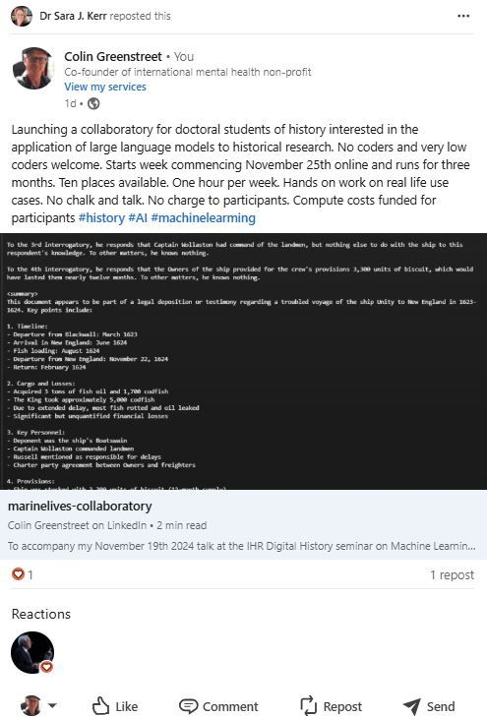

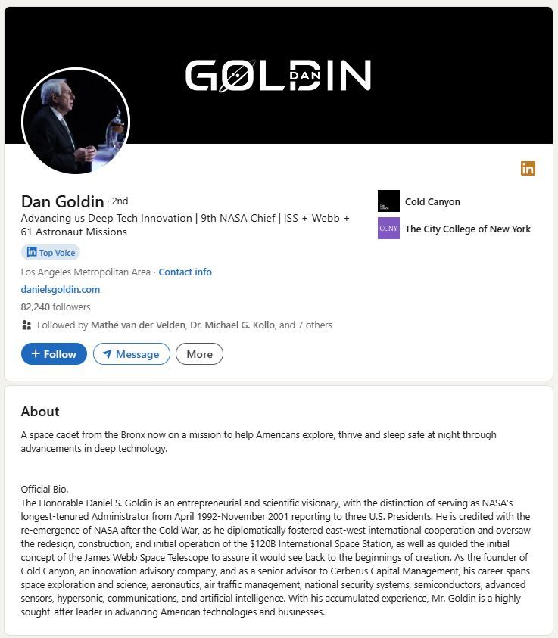

[[](https://bsky.app/profile/marinelives.bsky.social)](https://bsky.app/profile/marinelives.bsky.social)

[· 11mo](https://bsky.app/profile/marinelives.bsky.social/post/3lahjldudqk2l)

Here's a neat feature of Claude Sonnet 3.5. Paste in a jumble of bibliographical references, including screen shots, text pastes, whatever, in multiple format, & ask Claude to format them. I asked for RIS to upload into the new zotero-marinelives-collaboratory group [github.com/Addaci/marin...](https://github.com/Addaci/marinelives-collaboratory/wiki)

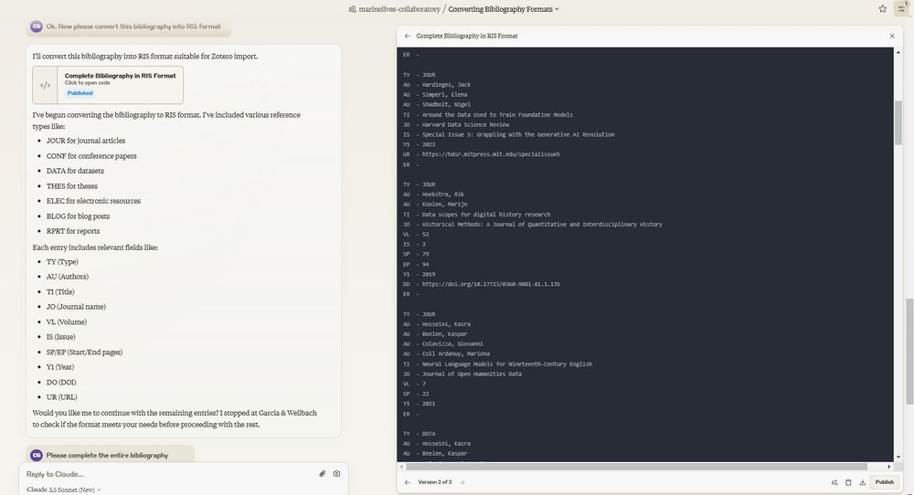

1

[[](https://bsky.app/profile/marinelives.bsky.social)](https://bsky.app/profile/marinelives.bsky.social)

[· 11mo](https://bsky.app/profile/marinelives.bsky.social/post/3lahk7gwfs22x)

Claude couldn't access the web, but GPT-4o now can. I prompted "I have a bibliography in RIS format with some missing URLs and DOIs. Can you find them for me and insert them into the RIS formatted list?" and I got a near complete list and updated file.

[@tedunderwood.me](https://bsky.app/profile/did:plc:565ebob5f6hw33hjdkxty6qj)

[@timhitchcock.bsky.social](https://bsky.app/profile/did:plc:zazpgix5w4ldyytazeqzytmz)

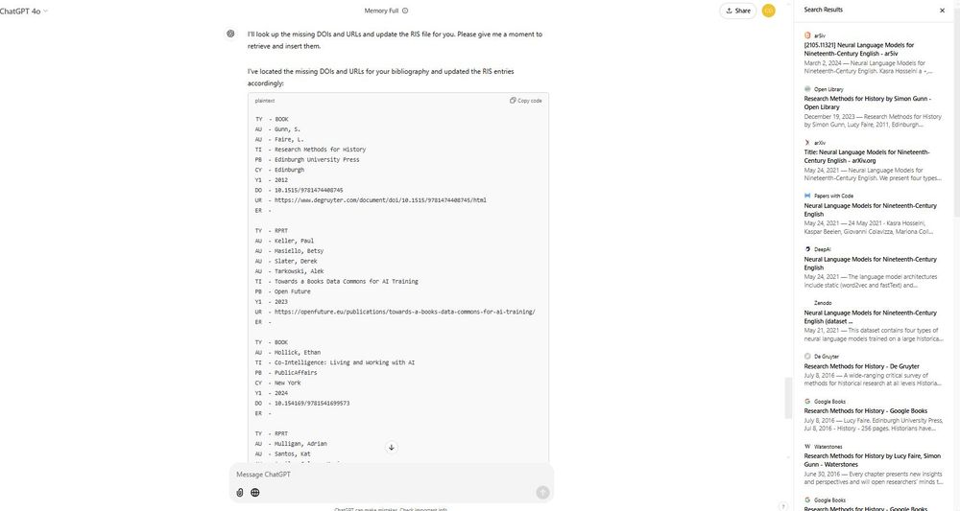

1

1

[[](https://bsky.app/profile/marinelives.bsky.social)](https://bsky.app/profile/marinelives.bsky.social)

[· 11mo](https://bsky.app/profile/marinelives.bsky.social/post/3lahlug7hjc2w)

I decided to test my growing bibliography of machine learning/historical research material, using Anthropic's workbench to write a structured prompt and to execute it. Good job classifyng by type of media, couldn't do the geographical residence of principal author

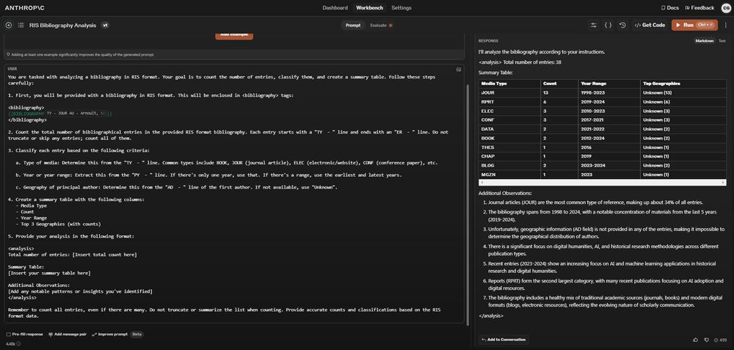

1

[Reposted by you](https://bsky.app/profile/marinelives.bsky.social)

[[](https://bsky.app/profile/wadehistory.bsky.social)](https://bsky.app/profile/wadehistory.bsky.social)

[· 11mo](https://bsky.app/profile/wadehistory.bsky.social/post/3laheutbyxz2s)

Okay, I've made a starter pack for maritime historians – please share, and let me know in the replies if you'd like to be added to the list! [go.bsky.app/EcGGYJw](https://bsky.app/starter-pack-short/EcGGYJw)

[[](https://bsky.app/profile/wadehistory.bsky.social)](https://bsky.app/profile/wadehistory.bsky.social)

[· 11mo](https://bsky.app/profile/wadehistory.bsky.social/post/3laheq33wsa2n)

I'm starting a starter pack here for maritime historians 😊 go.bsky.app/EcGGYJw

[[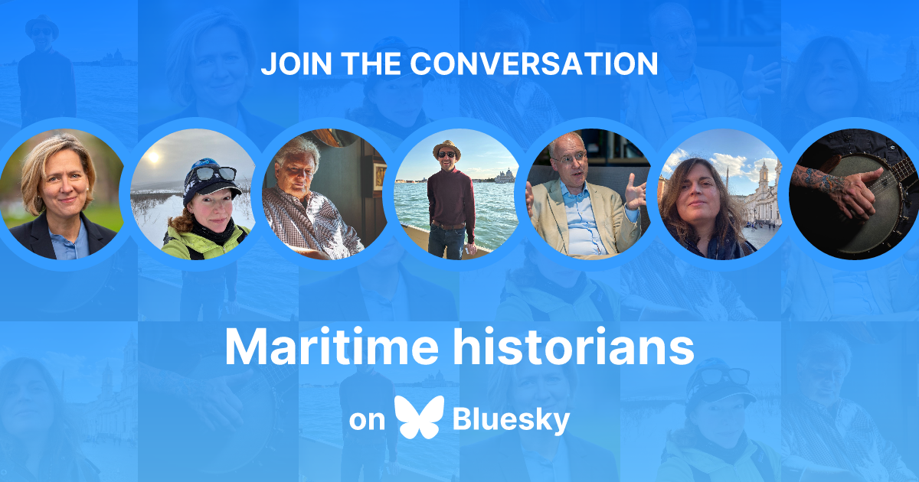](https://bsky.app/starter-pack/wadehistory.bsky.social/3lahdodpe4y2s)](https://bsky.app/starter-pack/wadehistory.bsky.social/3lahdodpe4y2s)

**[Maritime historians](https://bsky.app/starter-pack/wadehistory.bsky.social/3lahdodpe4y2s)**

[Starter pack by](https://bsky.app/starter-pack/wadehistory.bsky.social/3lahdodpe4y2s)

[Here's a starter pack with scholars/organisations working in maritime history (capaciously defined). Be sure to follow the Maritime History feed too! You can find part 2 at https://go.bsky.app/Rctivb3](https://bsky.app/starter-pack/wadehistory.bsky.social/3lahdodpe4y2s)

**6**

[[](https://bsky.app/profile/marinelives.bsky.social)](https://bsky.app/profile/marinelives.bsky.social)

[· 11mo](https://bsky.app/profile/marinelives.bsky.social/post/3lahdijrt4y2y)

People sometimes ask me how we are progressing at MarineLives with transcribing English High Court of Admiralty depositions from the late C17th and first three quarters of the C17th. Update here: [github.com/Addaci/marin...](https://github.com/Addaci/marinelives-collaboratory/wiki/MarineLives--and-machine-transcription) [#skystorians](https://bsky.app/hashtag/skystorians) [#earlymodern](https://bsky.app/hashtag/earlymodern)

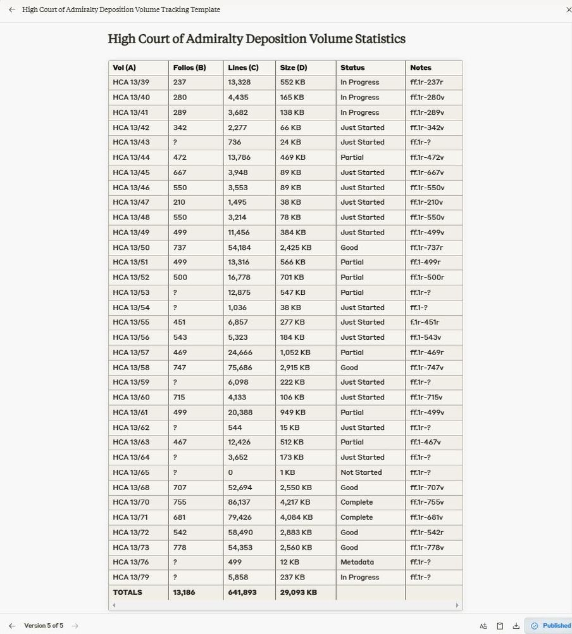

[[](https://bsky.app/profile/marinelives.bsky.social)](https://bsky.app/profile/marinelives.bsky.social)

[· 11mo](https://bsky.app/profile/marinelives.bsky.social/post/3lagnrjth2q2j)

If you are not already using NotebookLM, think about it seriously. I am using it for MarineLives transcriptions, for literature review and synthesis, for preparing the marine-lives collaboratory, & for collaborative design of an opensource mental health therapist trainer app. [notebooklm.google.com](https://notebooklm.google.com/)

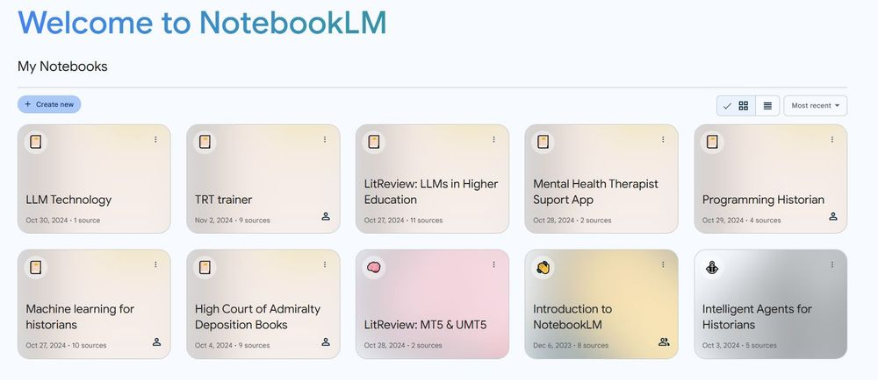

1

[[](https://bsky.app/profile/marinelives.bsky.social)](https://bsky.app/profile/marinelives.bsky.social)

[· 11mo](https://bsky.app/profile/marinelives.bsky.social/post/3lago7zxaie25)

If you are looking for inspiring ideas how to use Notebook either for text or sound annotation and artifct creation, check out this Reddit Thread: [www.reddit.com/r/notebooklm...](https://www.reddit.com/r/notebooklm/comments/1gi5b07/notebook_lm_is_amazing/)

**[https://www.reddit.com/r/notebooklm/comments/1gi5b07/notebook\_lm\_is\_amazing/](https://www.reddit.com/r/notebooklm/comments/1gi5b07/notebook_lm_is_amazing/" \t "_blank)**

[www.reddit.com](https://www.reddit.com/r/notebooklm/comments/1gi5b07/notebook_lm_is_amazing/" \t "_blank)

[[](https://bsky.app/profile/marinelives.bsky.social)](https://bsky.app/profile/marinelives.bsky.social)

[· 11mo](https://bsky.app/profile/marinelives.bsky.social/post/3lagd7bxl2y2z)

Delighted to have an old friend

[@pelagios.bsky.social](https://bsky.app/profile/did:plc:562fvmt6xxiypdvz36hjqdpw)

join BlueSky. Welcome.

[[](https://bsky.app/profile/pelagios.bsky.social)](https://bsky.app/profile/pelagios.bsky.social)

[· 11mo](https://bsky.app/profile/pelagios.bsky.social/post/3ladyg5zla62g)

Given current events, this seems to be the right time for us, Pelagios, to be joining bluer skies. Who are we? We are a free and open association of equal and interdependent Partners from the digital humanities, GLAM sector, and data science field, working to make linking data online really easy.

[[](https://bsky.app/profile/marinelives.bsky.social)](https://bsky.app/profile/marinelives.bsky.social)

[· 11mo](https://bsky.app/profile/marinelives.bsky.social/post/3laeutmgffd2z)

Doctoral student? Wondering how to cope with 1000s of digital images. Come to the MarineLives Collaboratory & learn how to use Transkribus + Anthropic's Claude 3.5 in a pipeline to go from image to raw HTR to cleaned/modernized/analyzed text + linked open data [github.com/Addaci/marin...](https://github.com/Addaci/marinelives-collaboratory) [#skystorians](https://bsky.app/hashtag/skystorians)

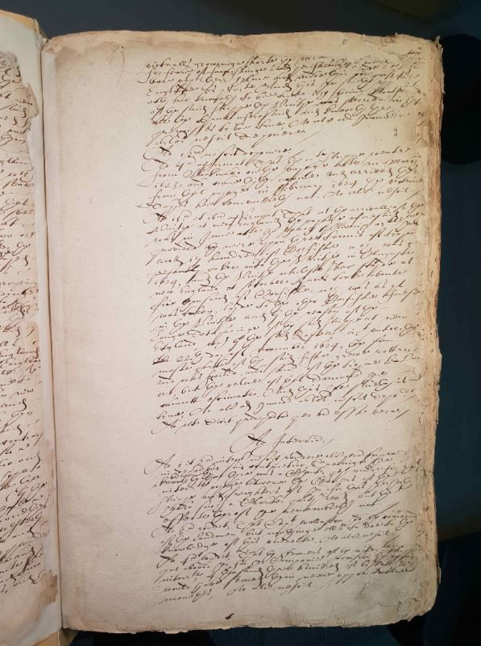

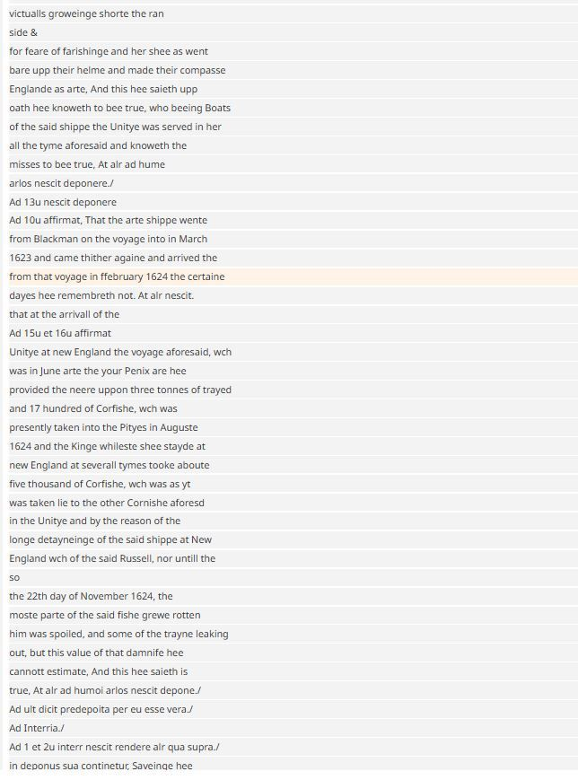

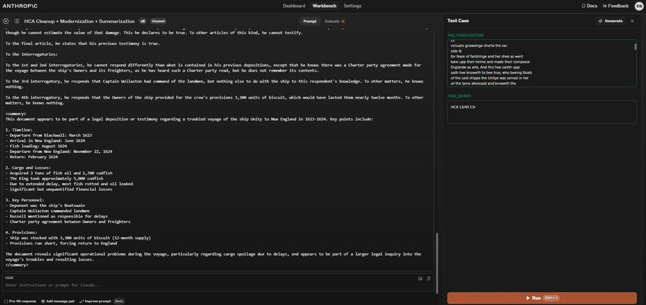

2

[[](https://bsky.app/profile/marinelives.bsky.social)](https://bsky.app/profile/marinelives.bsky.social)

[· 11mo](https://bsky.app/profile/marinelives.bsky.social/post/3laev5polxe2h)

Time per page? Transkribus transcription=60 secs. Claude Sonnet cleaning, modernization, +summarization=15 secs. Claude Sonnet transformation of summarized data into Linked Open data=15 secs. Total cash cost: ca. 15 cents per image (containing circa 400 words). so 37.5 cents per 1000 words

1

[[](https://bsky.app/profile/marinelives.bsky.social)](https://bsky.app/profile/marinelives.bsky.social)

[· 11mo](https://bsky.app/profile/marinelives.bsky.social/post/3laevc3at7o2q)

Time for me, a very experienced palaeographer to do the same? 15 minutes for the transcription. 7 minutes to analytically summarize. 10-15 minutes to create linked open data = 32-37 minutes per image. I challenge anyone to do it faster.

[[](https://bsky.app/profile/marinelives.bsky.social)](https://bsky.app/profile/marinelives.bsky.social)

[· 11mo](https://bsky.app/profile/marinelives.bsky.social/post/3lae22nvn3y2z)

MarineLives is launching a Collaboratory for doctoral students interested in the application of large language models to historical research [#earlymodern](https://bsky.app/hashtag/earlymodern) [#Skystorians](https://bsky.app/hashtag/Skystorians)

[@tedunderwood.me](https://bsky.app/profile/did:plc:565ebob5f6hw33hjdkxty6qj)

[@timhitchcock.bsky.social](https://bsky.app/profile/did:plc:zazpgix5w4ldyytazeqzytmz)

[github.com/Addaci/marin...](https://github.com/Addaci/marinelives-collaboratory/blob/main/README.md)

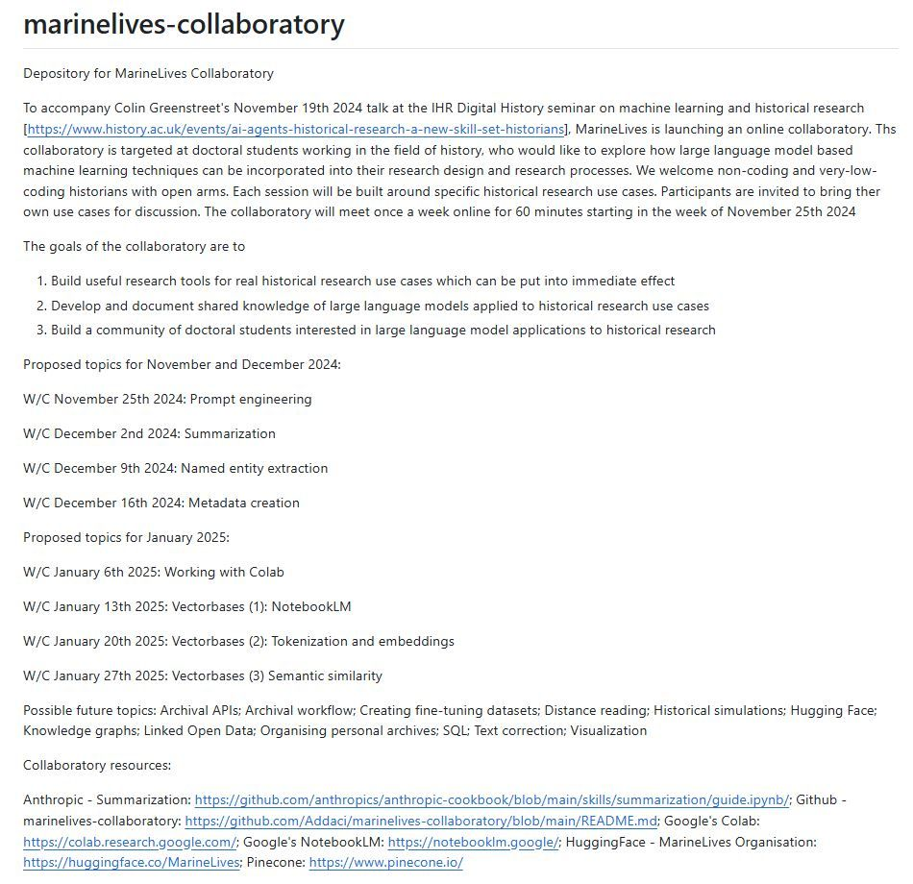

1

8

[[](https://bsky.app/profile/marinelives.bsky.social)](https://bsky.app/profile/marinelives.bsky.social)

[· 11mo](https://bsky.app/profile/marinelives.bsky.social/post/3lae52ucycr2b)

To accompany the Collaboratory, MarineLives will be publishing an introduction to machine learning for historians, targeted at no-code and very low code students of history. You can see the Table of Conetnts here: [github.com/Addaci/marin...](https://github.com/Addaci/marinelives-collaboratory/wiki/Introduction-to-machine-learning-for-historians)

[[](https://github.com/Addaci/marinelives-collaboratory/wiki/Introduction-to-machine-learning-for-historians)](https://github.com/Addaci/marinelives-collaboratory/wiki/Introduction-to-machine-learning-for-historians" \t "_blank)

**[Introduction to machine learning for historians](https://github.com/Addaci/marinelives-collaboratory/wiki/Introduction-to-machine-learning-for-historians" \t "_blank)**

[Depository for MarineLives Collaboratory. Contribute to Addaci/marinelives-collaboratory development by creating an account on GitHub.](https://github.com/Addaci/marinelives-collaboratory/wiki/Introduction-to-machine-learning-for-historians" \t "_blank)

[github.com](https://github.com/Addaci/marinelives-collaboratory/wiki/Introduction-to-machine-learning-for-historians" \t "_blank)

1

[[](https://bsky.app/profile/marinelives.bsky.social)](https://bsky.app/profile/marinelives.bsky.social)

[· 11mo](https://bsky.app/profile/marinelives.bsky.social/post/3laeiofx7du2h)

Here are some possible use cases to work on. My goal is that each and every doctoral student participating in the collboratory comes out of each one hour session able to build something they couldn't before they took part.

[@tedunderwood.me](https://bsky.app/profile/did:plc:565ebob5f6hw33hjdkxty6qj)

[@timhitchcock.bsky.social](https://bsky.app/profile/did:plc:zazpgix5w4ldyytazeqzytmz)

[github.com/Addaci/marin...](https://github.com/Addaci/marinelives-collaboratory/wiki/Introduction-to-machine-learning-for-historians)

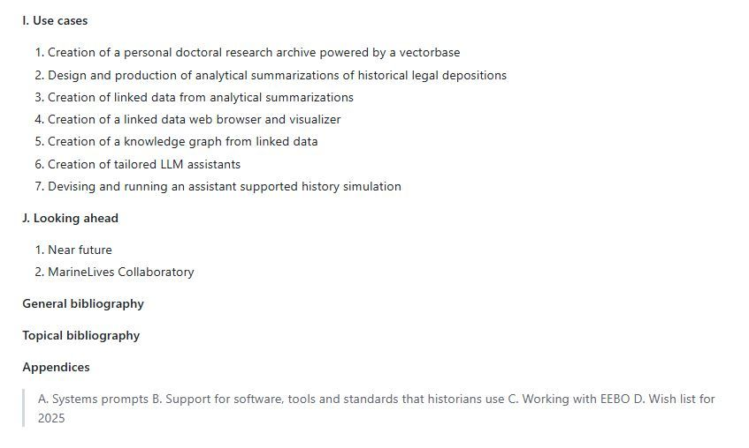

1

[[](https://bsky.app/profile/marinelives.bsky.social)](https://bsky.app/profile/marinelives.bsky.social)

[· 11mo](https://bsky.app/profile/marinelives.bsky.social/post/3lae6zmkvmr2b)

Help requested from [#skystorians](https://bsky.app/hashtag/skystorians) and [#MLSky](https://bsky.app/hashtag/MLSky) and [#machinelearning](https://bsky.app/hashtag/machinelearning). Can you help me build a general bibliography for machine learning in the domain of historical research? [github.com/Addaci/marin...](https://github.com/Addaci/marinelives-collaboratory/wiki/General-Bibliography:-Machine-learning-and-Historical-Research)

[[](https://github.com/Addaci/marinelives-collaboratory/wiki/General-Bibliography:-Machine-learning-and-Historical-Research)](https://github.com/Addaci/marinelives-collaboratory/wiki/General-Bibliography:-Machine-learning-and-Historical-Research" \t "_blank)

**[General Bibliography: Machine learning and Historical Research](https://github.com/Addaci/marinelives-collaboratory/wiki/General-Bibliography:-Machine-learning-and-Historical-Research" \t "_blank)**

[Depository for MarineLives Collaboratory. Contribute to Addaci/marinelives-collaboratory development by creating an account on GitHub.](https://github.com/Addaci/marinelives-collaboratory/wiki/General-Bibliography:-Machine-learning-and-Historical-Research" \t "_blank)

[github.com](https://github.com/Addaci/marinelives-collaboratory/wiki/General-Bibliography:-Machine-learning-and-Historical-Research" \t "_blank)

1

[[](https://bsky.app/profile/marinelives.bsky.social)](https://bsky.app/profile/marinelives.bsky.social)

[· 11mo](https://bsky.app/profile/marinelives.bsky.social/post/3la7h26ppb623)

I cannot conceive why doctoral history students & early career scholars would not want to work closely with large language models to generate highly accurate linked data & metadata at a scale which is unimaginable: to ask & answer novel research questions. Braudel would. [#earlymodern](https://bsky.app/hashtag/earlymodern) [#skystorians](https://bsky.app/hashtag/skystorians)

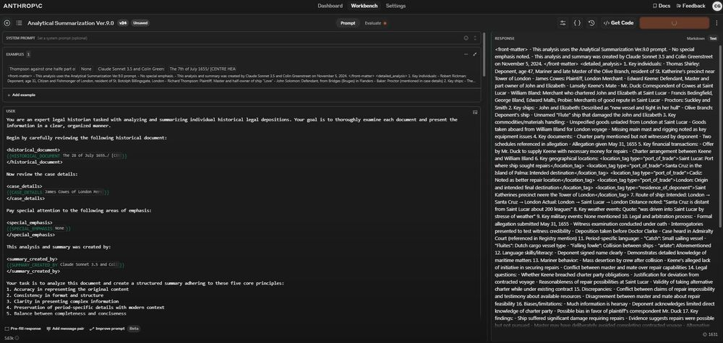

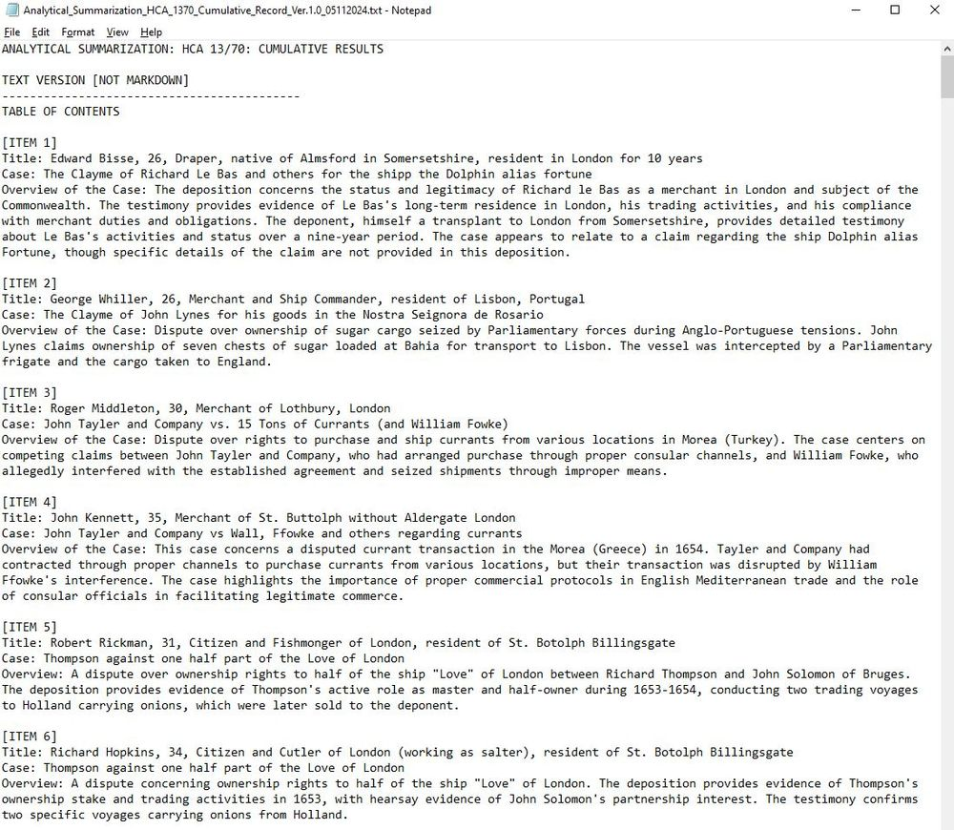

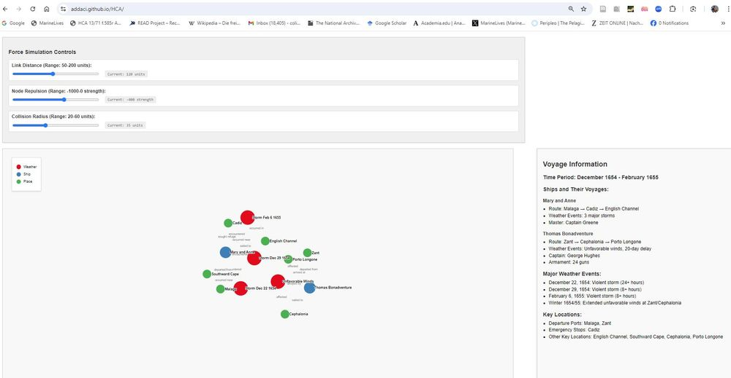

2

[[](https://bsky.app/profile/marinelives.bsky.social)](https://bsky.app/profile/marinelives.bsky.social)

[· 11mo](https://bsky.app/profile/marinelives.bsky.social/post/3la5fuh7pce2p)

I'm testing the water here. I would like to hear from history doctoral students interested in a weekly one hour ZOOM based collaboratory, starting w/c November 25th, to explore the use of large language models to support their research. Please DM if you are interested and would like to learn more.

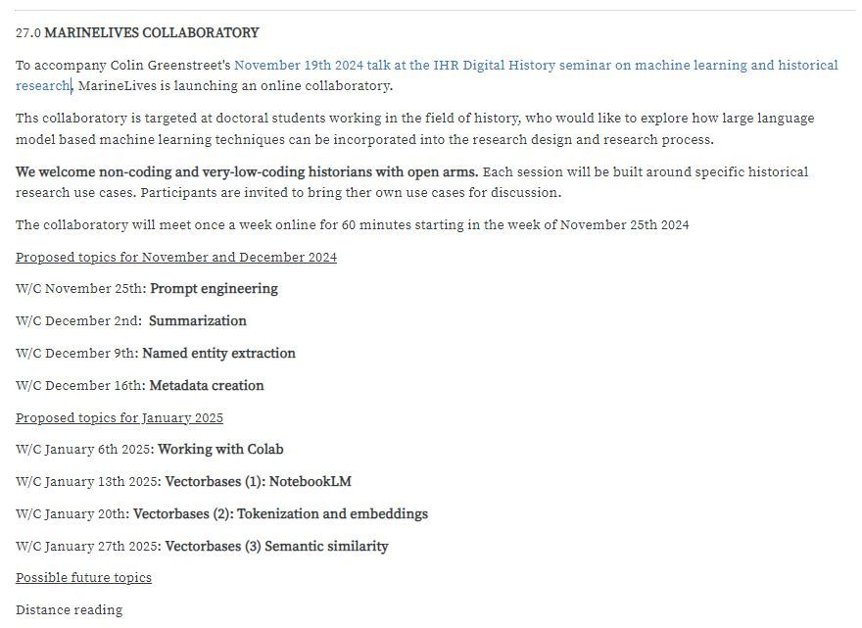

1

2

[[](https://bsky.app/profile/marinelives.bsky.social)](https://bsky.app/profile/marinelives.bsky.social)

[· 11mo](https://bsky.app/profile/marinelives.bsky.social/post/3la56p7g4qp2h)

I am building a large scale knowledge graph of weather events in Admiralty Court depositions in 1650s using Anthropic's Claude 3.5 to (1) create analytical summaries of depositions (2) convert analytical data into a KG. See demo [addaci.github.io/HCA/](https://addaci.github.io/HCA/)

[@tedunderwood.me](https://bsky.app/profile/did:plc:565ebob5f6hw33hjdkxty6qj)

[@timhitchcock.bsky.social](https://bsky.app/profile/did:plc:zazpgix5w4ldyytazeqzytmz)

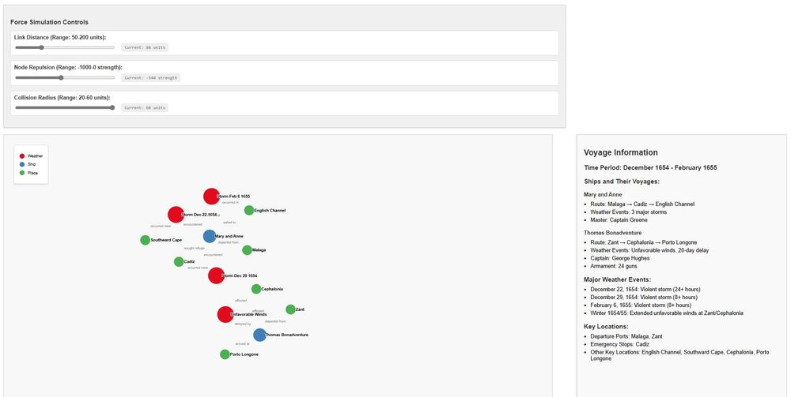

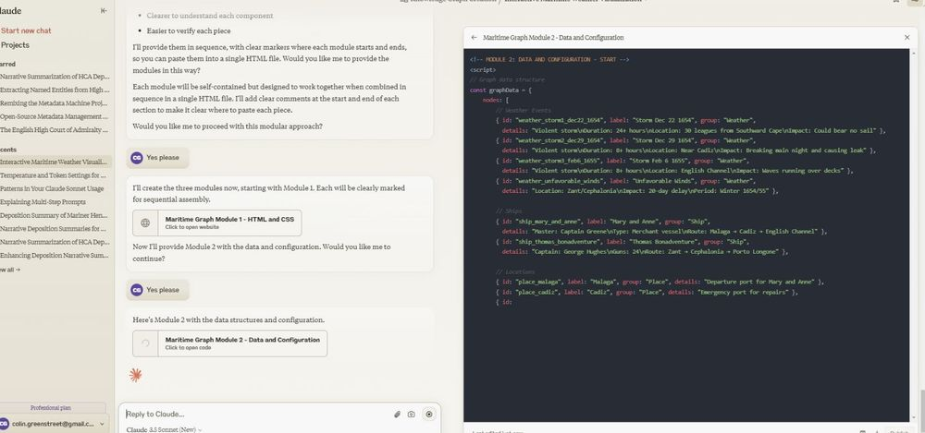

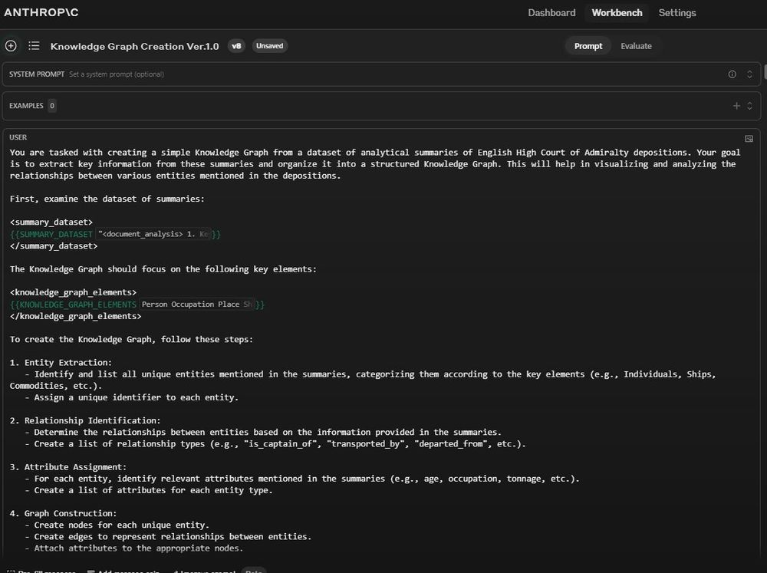

2

[[](https://bsky.app/profile/marinelives.bsky.social)](https://bsky.app/profile/marinelives.bsky.social)

[· 11mo](https://bsky.app/profile/marinelives.bsky.social/post/3la2hu7wx4j2p)

This analytical sumamry is totally accurate. Using Anthropic developer console. Not fine-tuned to Early Modern English. Extraordinary. It creates chronologies, does named entity analysis, correctly identifies the proctor. Makes interesting comments on literacy/language skills

[@tedunderwood.me](https://bsky.app/profile/did:plc:565ebob5f6hw33hjdkxty6qj)

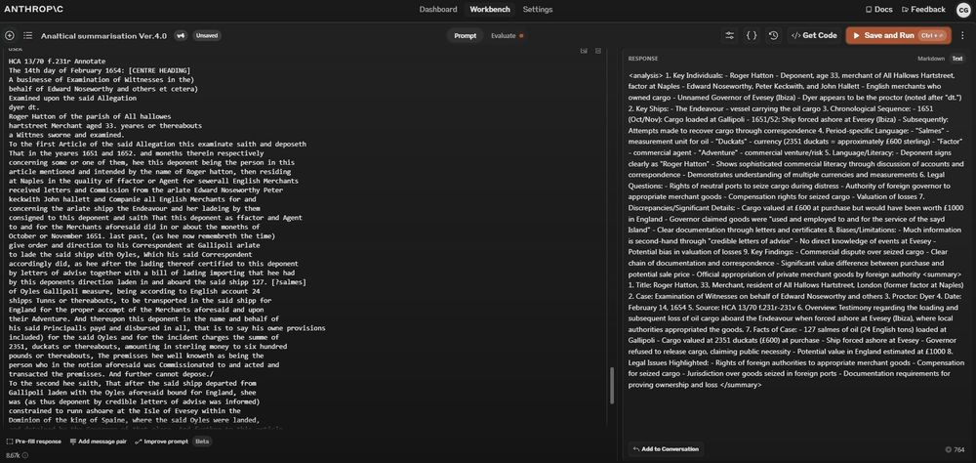

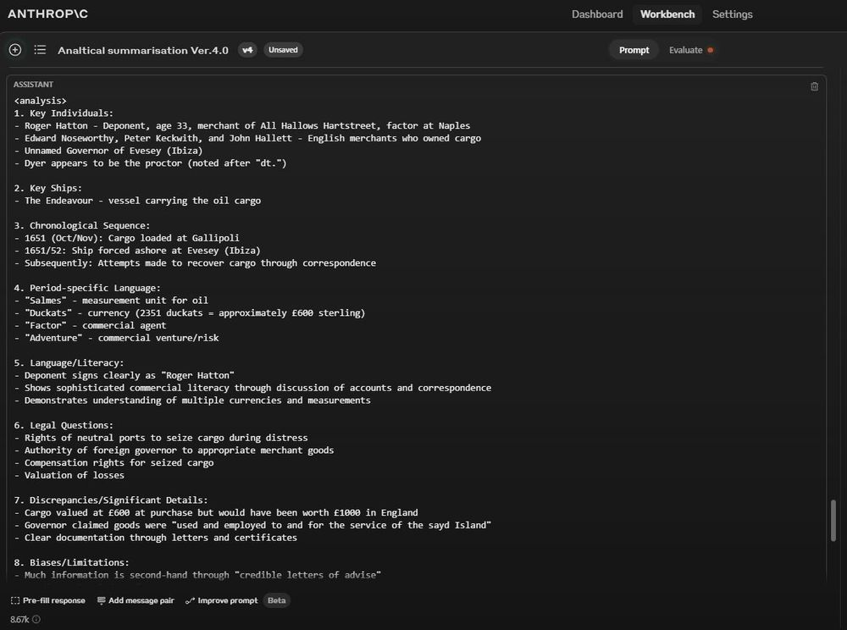

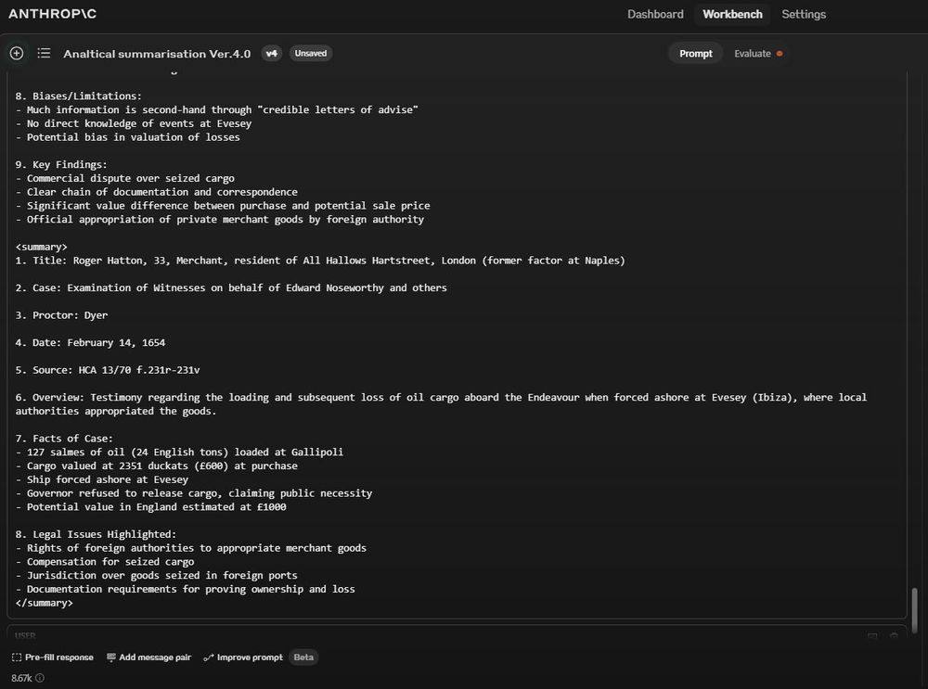

2

[[](https://bsky.app/profile/marinelives.bsky.social)](https://bsky.app/profile/marinelives.bsky.social)

[· 11mo](https://bsky.app/profile/marinelives.bsky.social/post/3l7xmahm4aq2p)

Does anyone fancy giving me some feedback on a short narrative form of summarization for C17th High Court of Admiralty depositions before I press a button and generate 1000 of them? Link here to five summary examples: [claude.site/artifacts/d4...](https://claude.site/artifacts/d443ea9f-b01f-4503-bc1b-a59ead88479d) Link to editorial policy: [claude.site/artifacts/fe...](https://claude.site/artifacts/fed35fad-c341-4bb8-98af-a46fcfbec8a0)

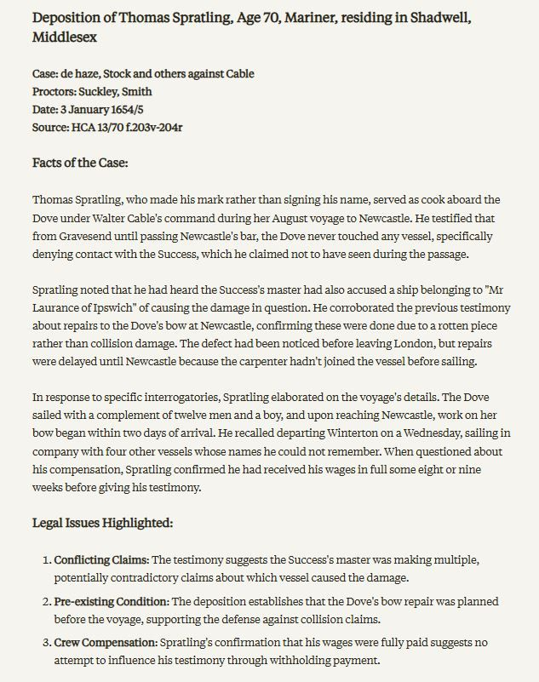

1

[[](https://bsky.app/profile/marinelives.bsky.social)](https://bsky.app/profile/marinelives.bsky.social)

[· 01/11/2024](https://bsky.app/profile/marinelives.bsky.social/post/3l7utk2fjko2m)

Just tried Claude Sonnet 3.5's ability to sumamrize C17th legal depositions from the High Court of Admiralty with a simple prompt: "Summarize the facts in this deposition from the High Court of Admiralty and highlight any legal issues". Accurate and a very useful format. [#earlymodern](https://bsky.app/hashtag/earlymodern) [#Skystorians](https://bsky.app/hashtag/Skystorians)

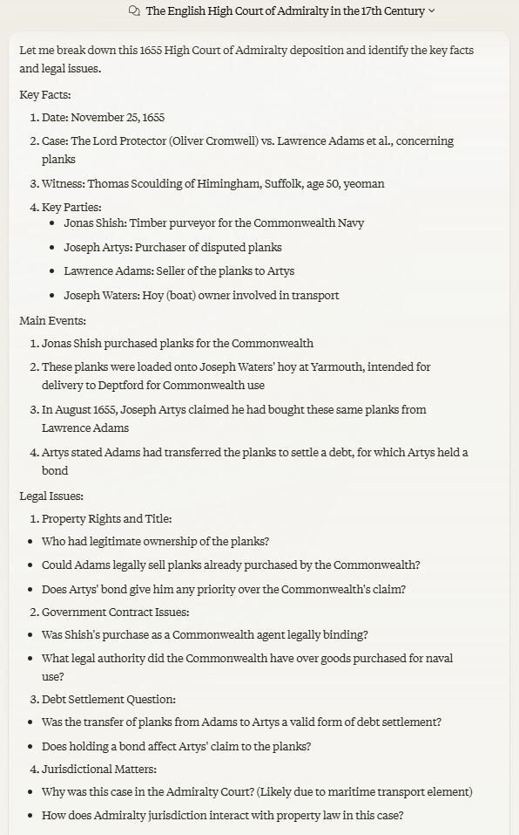

[[](https://bsky.app/profile/marinelives.bsky.social)](https://bsky.app/profile/marinelives.bsky.social)

[· 01/11/2024](https://bsky.app/profile/marinelives.bsky.social/post/3l7us7sn4gi2d)

ChatGPT 4o has introduced new functionality to make its sourcing for a specific answer clearer. Delighted to see a MarineLives article on the High Court of Admiralty is being accessed from humanities commons

[@thiagokrause.bsky.social](https://bsky.app/profile/did:plc:m6ub6fozxlo3gzqn2rayoiwy)

[@timhitchcock.bsky.social](https://bsky.app/profile/did:plc:zazpgix5w4ldyytazeqzytmz)

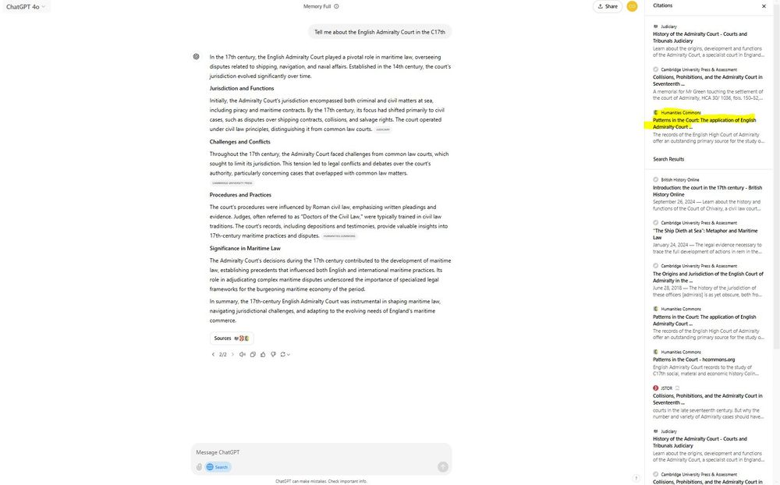

1

[[](https://bsky.app/profile/marinelives.bsky.social)](https://bsky.app/profile/marinelives.bsky.social)

[· 30/10/2024](https://bsky.app/profile/marinelives.bsky.social/post/3l7q5mshum22z)

I am working on a resource for non-coding historians to explore machine learning and its varied potential applications to academic historical research (research specifically rather than writing and publication). Let me know if you would like access and be prepared to give feedback.

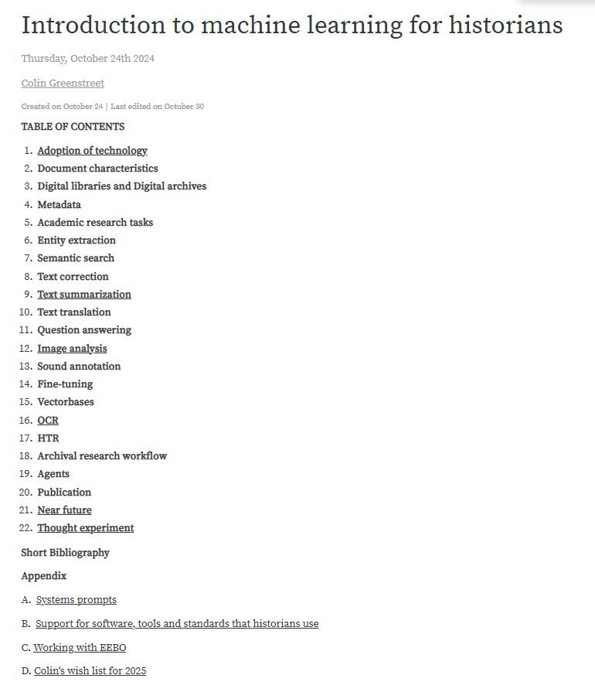

1

[[](https://bsky.app/profile/marinelives.bsky.social)](https://bsky.app/profile/marinelives.bsky.social)

[· 28/10/2024](https://bsky.app/profile/marinelives.bsky.social/post/3l7lcdgklyk2z)

Which summary do you prefer of a C17th mariner's deposition? The first is by Gemini 1.5 Pro. The second is by ChatGPT-4o. Both are factually accurate. I used the same prompt for both & provided the full unmodernized transcription. But ChatGPT4o has embedded memories of my summarization preferences.

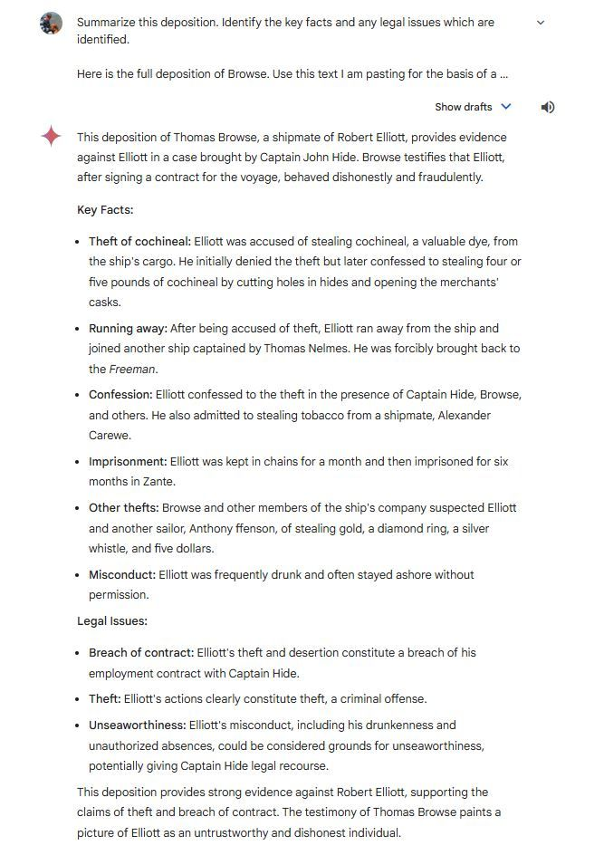

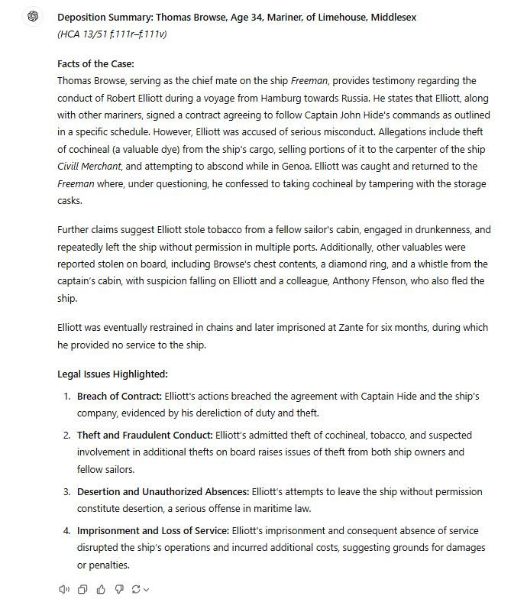

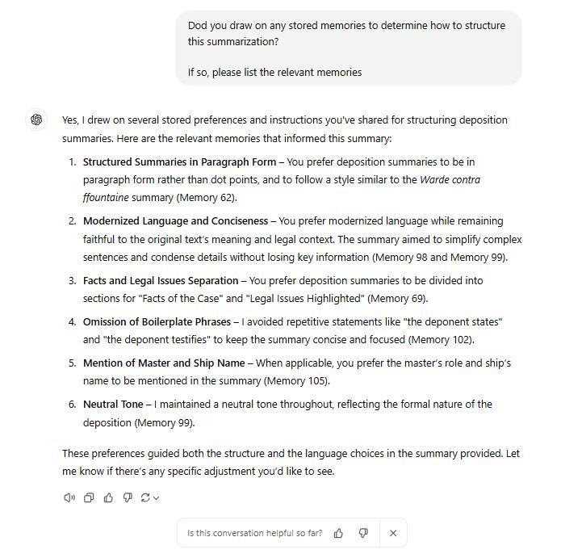

[[](https://bsky.app/profile/marinelives.bsky.social)](https://bsky.app/profile/marinelives.bsky.social)

[· 28/10/2024](https://bsky.app/profile/marinelives.bsky.social/post/3l7lb75vqqy27)

I'm working on a Google NotebookLM which will be publicly shareable & will contain 20 volumes of High Court of Admiralty depositions which can be interrogated within the Notebook. The quality of the data extraction & answering is exceptional. See this "on the fly index" of HCA 13/51 depositions.

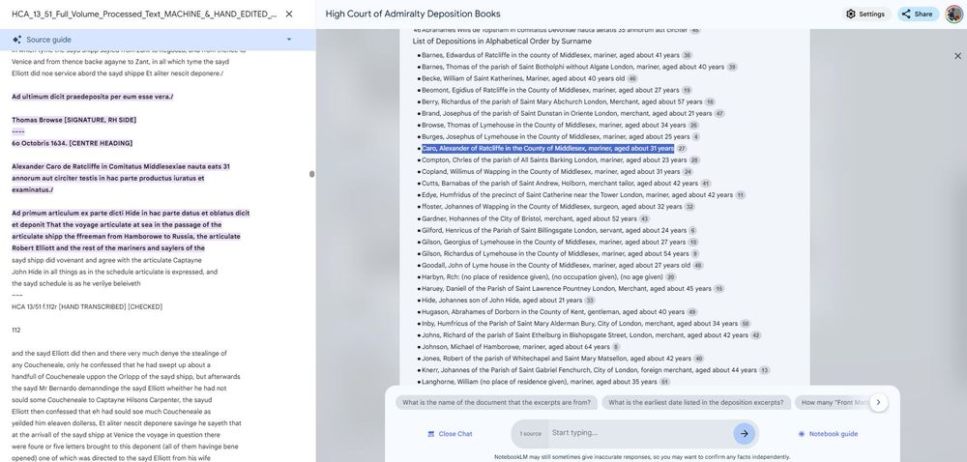

[[](https://bsky.app/profile/marinelives.bsky.social)](https://bsky.app/profile/marinelives.bsky.social)

[· 24/10/2024](https://bsky.app/profile/marinelives.bsky.social/post/3l7bkymr3es26)

ChatGPT-4o with its memory enabled makes a very useful assistant when you are learning a new skill. I have been working on a demo Pinecone vectorbase these last three days and my assistant has codified its intersessional memory of my preferences

[@tedunderwood.me](https://bsky.app/profile/did:plc:565ebob5f6hw33hjdkxty6qj)

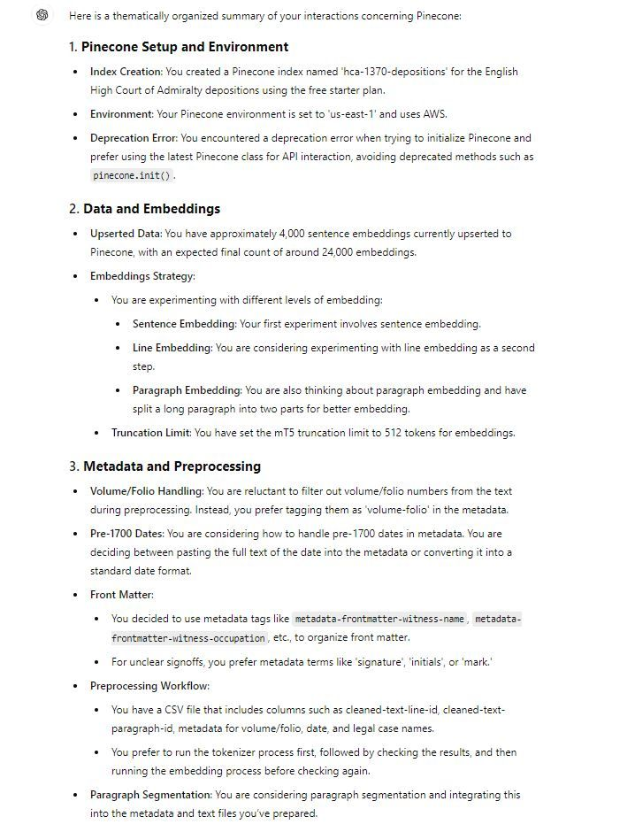

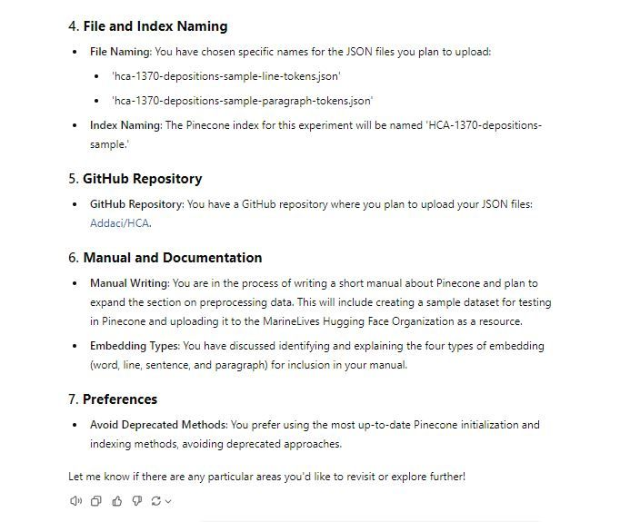

[[](https://bsky.app/profile/marinelives.bsky.social)](https://bsky.app/profile/marinelives.bsky.social)

[· 24/10/2024](https://bsky.app/profile/marinelives.bsky.social/post/3l7b42uygig26)

No-code historian? That's me. But in four days I have gone from no knowledge of vectorbases for use in historical research to an up and running instance for Admiralty Court records. How did I do this? I had help. Click here for resources: [wandb.ai/colin-greens...](https://wandb.ai/colin-greenstreet-marinelives/huggingface/reports/Introduction-to-Pinecone-vectorbases-for-historians--Vmlldzo5ODExNjY4/edit?draftId=Vmlldzo5ODYzMTU2)

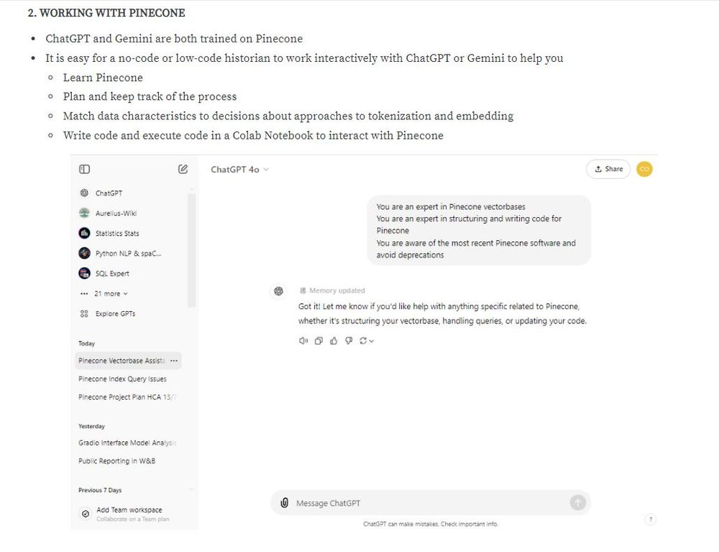

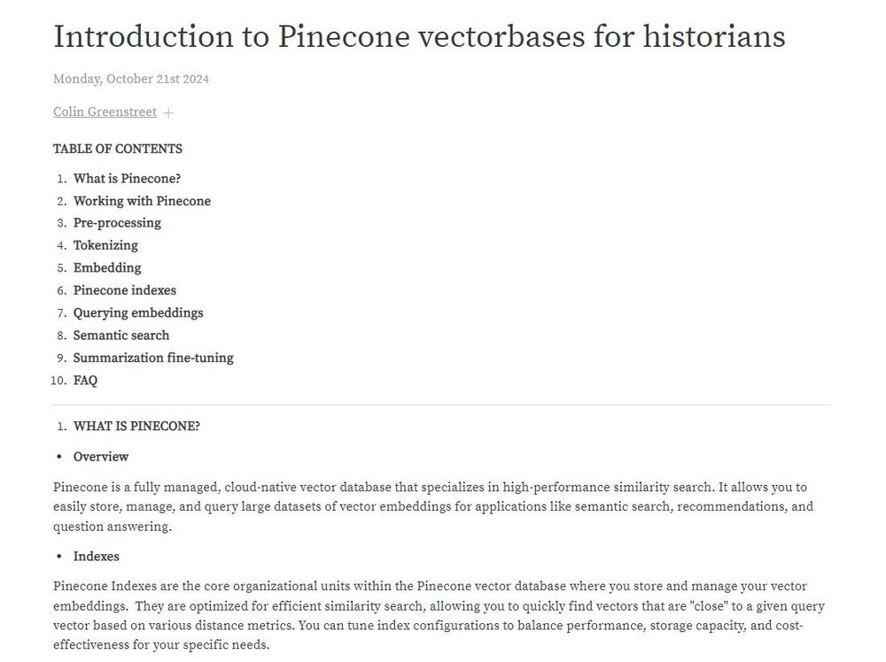

1

1

[[](https://bsky.app/profile/marinelives.bsky.social)](https://bsky.app/profile/marinelives.bsky.social)

[· 18/10/2024](https://bsky.app/profile/marinelives.bsky.social/post/3l6s2u2dgtd2b)

Would love feedback from historians. What research tasks would you like us to explore in future versions of the MarineLives LLM?

[@thiagokrause.bsky.social](https://bsky.app/profile/did:plc:m6ub6fozxlo3gzqn2rayoiwy)

[@anterotesis.bsky.social](https://bsky.app/profile/did:plc:5ea6mwiru6wfle4qzsj5r7td)

[@timhitchcock.bsky.social](https://bsky.app/profile/did:plc:zazpgix5w4ldyytazeqzytmz)

[@jwbaker.bsky.social](https://bsky.app/profile/did:plc:fvq2ectc56unbolhmeymsjfu)

[@tedunderwood.me](https://bsky.app/profile/did:plc:565ebob5f6hw33hjdkxty6qj)

[#earlymodern](https://bsky.app/hashtag/earlymodern) [#Skystorians](https://bsky.app/hashtag/Skystorians)

[[](https://bsky.app/profile/marinelives.bsky.social)](https://bsky.app/profile/marinelives.bsky.social)

[· 18/10/2024](https://bsky.app/profile/marinelives.bsky.social/post/3l6s2p4p3v32b)

The MarineLives team is experimenting with fine-tuning a small multi-lingual large language model to become competent in C17th Early Modern English & Latin. The base model is mT5-small trained on Admiralty Court data. Here is our first very early attempt (Experiment 4) huggingface.co/spaces/Marin...

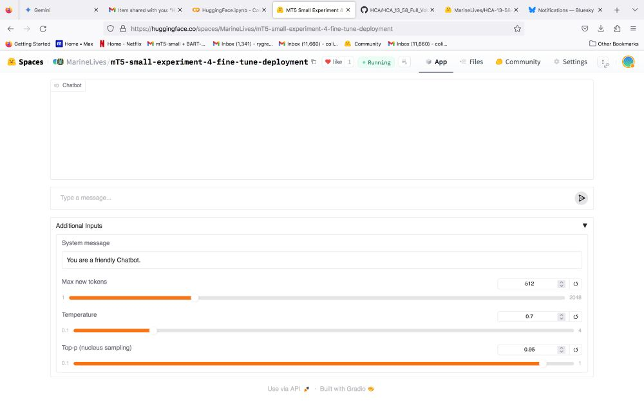

1

[[](https://bsky.app/profile/marinelives.bsky.social)](https://bsky.app/profile/marinelives.bsky.social)

[· 18/10/2024](https://bsky.app/profile/marinelives.bsky.social/post/3l6s2p4p3v32b)

The MarineLives team is experimenting with fine-tuning a small multi-lingual large language model to become competent in C17th Early Modern English & Latin. The base model is mT5-small trained on Admiralty Court data. Here is our first very early attempt (Experiment 4) [huggingface.co/spaces/Marin...](https://huggingface.co/spaces/MarineLives/mT5-small-experiment-4-fine-tune-deployment)



1

[[](https://bsky.app/profile/marinelives.bsky.social)](https://bsky.app/profile/marinelives.bsky.social)

[· 02/10/2024](https://bsky.app/profile/marinelives.bsky.social/post/3l5jmgsrvh223)

I rather like this one. Robert Lowe, master of a ship bound from Archangel in Russia to London. So overcome with drincke that at prayers he had to had the prayer book to another to read it aloud! [HCA 13/51 f.280v] [1635] [#earlymodern](https://bsky.app/hashtag/earlymodern) [#skystorian](https://bsky.app/hashtag/skystorian)

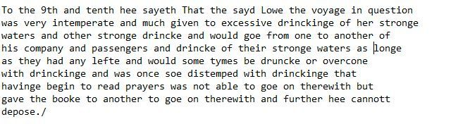

1

1

[[](https://bsky.app/profile/marinelives.bsky.social)](https://bsky.app/profile/marinelives.bsky.social)

[· 23/09/2024](https://bsky.app/profile/marinelives.bsky.social/post/3l4tjgbuinu2k)

1/2 Mr Harrogates Monkey (1642): "a certaine wilde beaste comonlye called or knowen by the name of an ape Munkye or baboone" (runs across six ships in the River Thames, enters cook room, bites 18 year old apprentice of Mr Lee, master of the Good Successe)

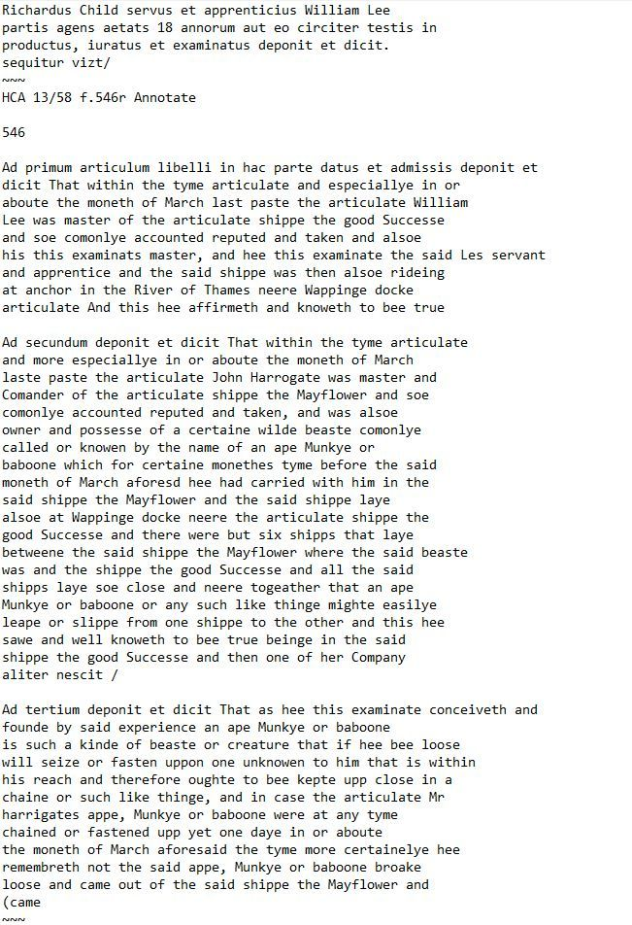

2

1

[[](https://bsky.app/profile/marinelives.bsky.social)](https://bsky.app/profile/marinelives.bsky.social)

[· 23/09/2024](https://bsky.app/profile/marinelives.bsky.social/post/3l4tjjakijk2h)

2/2 Witness statement of Richard Child, 18 years of age: 6 weeks under tha hands of the surgeon after a vicious bite by an out of control ape, monkey or baboon [#skystorians](https://bsky.app/hashtag/skystorians) [#earlymodern](https://bsky.app/hashtag/earlymodern)

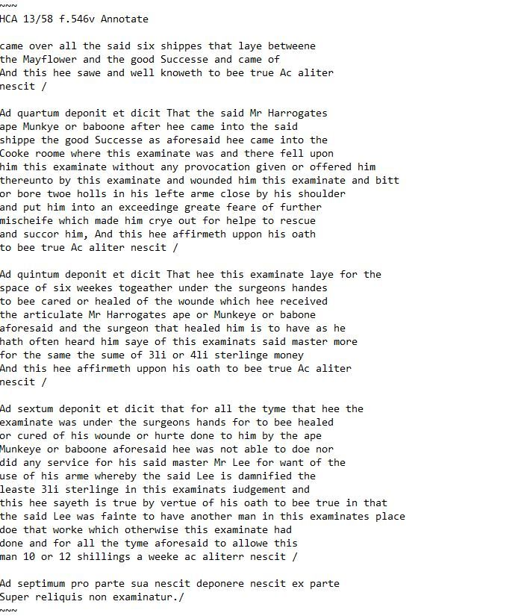

[[](https://bsky.app/profile/marinelives.bsky.social)](https://bsky.app/profile/marinelives.bsky.social)

[· 23/09/2024](https://bsky.app/profile/marinelives.bsky.social/post/3l4sv5yopdh2c)

This looks fascinating. I'm especially looking forward to reading about the use of South and Central American dye woods

[[](https://bsky.app/profile/ecurrie.bsky.social)](https://bsky.app/profile/ecurrie.bsky.social)

[· 11mo](https://bsky.app/profile/ecurrie.bsky.social/post/3l4stguo7q22n)

Published last week, 'A Revolution in Colour', edited by Hayward/Riello/Rublack, including chapters on red and black clothing and dyes. #earlymodern #fashionhistory www.bloomsbury.com/uk/revolutio...

[[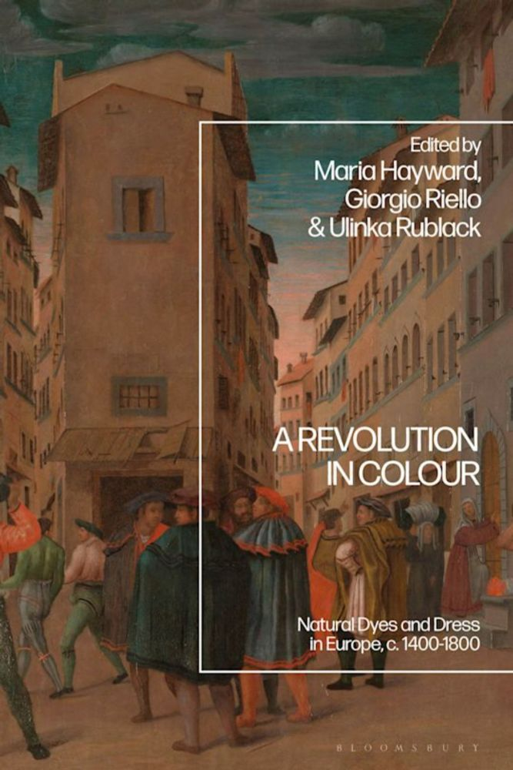](https://www.bloomsbury.com/uk/revolution-in-colour-9781350405622/)](https://www.bloomsbury.com/uk/revolution-in-colour-9781350405622/" \t "_blank)

**[A Revolution in Colour](https://www.bloomsbury.com/uk/revolution-in-colour-9781350405622/" \t "_blank)**

[This major volume aims to re-colour the European world of dress, c.1300-1800. New dyes created one of the most important visual experiences of the period, yet t…](https://www.bloomsbury.com/uk/revolution-in-colour-9781350405622/" \t "_blank)

[www.bloomsbury.com](https://www.bloomsbury.com/uk/revolution-in-colour-9781350405622/" \t "_blank)

[[](https://bsky.app/profile/marinelives.bsky.social)](https://bsky.app/profile/marinelives.bsky.social)

[· 21/09/2024](https://bsky.app/profile/marinelives.bsky.social/post/3l4nrdyt7hq2n)

1/ I have never coded. I have never designed a game. This morning in 90 minutes, working with ChatGPT4 oi preview, I designed a transcription editing word game, wrote, tested, & refined code, &have a working browser based game to train MarineLives volunteers. Want to try it? [#ml](https://bsky.app/hashtag/ml) [#earlymodern](https://bsky.app/hashtag/earlymodern)

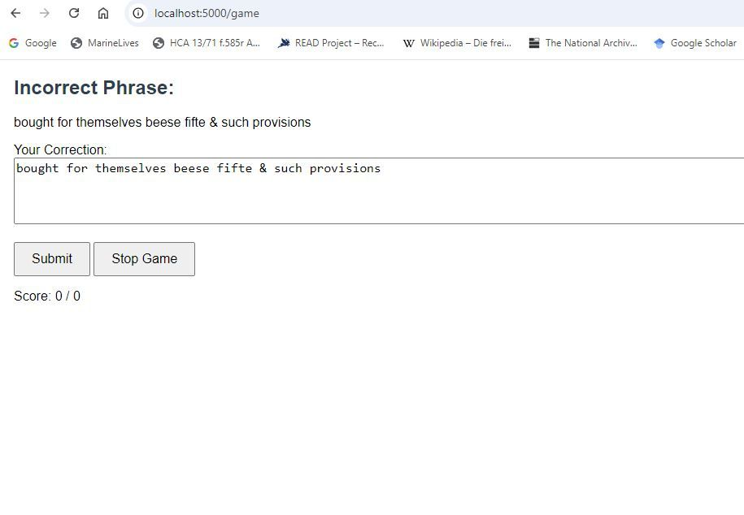

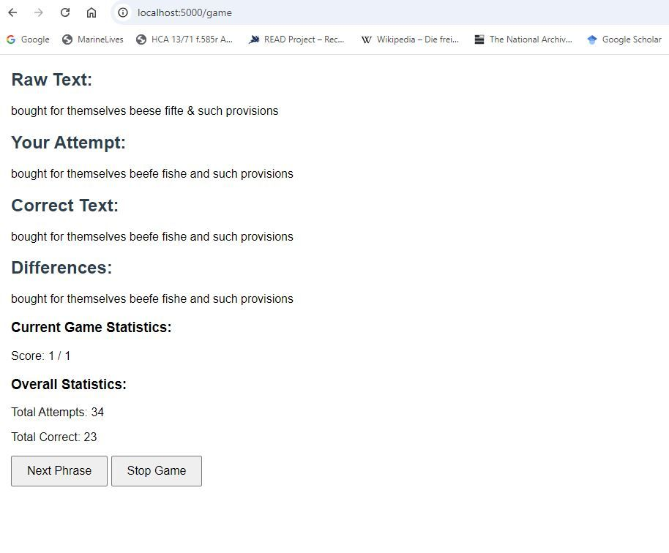

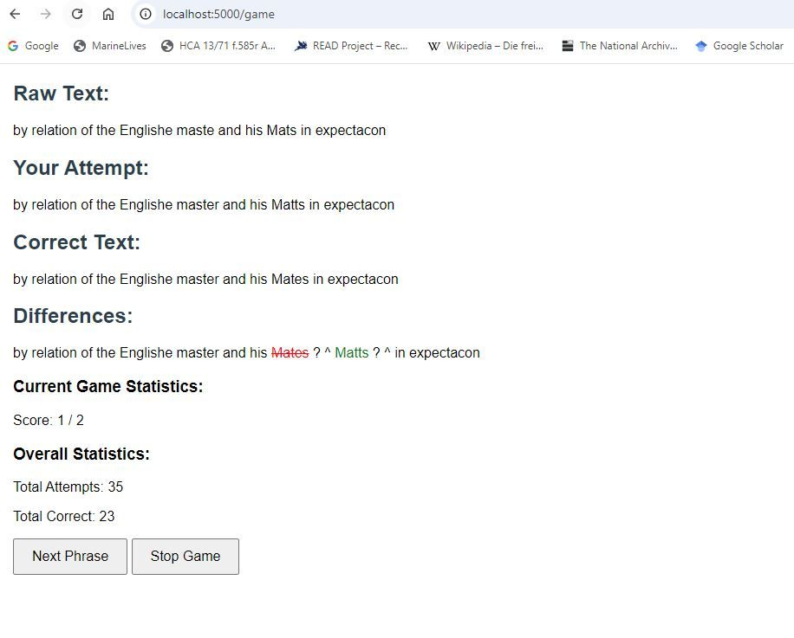

2

2

[View full thread](https://bsky.app/profile/did:plc:3haql47cl6jucf32mlqtre4p/post/3l4nrdyt7hq2n)

[[](https://bsky.app/profile/marinelives.bsky.social)](https://bsky.app/profile/marinelives.bsky.social)

[· 21/09/2024](https://bsky.app/profile/marinelives.bsky.social/post/3l4nujgvf3e2s)

5/ My advisor (ChatGOT oi preview) and I have already discussed potential enhancements (mistake analysis and feedback; multiplayer; mobile app) and an opensource approach to product enhancement. And remember, I DON'T CODE [#ml](https://bsky.app/hashtag/ml)

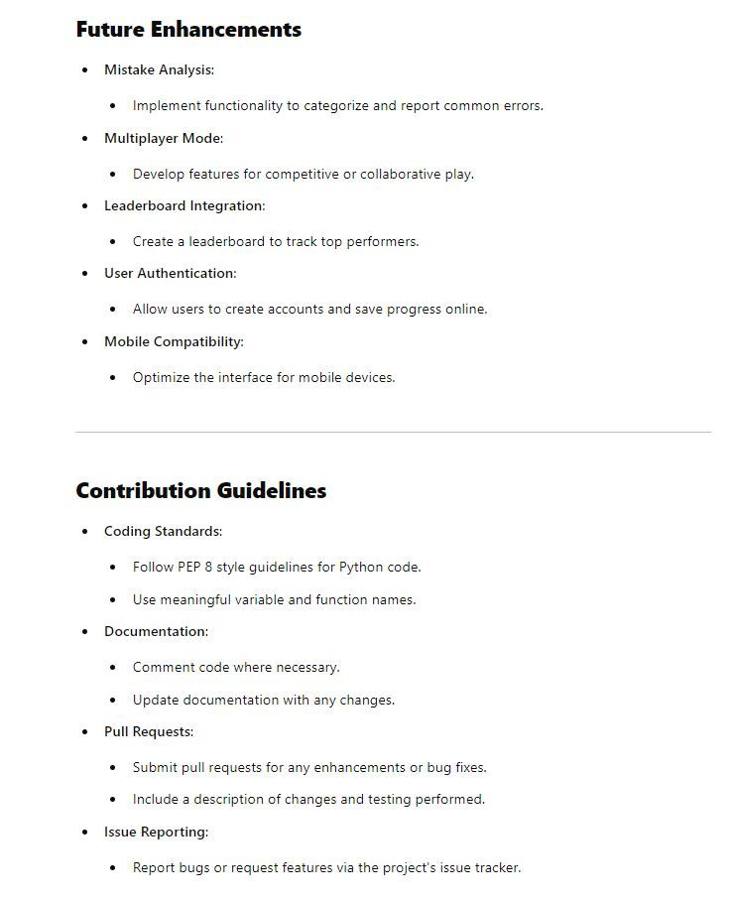

1

[[](https://bsky.app/profile/marinelives.bsky.social)](https://bsky.app/profile/marinelives.bsky.social)

[· 21/09/2024](https://bsky.app/profile/marinelives.bsky.social/post/3l4nyngmxj52g)

6/ I am now working on an enhancement to the MarineLives Transcription Game: Mistake Analysis of answers by MarineLives Volunteers

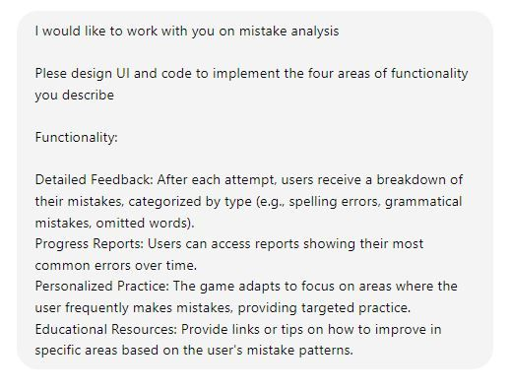

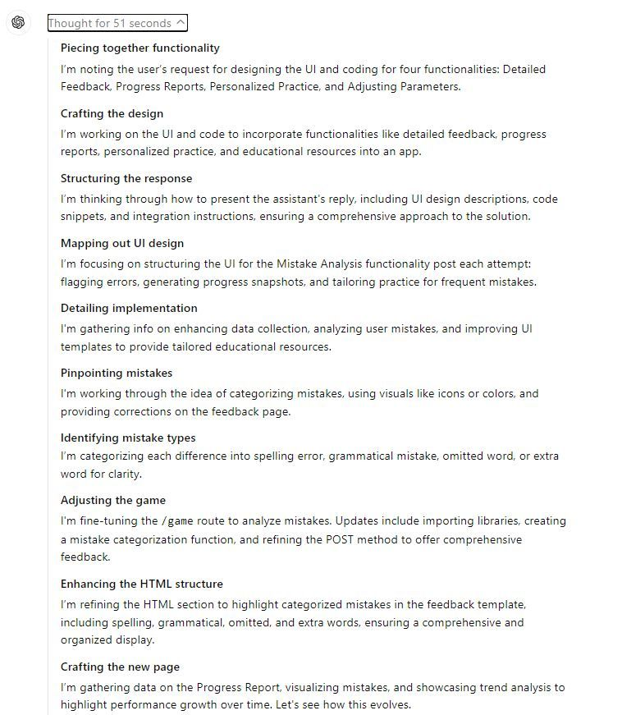

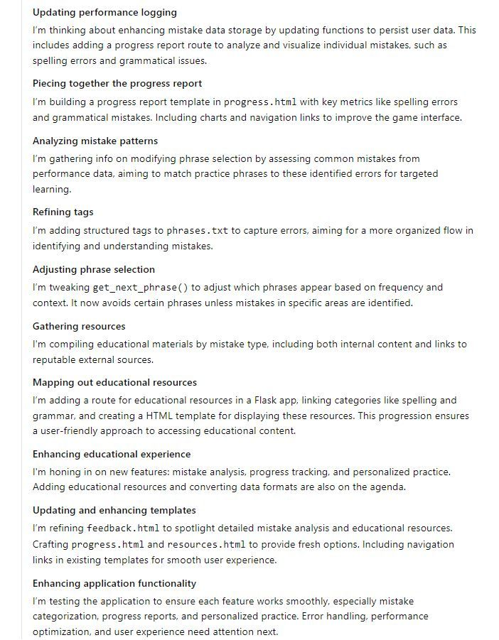

[[](https://bsky.app/profile/marinelives.bsky.social)](https://bsky.app/profile/marinelives.bsky.social)

[· 21/09/2024](https://bsky.app/profile/marinelives.bsky.social/post/3l4nu3qmcey2a)

Ping

[@tedunderwood.me](https://bsky.app/profile/did:plc:565ebob5f6hw33hjdkxty6qj)

[@thiagokrause.bsky.social](https://bsky.app/profile/did:plc:m6ub6fozxlo3gzqn2rayoiwy)

[@timhitchcock.bsky.social](https://bsky.app/profile/did:plc:zazpgix5w4ldyytazeqzytmz)

[@jwbaker.bsky.social](https://bsky.app/profile/did:plc:fvq2ectc56unbolhmeymsjfu)

[@lhaasis.bsky.social](https://bsky.app/profile/did:plc:fncb35b5lcyhvug2ahjjolya)

[@bschmidt.bsky.social](https://bsky.app/profile/did:plc:r36govxkk4hmrcqlrjmbrjtl)

[[](https://bsky.app/profile/marinelives.bsky.social)](https://bsky.app/profile/marinelives.bsky.social)

[· 21/09/2024](https://bsky.app/profile/marinelives.bsky.social/post/3l4nrdyt7hq2n)

1/ I have never coded. I have never designed a game. This morning in 90 minutes, working with ChatGPT4 oi preview, I designed a transcription editing word game, wrote, tested, & refined code, &have a working browser based game to train MarineLives volunteers. Want to try it? #ml #earlymodern







[[](https://bsky.app/profile/marinelives.bsky.social)](https://bsky.app/profile/marinelives.bsky.social)

[· 19/09/2024](https://bsky.app/profile/marinelives.bsky.social/post/3l4jpf72rcj2a)

I have spent the day pretending to be a Large Language Model. Correcting many pages of raw machine transcribed text by predicting the next word purely from deep lingusitic knowledge of Admiralty depositions. Extraordinarily this has greatly improved my hand corrections

[@tedunderwood.me](https://bsky.app/profile/did:plc:565ebob5f6hw33hjdkxty6qj)

1

[View full thread](https://bsky.app/profile/did:plc:3haql47cl6jucf32mlqtre4p/post/3l4jpf72rcj2a)

[[](https://bsky.app/profile/marinelives.bsky.social)](https://bsky.app/profile/marinelives.bsky.social)

[· 19/09/2024](https://bsky.app/profile/marinelives.bsky.social/post/3l4jppvoegf2r)

What I am now exploring is whether a small LLM (mT5 [300 mill parameters] can be fine-tuned with Admiralty COurt data [we have up to 4 mill words] to achieve similar results to me, and to achieve the extraordinary Latin capabilities of GPT-4o

1

[[](https://bsky.app/profile/marinelives.bsky.social)](https://bsky.app/profile/marinelives.bsky.social)

[· 19/09/2024](https://bsky.app/profile/marinelives.bsky.social/post/3l4jw6dz5dg2p)

The other challenge I have

[@tedunderwood.me](https://bsky.app/profile/did:plc:565ebob5f6hw33hjdkxty6qj)

ideas? Is how to build in an intersessional 'memory file' similar to what GPT-4o now has per user, essentially a rolling configuration file, which can shappe the small LLM output [#ml](https://bsky.app/hashtag/ml)

[[](https://bsky.app/profile/marinelives.bsky.social)](https://bsky.app/profile/marinelives.bsky.social)

[· 19/09/2024](https://bsky.app/profile/marinelives.bsky.social/post/3l4iizghacu2w)

1/ I am work iteratively and meticulously with GPT-4o to create an assistant to support volunteers cleaning up raw HTR text of Admiralty Court records. Using GPT-4o's ability to create memories of my requirements which last between sessions [#skystorians](https://bsky.app/hashtag/skystorians) [#earlymodern](https://bsky.app/hashtag/earlymodern)

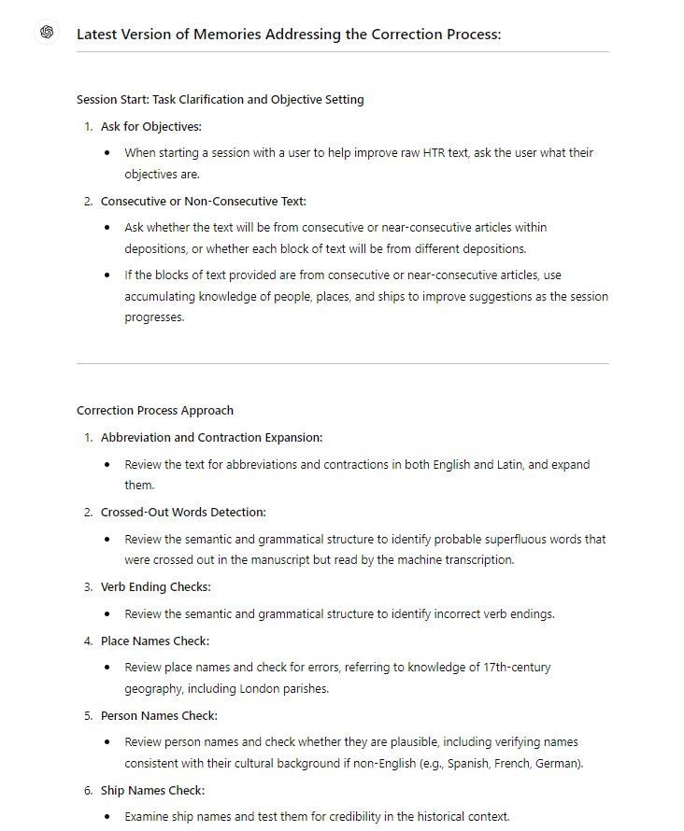

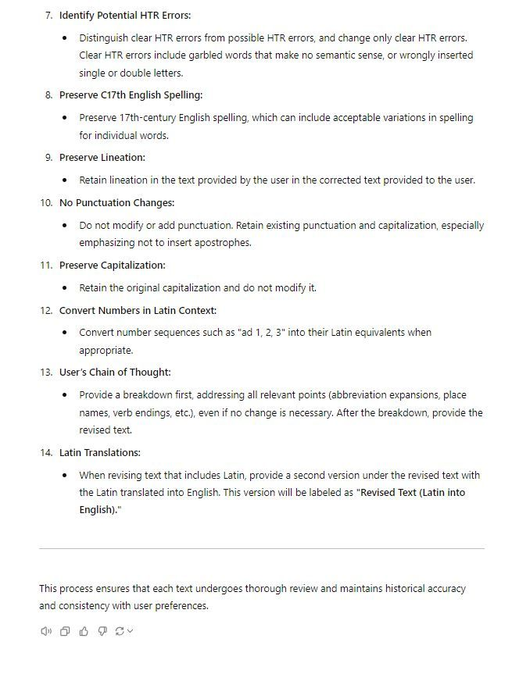

1

1

[View full thread](https://bsky.app/profile/did:plc:3haql47cl6jucf32mlqtre4p/post/3l4iizghacu2w)

[[](https://bsky.app/profile/marinelives.bsky.social)](https://bsky.app/profile/marinelives.bsky.social)

[· 19/09/2024](https://bsky.app/profile/marinelives.bsky.social/post/3l4ik4ub7mo2m)

6/ I have opened a new chat to check whether my broad process instructions are working, with GPT4o primed to ask me about the nature of the task

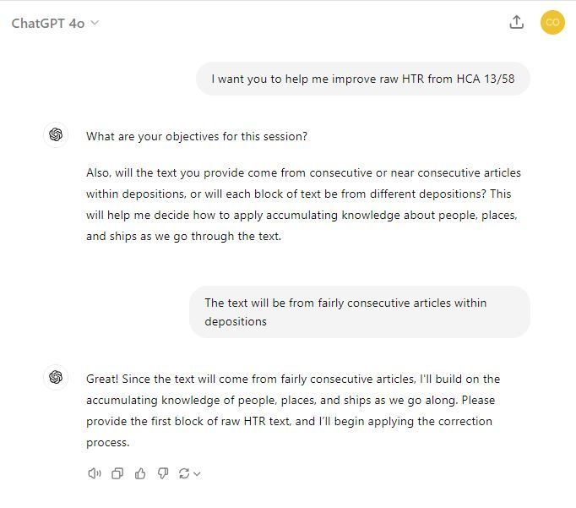

1

[[](https://bsky.app/profile/marinelives.bsky.social)](https://bsky.app/profile/marinelives.bsky.social)

[· 19/09/2024](https://bsky.app/profile/marinelives.bsky.social/post/3l4ikecqccn23)

7/ I pasted the same text from the previous chat and the result in the Revised Text (Latin into English) was better. Kept to the original lineation, but some modernisation of English spelling has slipped in

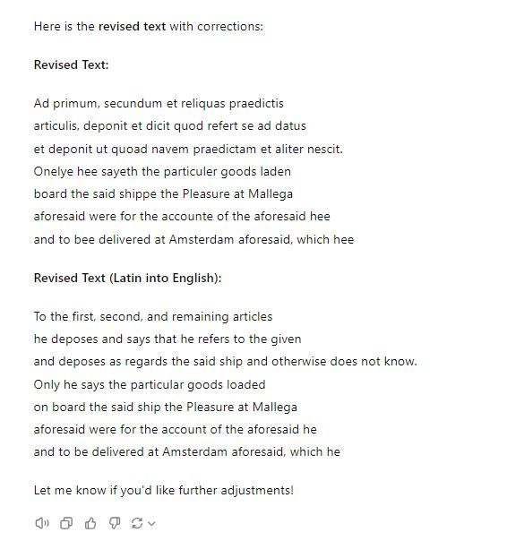

[[](https://bsky.app/profile/marinelives.bsky.social)](https://bsky.app/profile/marinelives.bsky.social)

[· 17/09/2024](https://bsky.app/profile/marinelives.bsky.social/post/3l4dxk73bin2a)

1/2 Food for thought. LLMs are here to stay. Historians & Archivists (in my opinion) need to get their authored material (I do everything CCBY4.0 but others may differ) together with primary & secondary sources for the world's languages and culture into training sets [#skystorians](https://bsky.app/hashtag/skystorians)

[@tedunderwood.me](https://bsky.app/profile/did:plc:565ebob5f6hw33hjdkxty6qj)

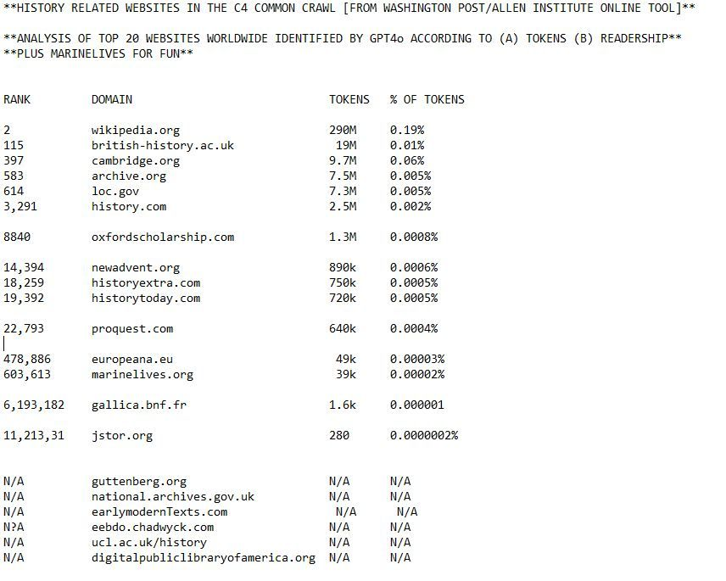

1

[[](https://bsky.app/profile/marinelives.bsky.social)](https://bsky.app/profile/marinelives.bsky.social)

[· 17/09/2024](https://bsky.app/profile/marinelives.bsky.social/post/3l4dxpmygrh2a)

2/2 [Marinelives.org](https://marinelives.org/) has only 10,000 fewer tokens than [europeana.eu](https://europeana.eu/) in the Common Crawl (C4) dataset used by Google & Meta. [Gallica.bnf.fr](https://gallica.bnf.fr/) has 5% of the MarineLives tokens [we actually have 5 mill available to crawl]. JSTOR has 280 tokens!! [Nationalarchives.gov.uk](https://nationalarchives.gov.uk/) = 0

[@timhitchcock.bsky.social](https://bsky.app/profile/did:plc:zazpgix5w4ldyytazeqzytmz)

**[https://Marinelives.org](https://marinelives.org/" \t "_blank)**

[marinelives.org](https://marinelives.org/" \t "_blank)

1

[[](https://bsky.app/profile/marinelives.bsky.social)](https://bsky.app/profile/marinelives.bsky.social)

[· 17/09/2024](https://bsky.app/profile/marinelives.bsky.social/post/3l4dxwvar542p)

3/3 There is a strong argument that the worlds archives, digital projects, & principal publishing houses [all languages, not just English] should get to gether & create a history dataset for licensing to LLM creators, including (crucially) archival and library metadata

[@timhitchcock.bsky.social](https://bsky.app/profile/did:plc:zazpgix5w4ldyytazeqzytmz)

1

[[](https://bsky.app/profile/marinelives.bsky.social)](https://bsky.app/profile/marinelives.bsky.social)

[· 17/09/2024](https://bsky.app/profile/marinelives.bsky.social/post/3l4dtthdwyk2w)

Interesting that Google's C4 dataset used to train a range of Large Language Models, including Google's T5 and Meta's LLaMA includes content from British History OnLine. Good news for historians in my view

[@anterotesis.bsky.social](https://bsky.app/profile/did:plc:5ea6mwiru6wfle4qzsj5r7td)

[www.washingtonpost.com/technology/i...](https://www.washingtonpost.com/technology/interactive/2023/ai-chatbot-learning/)

[[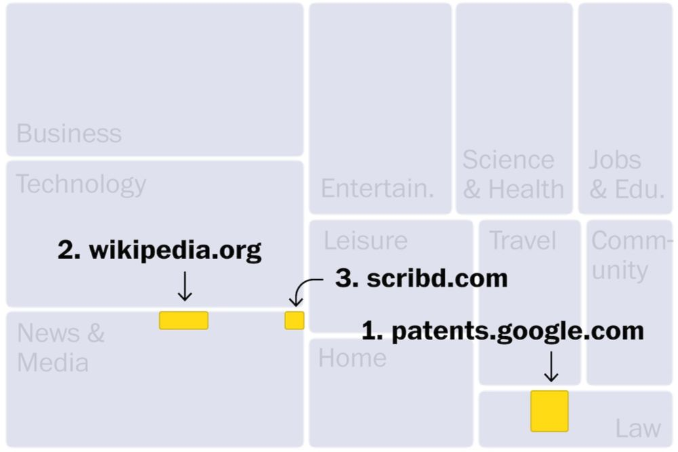](https://www.washingtonpost.com/technology/interactive/2023/ai-chatbot-learning/)](https://www.washingtonpost.com/technology/interactive/2023/ai-chatbot-learning/" \t "_blank)

**[Inside the secret list of websites that make AI like ChatGPT sound smart](https://www.washingtonpost.com/technology/interactive/2023/ai-chatbot-learning/" \t "_blank)**

[An analysis of a chatbot data set by The Washington Post reveals the proprietary, personal, and often offensive websites that go into an AI’s training data.](https://www.washingtonpost.com/technology/interactive/2023/ai-chatbot-learning/" \t "_blank)

[www.washingtonpost.com](https://www.washingtonpost.com/technology/interactive/2023/ai-chatbot-learning/" \t "_blank)

1

2

[[](https://bsky.app/profile/marinelives.bsky.social)](https://bsky.app/profile/marinelives.bsky.social)

[· 17/09/2024](https://bsky.app/profile/marinelives.bsky.social/post/3l4dujawbya2b)

2/ The Washington Post article (which was written in late 2023 with the help of the Allen Institute) has a helpful search tool to see if your website is inclied in the c4 dataset. The Guardian is represented by 67% more tokens than the Washington Post@anterotesis.bsky.social

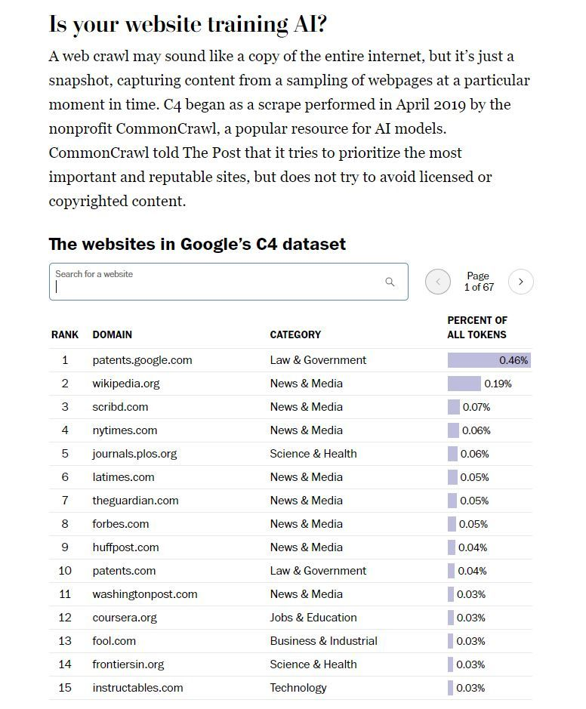

1

1

[[](https://bsky.app/profile/marinelives.bsky.social)](https://bsky.app/profile/marinelives.bsky.social)

[· 17/09/2024](https://bsky.app/profile/marinelives.bsky.social/post/3l4dulrwdqd2x)

3/ I am delighted to see that the MarineLives website has been sraped (all our data are CCBY4.0) though 39k tokens is about 0.5% of our total content

[@anterotesis.bsky.social](https://bsky.app/profile/did:plc:5ea6mwiru6wfle4qzsj5r7td)

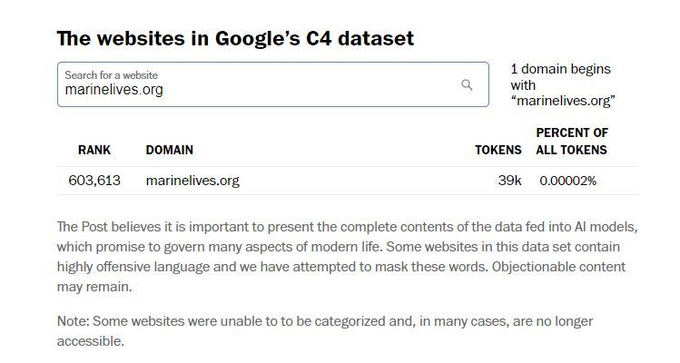

1

[[](https://bsky.app/profile/marinelives.bsky.social)](https://bsky.app/profile/marinelives.bsky.social)

[· 16/09/2024](https://bsky.app/profile/marinelives.bsky.social/post/3l4bkcyxwef2t)

1/3 We are looking for two volunteers to help MarineLives in the next eight weeks. It should be fun & you (and we) will learn a lot. We need 1 masters/early doctoral/CompSci student & 1 expert palaeographer who loves data. Follow this chat to learn more [#machinelearning](https://bsky.app/hashtag/machinelearning) [#CompSci](https://bsky.app/hashtag/CompSci)

[@tedunderwood.me](https://bsky.app/profile/did:plc:565ebob5f6hw33hjdkxty6qj)

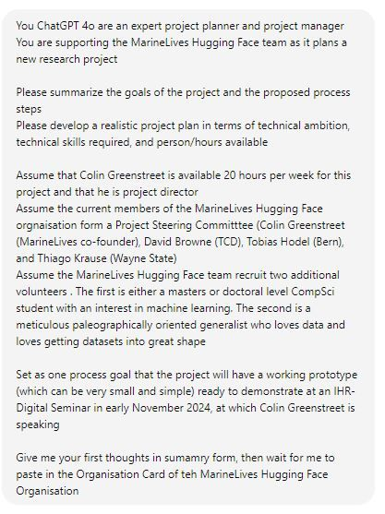

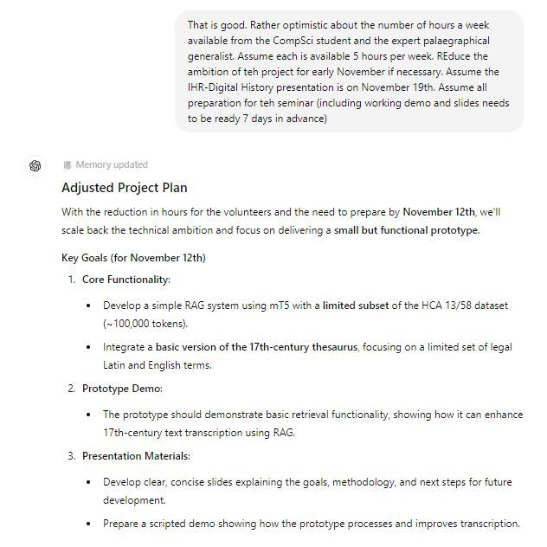

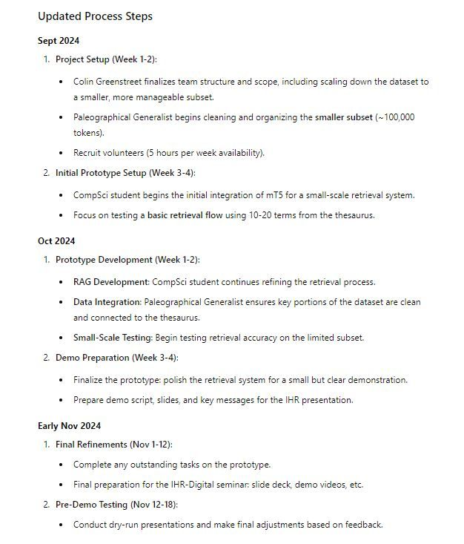

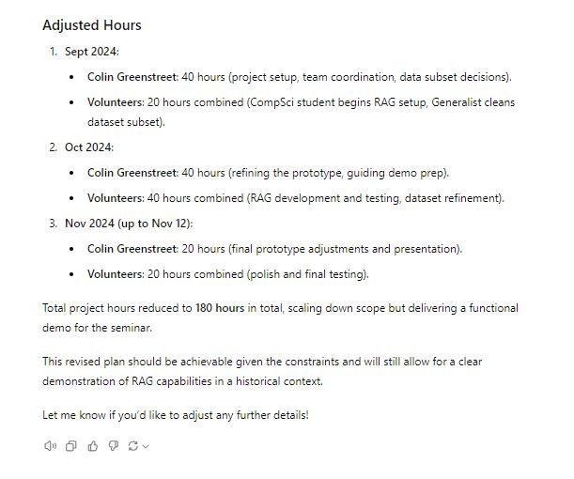

1

[[](https://bsky.app/profile/marinelives.bsky.social)](https://bsky.app/profile/marinelives.bsky.social)

[· 16/09/2024](https://bsky.app/profile/marinelives.bsky.social/post/3l4bksugzub25)

2/3 Here is the revised project plan, dialling down project ambitions and volunteer availability to something I hope may interest you. You can check out the HCA 13/58 volume data (the period 1642-44) here: [huggingface.co/datasets/Mar...](https://huggingface.co/datasets/MarineLives/HCA-13-58-TEXT)



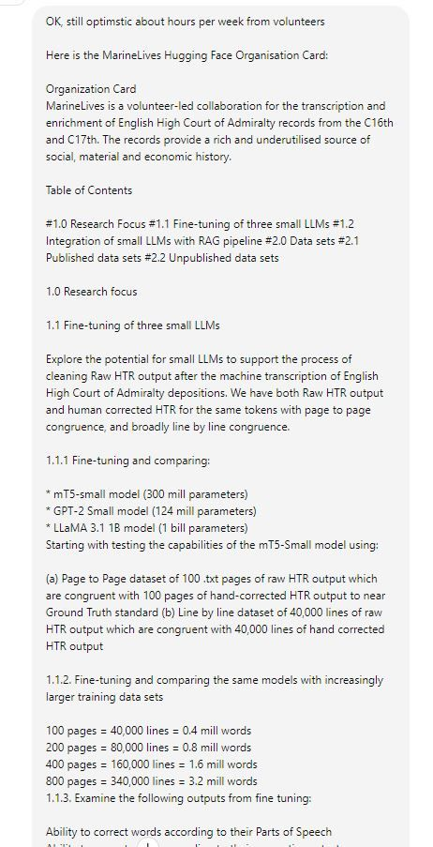

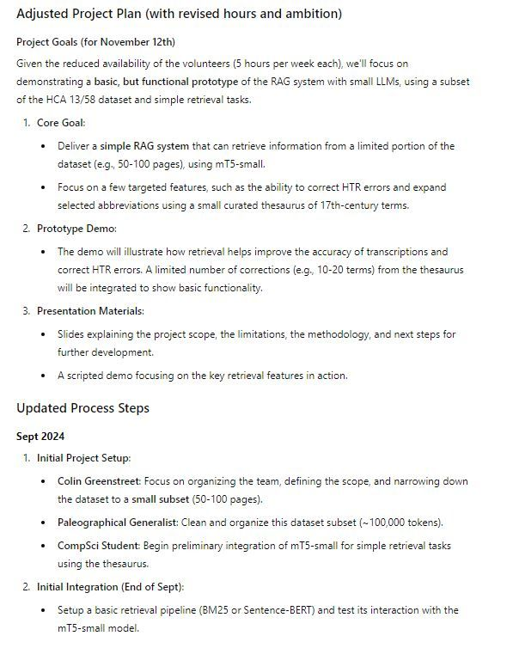

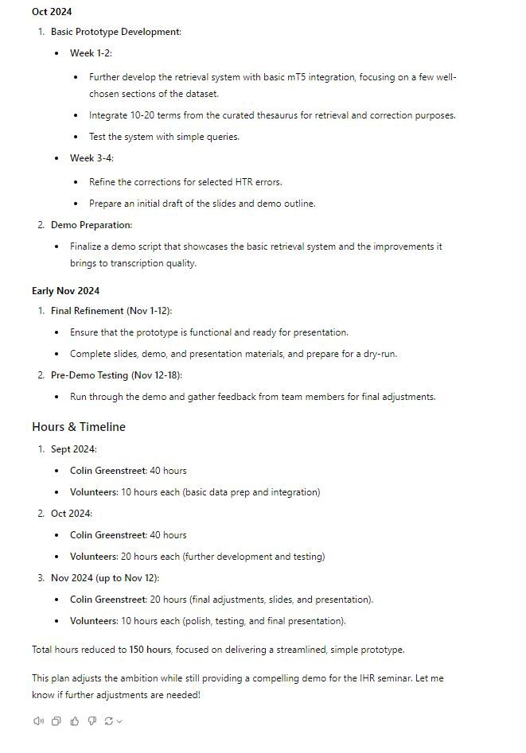

[[](https://bsky.app/profile/marinelives.bsky.social)](https://bsky.app/profile/marinelives.bsky.social)

[· 16/09/2024](https://bsky.app/profile/marinelives.bsky.social/post/3l4bjycci7m2p)

The [#IHR](https://bsky.app/hashtag/IHR) digital history seminar program is now online. I will be speaking on November 19th 2024 about the potential for using LLM (and other AI) tools to support historical research [#machinelearning](https://bsky.app/hashtag/machinelearning) [#earlymodern](https://bsky.app/hashtag/earlymodern) [#sSkystorian](https://bsky.app/hashtag/sSkystorian) [ihrdighist.blogs.sas.ac.uk/2024/09/tues...](https://ihrdighist.blogs.sas.ac.uk/2024/09/tuesday-19-november-2024-colin-greenstreet-ai-agents-for-historical-research-a-new-skill-set-for-historians/)

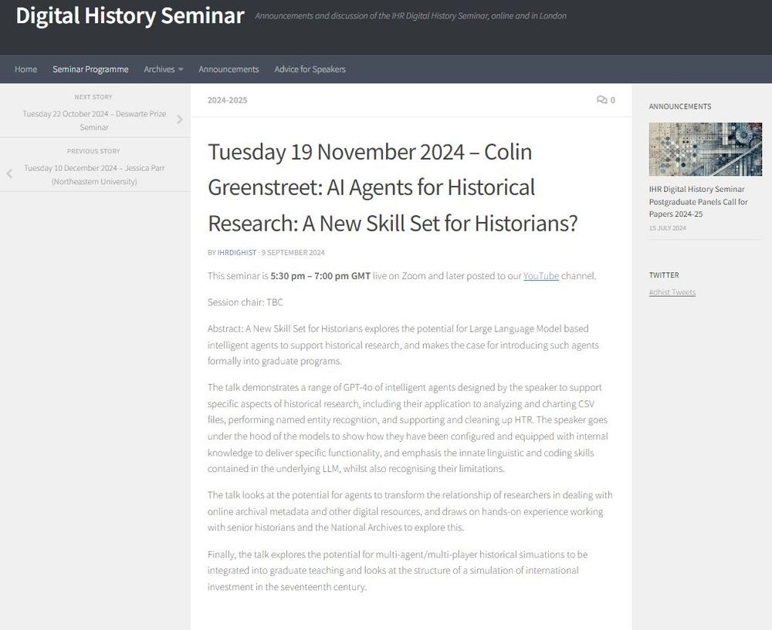

5

[[](https://bsky.app/profile/marinelives.bsky.social)](https://bsky.app/profile/marinelives.bsky.social)

[· 16/09/2024](https://bsky.app/profile/marinelives.bsky.social/post/3l4bitimrnr2n)

The MarineLives team invites masters & doctoral students studying [#CompSci](https://bsky.app/hashtag/CompSci) and [#machinelearning](https://bsky.app/hashtag/machinelearning) to join our Hugging Face organisation. We have great data all for opensource use, and need to strengthen our technical competence to do interesting stuff in the history domain [huggingface.co/MarineLives](https://huggingface.co/MarineLives)

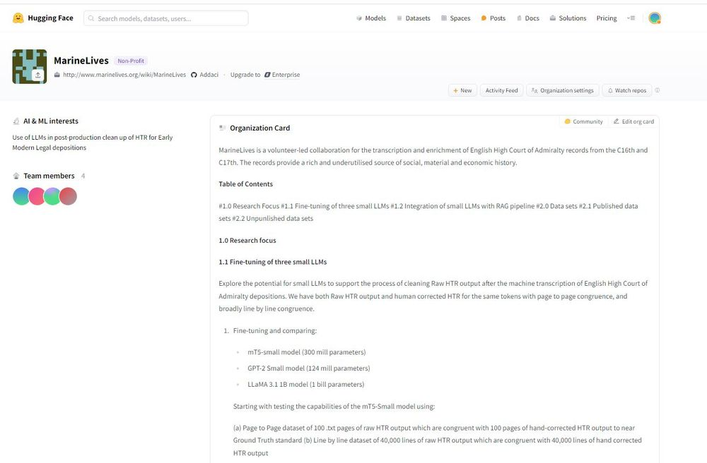

3

[[](https://bsky.app/profile/marinelives.bsky.social)](https://bsky.app/profile/marinelives.bsky.social)

[· 16/09/2024](https://bsky.app/profile/marinelives.bsky.social/post/3l4ayy7iy2f2p)

We are exploring adding a small RAG pipeline to our demo of mT5 (a 300 mill parameter LLM) in the history domain. We will use 600,000 words of text from HCA 13/58 as the content with which to populate the pipeline. This should improve reliability of search & referencing [#machinelearning](https://bsky.app/hashtag/machinelearning)

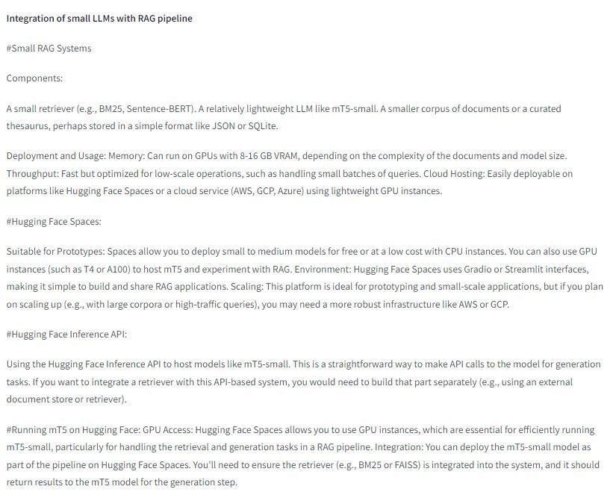

[[](https://bsky.app/profile/marinelives.bsky.social)](https://bsky.app/profile/marinelives.bsky.social)

[· 15/09/2024](https://bsky.app/profile/marinelives.bsky.social/post/3l47qezzy4l2t)

1 of ?/ I am giving a talk in early November to the IHR-Digital Seminar on the potential role of Large Language Models to enhancing historical research techniques. I am exploring how much "historical data" (broadly defined) is out there. Can you help/critique my thinking & help refine my estimates?

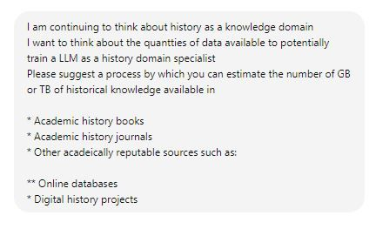

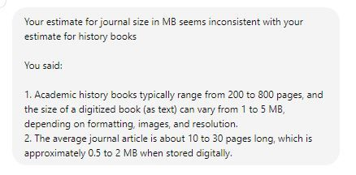

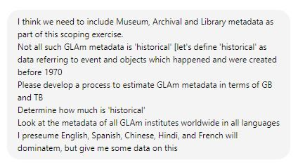

1

2

[View full thread](https://bsky.app/profile/did:plc:3haql47cl6jucf32mlqtre4p/post/3l47qezzy4l2t)

[[](https://bsky.app/profile/marinelives.bsky.social)](https://bsky.app/profile/marinelives.bsky.social)

[· 15/09/2024](https://bsky.app/profile/marinelives.bsky.social/post/3l47ruttdd22k)

4/? I reminded myself what definitions I had suggested, then asked for a summary (very flaky) of what the linguistic distribution of historical data might look like for GLAM metadata

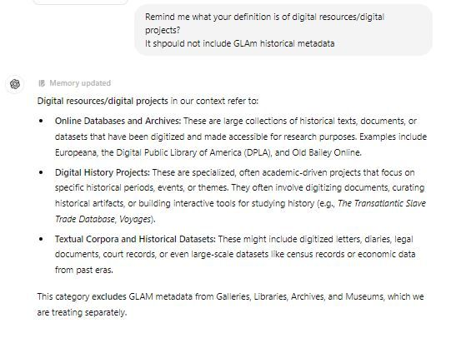

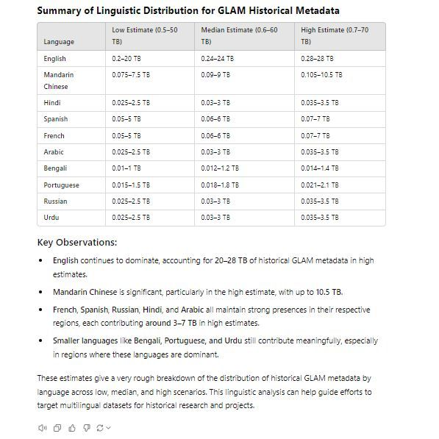

1

[[](https://bsky.app/profile/marinelives.bsky.social)](https://bsky.app/profile/marinelives.bsky.social)

[· 15/09/2024](https://bsky.app/profile/marinelives.bsky.social/post/3l47s2gjyhf2f)

So here is my question to [#skystorians](https://bsky.app/hashtag/skystorians) and [#earlymodern](https://bsky.app/hashtag/earlymodern). Imagine that Clio got together with Midas and came up with unlimited funds (yes, I have been watching Kaos on Netflix) how could you use an LLM trained on the world's history writing, historical records, and historical data?

2

[[](https://bsky.app/profile/marinelives.bsky.social)](https://bsky.app/profile/marinelives.bsky.social)

[· 15/09/2024](https://bsky.app/profile/marinelives.bsky.social/post/3l46inz6gq72a)

We have begun to add specialized datasets to the MarineLives Hugging face site. They are available CCBY4.0 to researchers working on HTR and OCR improvement. So far: Example volume of depositions (HCA 13/58: 1501 pages); small file of text insertion raw text and model answers [#machinelearning](https://bsky.app/hashtag/machinelearning)

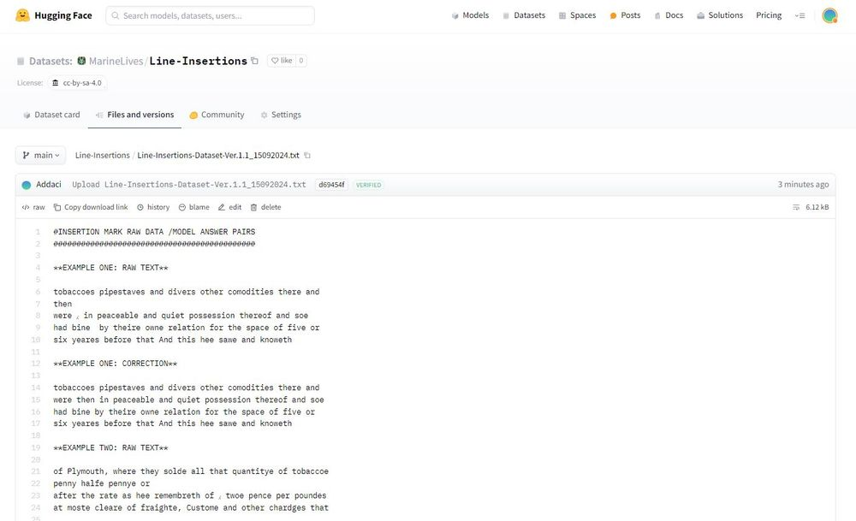

1

[[](https://bsky.app/profile/marinelives.bsky.social)](https://bsky.app/profile/marinelives.bsky.social)

[· 15/09/2024](https://bsky.app/profile/marinelives.bsky.social/post/3l47dgb2ci62a)

Three more data sets: [huggingface.co/MarineLives](https://huggingface.co/MarineLives)

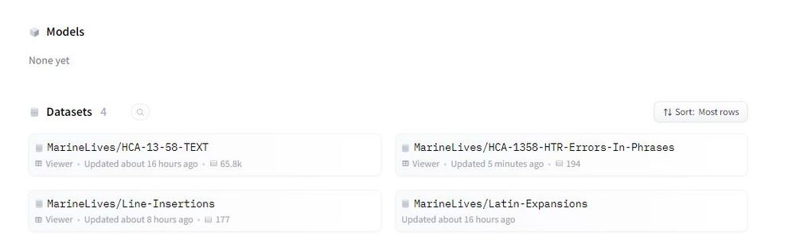

1

[[](https://bsky.app/profile/marinelives.bsky.social)](https://bsky.app/profile/marinelives.bsky.social)

[· 15/09/2024](https://bsky.app/profile/marinelives.bsky.social/post/3l47eqcyx6x2p)

Here is the link to the Latin abbreviations & expansions file: [huggingface.co/datasets/Mar...](https://huggingface.co/datasets/MarineLives/Latin-Expansions/blob/main/Latin_Abbreviations_Contractions_Expansions_Ver.1.0_15092025.txt)

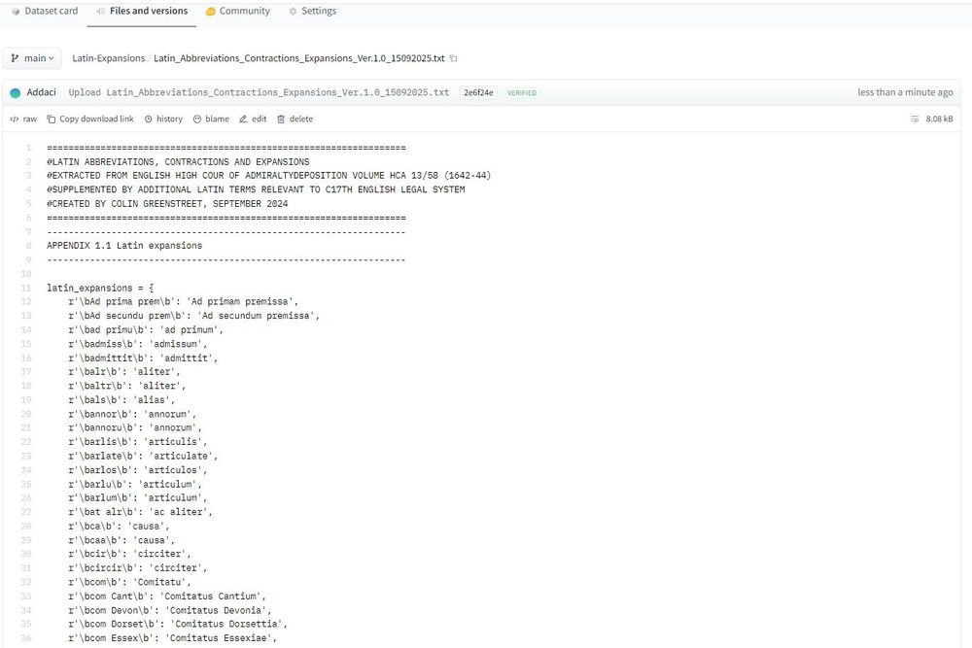

[[](https://bsky.app/profile/marinelives.bsky.social)](https://bsky.app/profile/marinelives.bsky.social)

[· 14/09/2024](https://bsky.app/profile/marinelives.bsky.social/post/3l447jl4a6r2w)

I have published a detailed look at ChatGPT's ability to identify patterns in HTR errors . Here is the link: [www.linkedin.com/pulse/workin...](https://www.linkedin.com/pulse/working-chatgpt-oi-preview-error-recognition-raw-colin-greenstreet-u2qde) [#machinelearning](https://bsky.app/hashtag/machinelearning) [#MLSky](https://bsky.app/hashtag/MLSky)

[@thiagokrause.bsky.social](https://bsky.app/profile/did:plc:m6ub6fozxlo3gzqn2rayoiwy)

[@anterotesis.bsky.social](https://bsky.app/profile/did:plc:5ea6mwiru6wfle4qzsj5r7td)

[[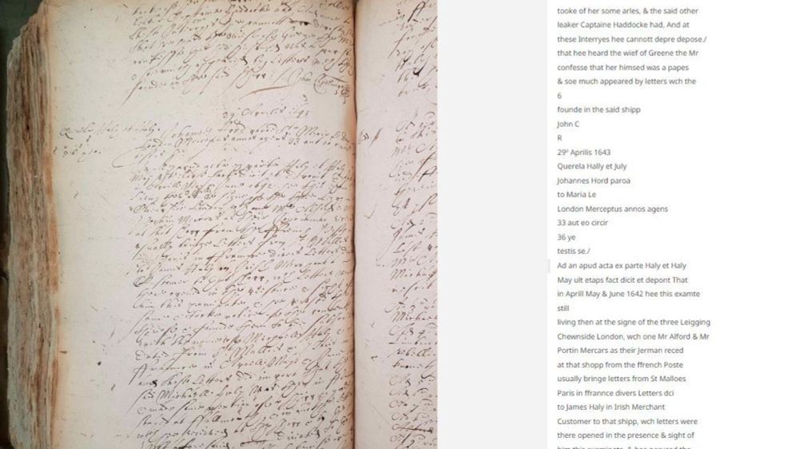](https://www.linkedin.com/pulse/working-chatgpt-oi-preview-error-recognition-raw-colin-greenstreet-u2qde)](https://www.linkedin.com/pulse/working-chatgpt-oi-preview-error-recognition-raw-colin-greenstreet-u2qde" \t "_blank)

**[Working with ChatGPT oi preview: Error recognition and classification in raw machine transcriptions of C17th legal depositions](https://www.linkedin.com/pulse/working-chatgpt-oi-preview-error-recognition-raw-colin-greenstreet-u2qde" \t "_blank)**

[Overview MarineLives is running a project to machine transcribe and machine/human correct 50,000 pages of legal depositions from the C17th. That's roughly 30 million words.](https://www.linkedin.com/pulse/working-chatgpt-oi-preview-error-recognition-raw-colin-greenstreet-u2qde" \t "_blank)

[www.linkedin.com](https://www.linkedin.com/pulse/working-chatgpt-oi-preview-error-recognition-raw-colin-greenstreet-u2qde" \t "_blank)

[Reposted by you](https://bsky.app/profile/marinelives.bsky.social)

[[](https://bsky.app/profile/bho.bsky.social)](https://bsky.app/profile/bho.bsky.social)

[· 13/09/2024](https://bsky.app/profile/bho.bsky.social/post/3l3ztrydg4o26)

Museum data service launched: [artuk.org/discover/sto...](https://artuk.org/discover/stories/museum-data-service-will-revolutionise-access-to-the-uks-cultural-heritage) The MDS itself: [museumdata.uk](https://museumdata.uk/) There's a lot of potential to this. [#GLAM](https://bsky.app/hashtag/GLAM) [#History](https://bsky.app/hashtag/History) 🗃️

[[](https://artuk.org/discover/stories/museum-data-service-will-revolutionise-access-to-the-uks-cultural-heritage)](https://artuk.org/discover/stories/museum-data-service-will-revolutionise-access-to-the-uks-cultural-heritage" \t "_blank)

**[Museum Data Service will revolutionise access to the UK's cultural heritage | Art UK](https://artuk.org/discover/stories/museum-data-service-will-revolutionise-access-to-the-uks-cultural-heritage" \t "_blank)**

[Discover artworks, explore venues and meet artists. Art UK is the online home for every public collection in the UK. Featuring over 300,000 artworks by over 50,000 artists.](https://artuk.org/discover/stories/museum-data-service-will-revolutionise-access-to-the-uks-cultural-heritage" \t "_blank)

[artuk.org](https://artuk.org/discover/stories/museum-data-service-will-revolutionise-access-to-the-uks-cultural-heritage" \t "_blank)

**9**

[[](https://bsky.app/profile/marinelives.bsky.social)](https://bsky.app/profile/marinelives.bsky.social)

[· 13/09/2024](https://bsky.app/profile/marinelives.bsky.social/post/3l3zyobzhfl2h)

I have fallen in love with the new ChatGPT-oi & spent 6 hours today with it. But it has a throttle! See images for what ChatGPToi and I have been working on. The functionality is stunningly good (process design; analysis; much better python) [#machinelearning](https://bsky.app/hashtag/machinelearning)

[@thiagokrause.bsky.social](https://bsky.app/profile/did:plc:m6ub6fozxlo3gzqn2rayoiwy)

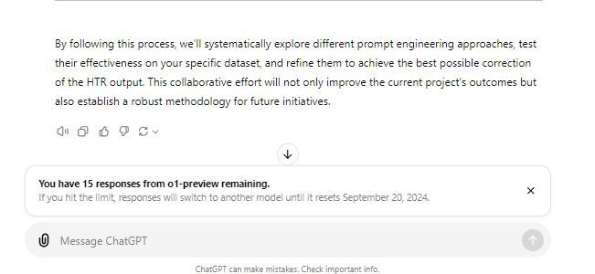

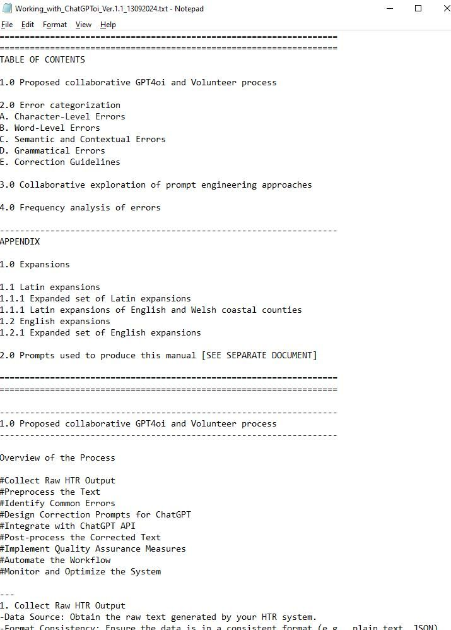

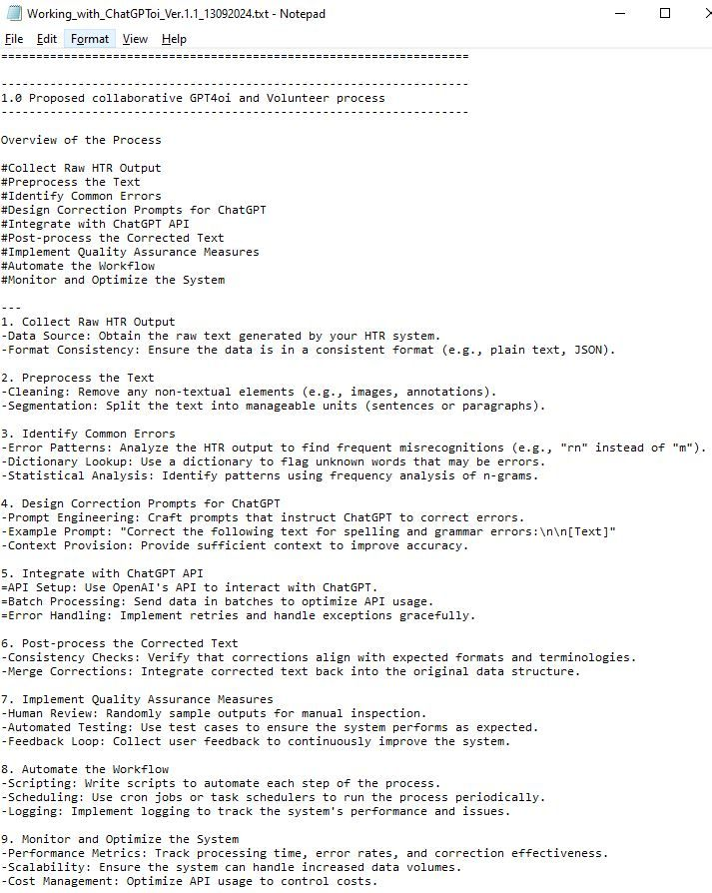

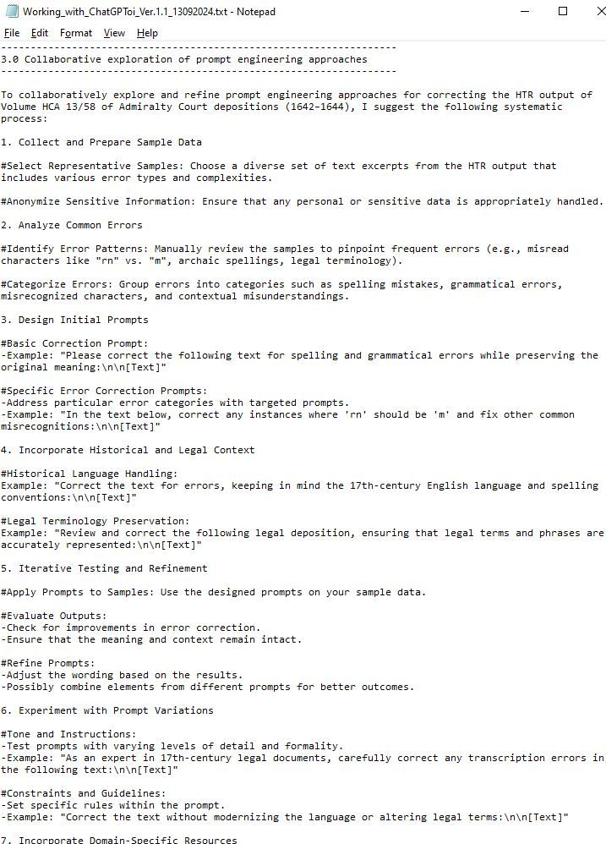

[[](https://bsky.app/profile/marinelives.bsky.social)](https://bsky.app/profile/marinelives.bsky.social)

[· 13/09/2024](https://bsky.app/profile/marinelives.bsky.social/post/3l3zursfxiz2s)

It cost £150 to machine transcribe 1501 pages of HCA 13/58 which we have just published to the Commons for you all to use. A generous gift of £150 will enable us to get the next 1500 page volume up and ready for you to search and use [#earlymodern](https://bsky.app/hashtag/earlymodern) [#Skystorians](https://bsky.app/hashtag/Skystorians) [www.gofundme.com/f/help-marin...](https://www.gofundme.com/f/help-marinelives-write-history)

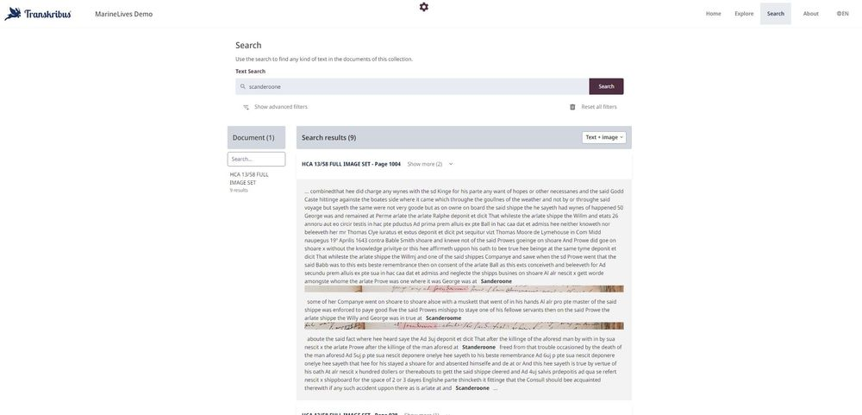

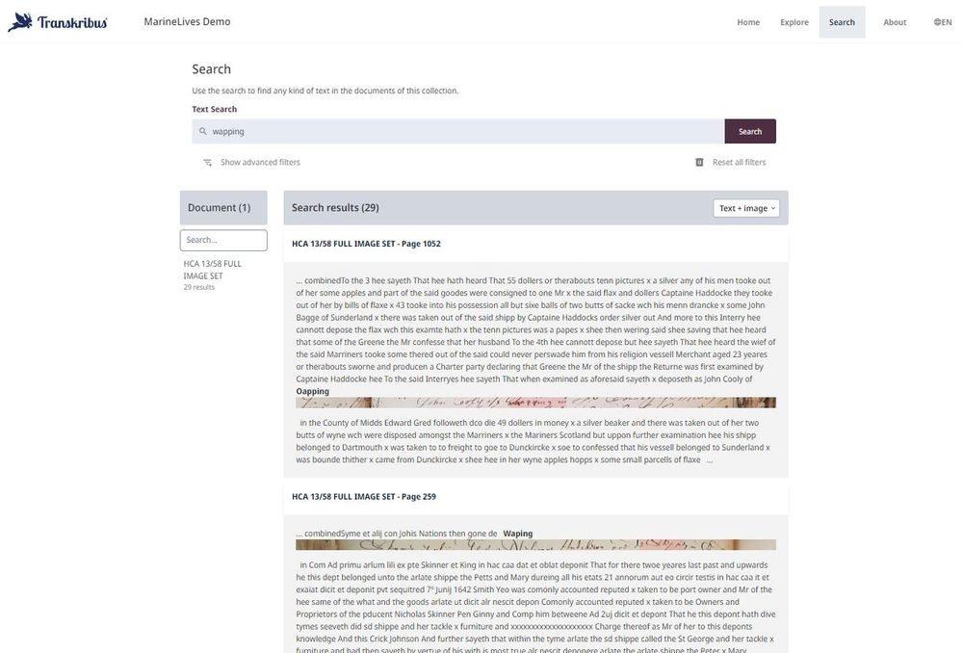

1

1

[[](https://bsky.app/profile/marinelives.bsky.social)](https://bsky.app/profile/marinelives.bsky.social)

[· 13/09/2024](https://bsky.app/profile/marinelives.bsky.social/post/3l3zsepmnrl2f)

Could some kind [#Skystorian](https://bsky.app/hashtag/Skystorian) [#earlymodern](https://bsky.app/hashtag/earlymodern) reader check that the URL from the MarineLives Demo site is working and that you get into view mode not edit mode? All feedback hugely appreciated [app.transkribus.org/sites/marine...](https://app.transkribus.org/sites/marinelivesorg)

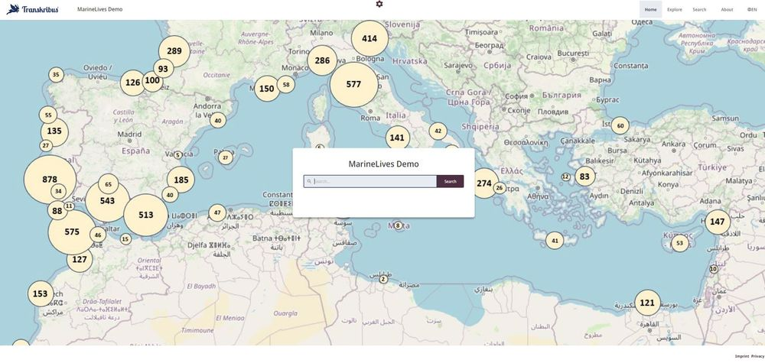

4

1

[[](https://bsky.app/profile/marinelives.bsky.social)](https://bsky.app/profile/marinelives.bsky.social)

[· 13/09/2024](https://bsky.app/profile/marinelives.bsky.social/post/3l3zsll3pta2w)

In parallel to the website we maintain .txt files of each volume we are editing. Out .txt file editorial style is to expand all Latin & English abbreviations & expansions, to correct HTR errors, and to remove HRT artefacts. We will post the link to the current edited 1501 pages of HCA 13/58 shortly

[[](https://bsky.app/profile/marinelives.bsky.social)](https://bsky.app/profile/marinelives.bsky.social)

[· 13/09/2024](https://bsky.app/profile/marinelives.bsky.social/post/3l3zsfu7n2c2w)

Ping

[@michwatsonoz.bsky.social](https://bsky.app/profile/did:plc:dszj4xibjjzzur72bqv5khzp)

[@thiagokrause.bsky.social](https://bsky.app/profile/did:plc:m6ub6fozxlo3gzqn2rayoiwy)

[[](https://bsky.app/profile/marinelives.bsky.social)](https://bsky.app/profile/marinelives.bsky.social)

[· 13/09/2024](https://bsky.app/profile/marinelives.bsky.social/post/3l3zsepmnrl2f)

Could some kind #Skystorian #earlymodern reader check that the URL from the MarineLives Demo site is working and that you get into view mode not edit mode? All feedback hugely appreciated app.transkribus.org/sites/marine...



[[](https://bsky.app/profile/marinelives.bsky.social)](https://bsky.app/profile/marinelives.bsky.social)

[· 13/09/2024](https://bsky.app/profile/marinelives.bsky.social/post/3l3zru6w6cn2p)

1/5 Big day

[@marinelivesorg.bsky.social](https://bsky.app/profile/did:plc:3haql47cl6jucf32mlqtre4p)

We are doing a soft launch of HCA 13/58 (1501 pages) from the years 1642 to 1643. Uncorrected machine transcription (we are correcting it as we go), but highly searchable & human readable Feedback please help@transkribus.org [app.transkribus.org/sites/marine...](https://app.transkribus.org/sites/marinelivesorg)



1

2

[[](https://bsky.app/profile/marinelives.bsky.social)](https://bsky.app/profile/marinelives.bsky.social)

[· 13/09/2024](https://bsky.app/profile/marinelives.bsky.social/post/3l3zrw3k37r2t)

2/5 You can view all 1501 images in thumbnail

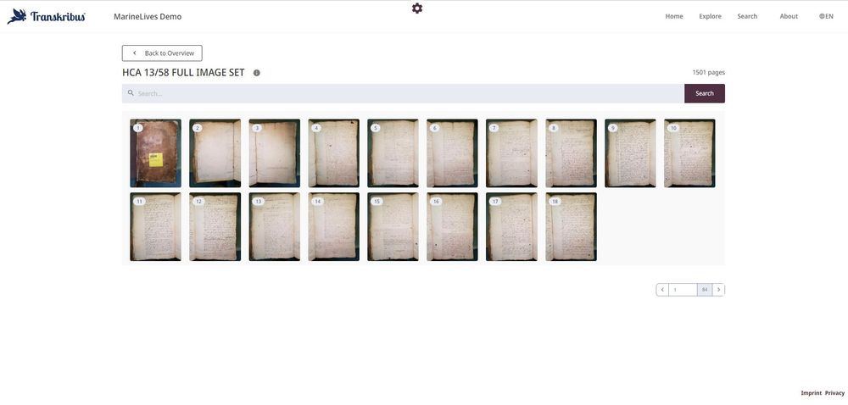

1

[[](https://bsky.app/profile/marinelives.bsky.social)](https://bsky.app/profile/marinelives.bsky.social)

[· 13/09/2024](https://bsky.app/profile/marinelives.bsky.social/post/3l3zrxnat272t)

3/5 You can search for terms (exact , fuzzy medium, fuzzy broad)



1

[[](https://bsky.app/profile/marinelives.bsky.social)](https://bsky.app/profile/marinelives.bsky.social)

[· 12/09/2024](https://bsky.app/profile/marinelives.bsky.social/post/3l3y7apv6rz2x)

Intriguing article in tonight's Financial Times. Speaking to an AI chatbot reduced people's level of belief in conspiracy theories by an average of 20% Article is behind a firewall, but here is a key table. Link works for subscribers: [#machinelearning](https://bsky.app/hashtag/machinelearning) [on.ft.com/4e1Uvuq](https://on.ft.com/4e1Uvuq)

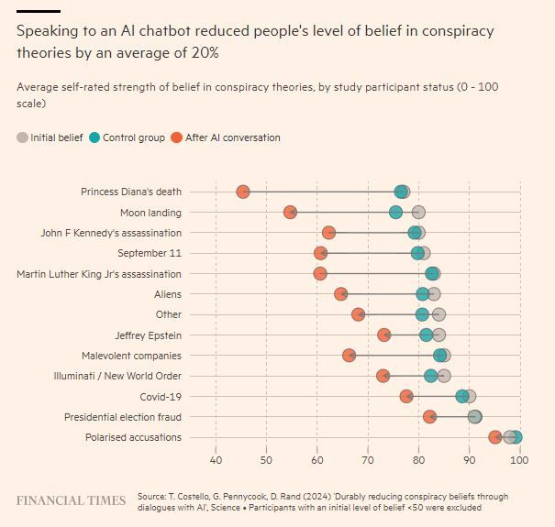

1

[Reposted by you](https://bsky.app/profile/marinelives.bsky.social)

[[](https://bsky.app/profile/justincolson.bsky.social)](https://bsky.app/profile/justincolson.bsky.social)

[· 10/09/2024](https://bsky.app/profile/justincolson.bsky.social/post/3l3ssdc2hdi2t)

I'll be teaching my

[@ihr.bsky.social](https://bsky.app/profile/did:plc:msb74n73t2heaaacburngrwh)

short courses in GIS for historians again this November! Two separate courses: using historical maps in GIS (i.e. archives and georeferencing) and making maps (geocoding and cartography) [www.history.ac.uk/search-event...](https://www.history.ac.uk/search-events/event_type/7008?online=1)

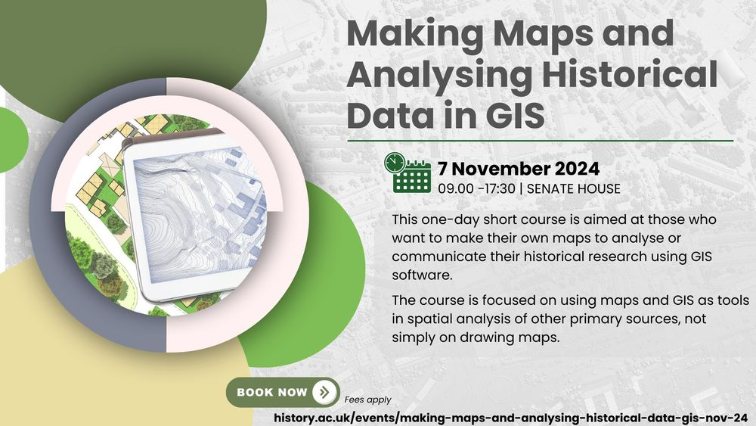

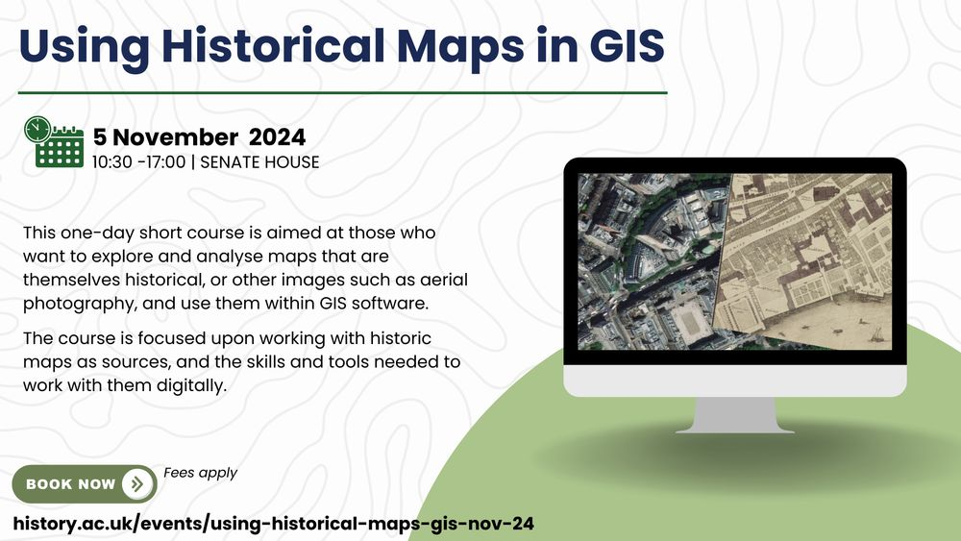

**28**

[[](https://bsky.app/profile/marinelives.bsky.social)](https://bsky.app/profile/marinelives.bsky.social)

[· 12/09/2024](https://bsky.app/profile/marinelives.bsky.social/post/3l3xsxd5ocd27)

Fascinating piece of archaeogenetics suggests that the Easter Island population never collapsed as suggested by US biologist Jared Diamond due to ecological destruction. Shocking to read 30% of the island's population was enslaved in 1860s by Peruvian slave raiders. [www.science.org/content/arti...](https://www.science.org/content/article/famed-polynesian-island-did-not-succumb-ecological-suicide-new-evidence-reveals?utm_source=sfmc&utm_medium=email&utm_campaign=ScienceAdviser&utm_content=distillation&et_rid=243877897&et_cid=5354319)

[[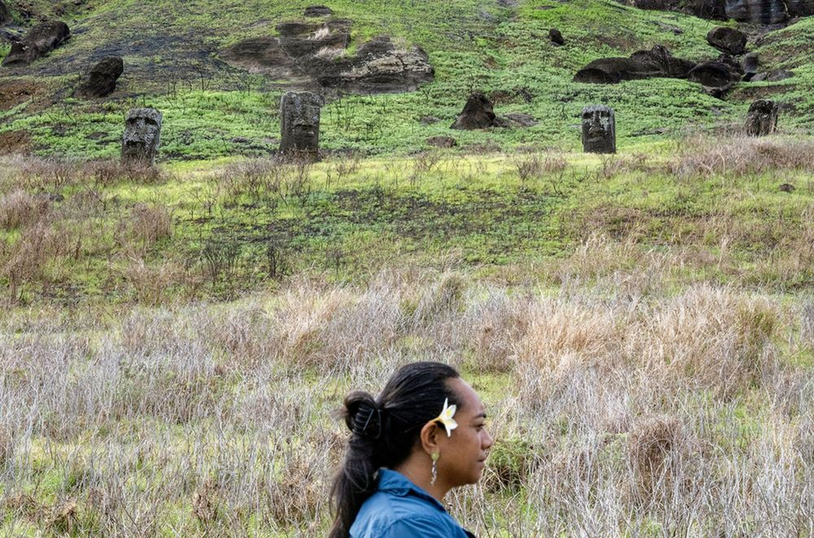](https://www.science.org/content/article/famed-polynesian-island-did-not-succumb-ecological-suicide-new-evidence-reveals?utm_source=sfmc&utm_medium=email&utm_campaign=ScienceAdviser&utm_content=distillation&et_rid=243877897&et_cid=5354319)](https://www.science.org/content/article/famed-polynesian-island-did-not-succumb-ecological-suicide-new-evidence-reveals?utm_source=sfmc&utm_medium=email&utm_campaign=ScienceAdviser&utm_content=distillation&et_rid=243877897&et_cid=5354319" \t "_blank)

**[Famed Polynesian island did not succumb to ‘ecological suicide,’ new evidence reveals](https://www.science.org/content/article/famed-polynesian-island-did-not-succumb-ecological-suicide-new-evidence-reveals?utm_source=sfmc&utm_medium=email&utm_campaign=ScienceAdviser&utm_content=distillation&et_rid=243877897&et_cid=5354319" \t "_blank)**

[Genomic, archaeological data show population on Rapa Nui, or Easter Island, never “collapsed” as some had argued](https://www.science.org/content/article/famed-polynesian-island-did-not-succumb-ecological-suicide-new-evidence-reveals?utm_source=sfmc&utm_medium=email&utm_campaign=ScienceAdviser&utm_content=distillation&et_rid=243877897&et_cid=5354319" \t "_blank)

[www.science.org](https://www.science.org/content/article/famed-polynesian-island-did-not-succumb-ecological-suicide-new-evidence-reveals?utm_source=sfmc&utm_medium=email&utm_campaign=ScienceAdviser&utm_content=distillation&et_rid=243877897&et_cid=5354319" \t "_blank)

[[](https://bsky.app/profile/marinelives.bsky.social)](https://bsky.app/profile/marinelives.bsky.social)

[· 12/09/2024](https://bsky.app/profile/marinelives.bsky.social/post/3l3xkbapywz2k)

Para nossos seguidores brasileiros interessados em paleografia e no século XVII, expandimos nosso manual sobre Como Trabalhar com Aurelius-HTR para propor colaboração página por página entre voluntários e Aurelius. A nova Tabela de Conteúdos e URL [raw.githubusercontent.com/Addaci/HCA/m...](https://raw.githubusercontent.com/Addaci/HCA/main/Working_with_Aurelius-HTR_Ch_1-5_PORTUGUESE_Ver.1.1_10092024.txt)

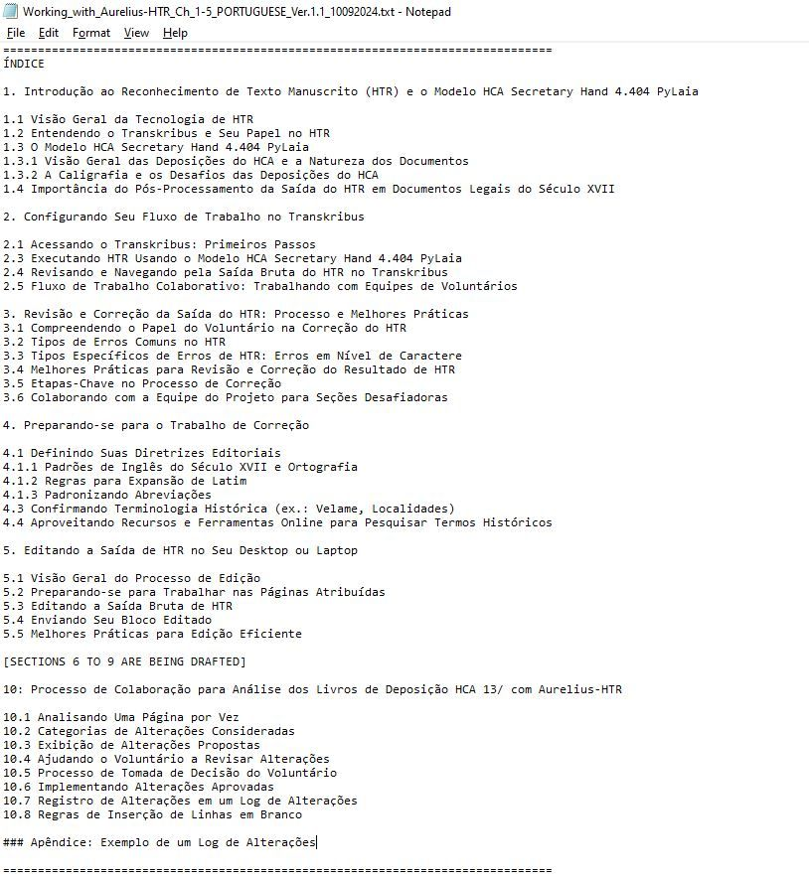

1

[[](https://bsky.app/profile/marinelives.bsky.social)](https://bsky.app/profile/marinelives.bsky.social)

[· 12/09/2024](https://bsky.app/profile/marinelives.bsky.social/post/3l3xlor3ie72x)

Aqui está um exemplo de uma interação de voluntário com Aurelius-HTR revisando HCA 13/58 f.376r Anotação [#HistoriadoresBrasileiros](https://bsky.app/hashtag/HistoriadoresBrasileiros) [#Brazilianhistorians](https://bsky.app/hashtag/Brazilianhistorians)

[@thiagokrause.bsky.social](https://bsky.app/profile/did:plc:m6ub6fozxlo3gzqn2rayoiwy)

[raw.githubusercontent.com/Addaci/HCA/m...](https://raw.githubusercontent.com/Addaci/HCA/main/Working_with_Aurelius-HTR_Ch_1-5_PORTUGUESE_Ver.1.1_10092024.txt)

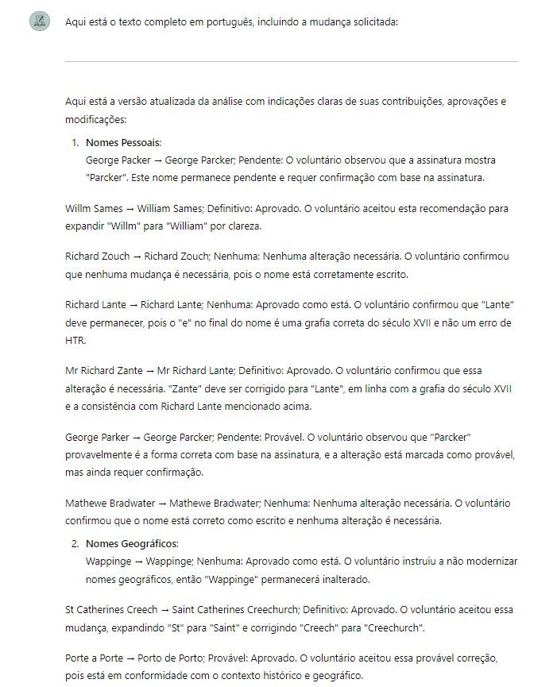

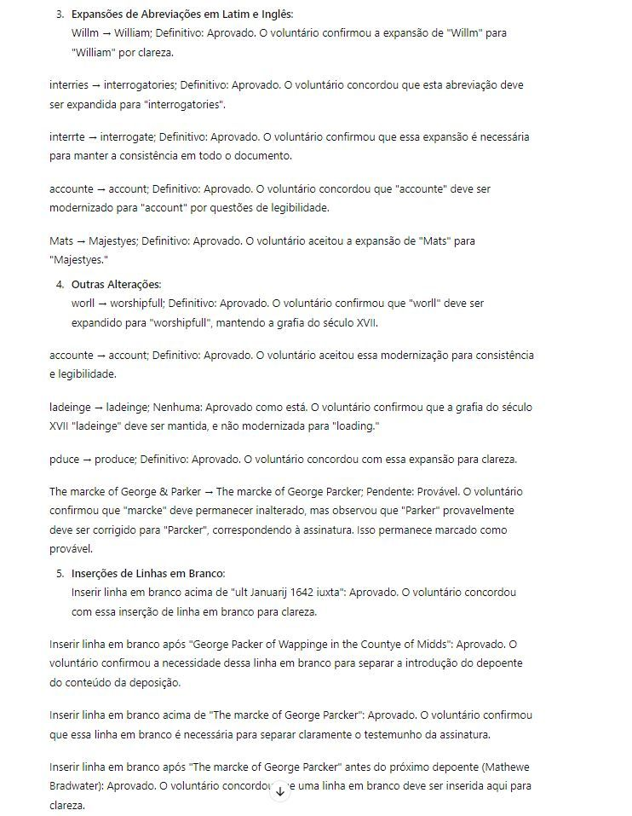

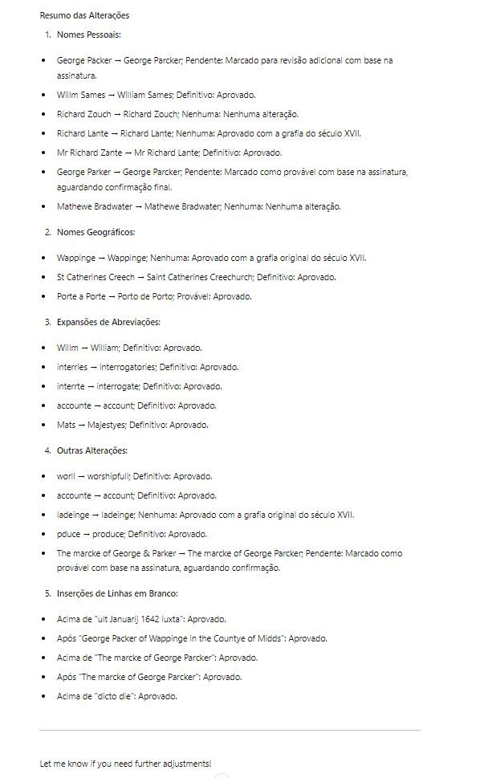

1

[[](https://bsky.app/profile/marinelives.bsky.social)](https://bsky.app/profile/marinelives.bsky.social)

[· 12/09/2024](https://bsky.app/profile/marinelives.bsky.social/post/3l3xn66kbf32w)

Pedi ao Aurelius-HTR para analisar em português o registro de alterações de três páginas do HCA 13/58 trabalhadas hoje. Procurando padrões nas sugestões do Aurelius e nas respostas do voluntário, comentando o comportamento de ambos e recomendando melhorias para o processo

[@thiagokrause.bsky.social](https://bsky.app/profile/did:plc:m6ub6fozxlo3gzqn2rayoiwy)

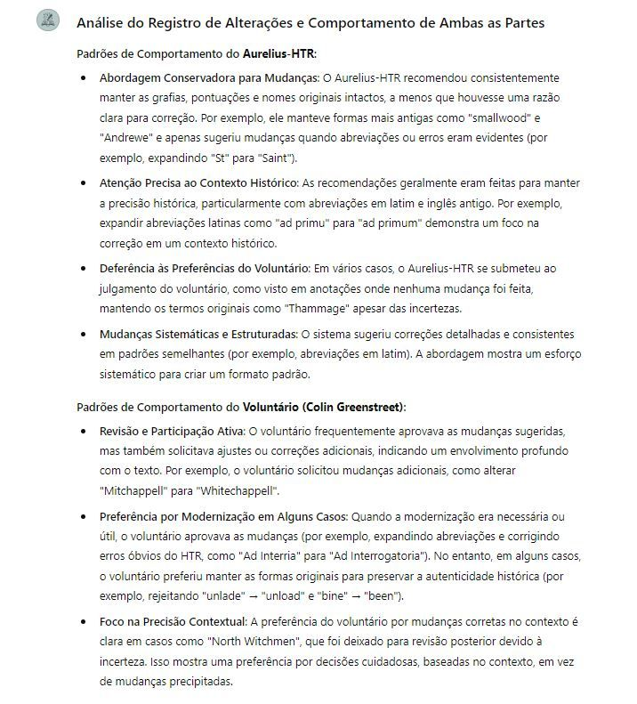

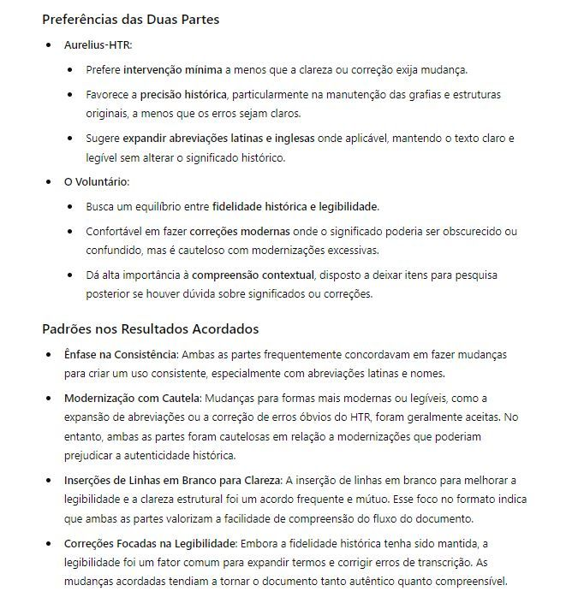

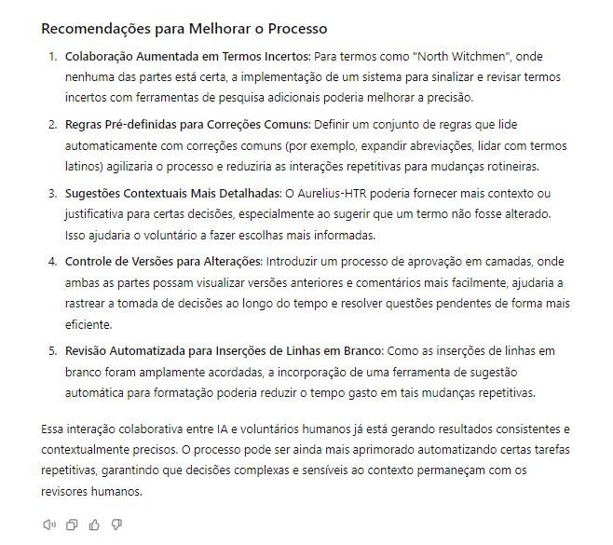

[[](https://bsky.app/profile/marinelives.bsky.social)](https://bsky.app/profile/marinelives.bsky.social)

[· 12/09/2024](https://bsky.app/profile/marinelives.bsky.social/post/3l3xayncdzb2x)

Aurelius-HTR is keeping a running change log as I work with it collaboratively to machine/hand correct raw-HTR for HCA 13/58, which is a volume of English High Court of Admiralty depositions from 1642-44. Read the remaining parts of this post to see the detail [#earlymodern](https://bsky.app/hashtag/earlymodern)

[@thiagokrause.bsky.social](https://bsky.app/profile/did:plc:m6ub6fozxlo3gzqn2rayoiwy)

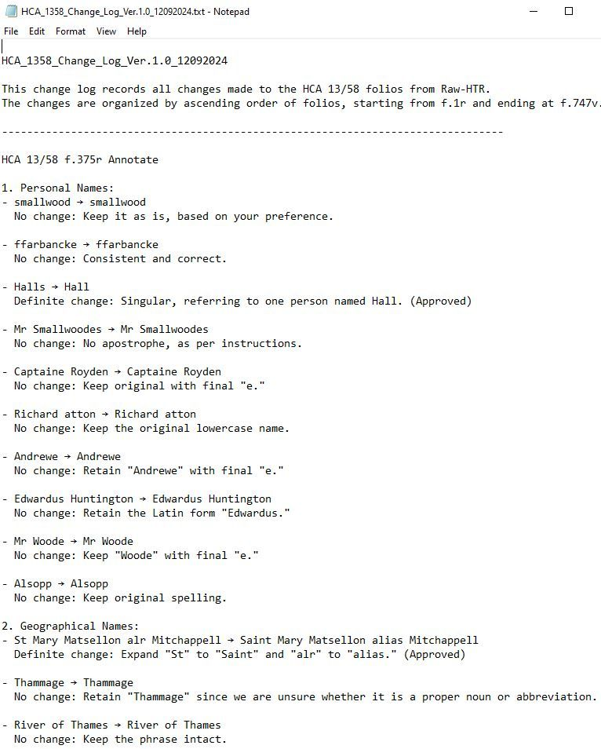

1

[View full thread](https://bsky.app/profile/did:plc:3haql47cl6jucf32mlqtre4p/post/3l3xayncdzb2x)

[[](https://bsky.app/profile/marinelives.bsky.social)](https://bsky.app/profile/marinelives.bsky.social)

[· 12/09/2024](https://bsky.app/profile/marinelives.bsky.social/post/3l3xfbgjk442q)

7/ Here is the HCA 13/58 f.375v Annotate page of the change log with (a) Aurelius-HTR recommendations (b) Decisions by volunteer (me) [Approved/Non-approved/?Pending]. This entry runs on from the entry for the earlier folio HCA 13/58 f.375r. The log expands over time. Data will further train agent

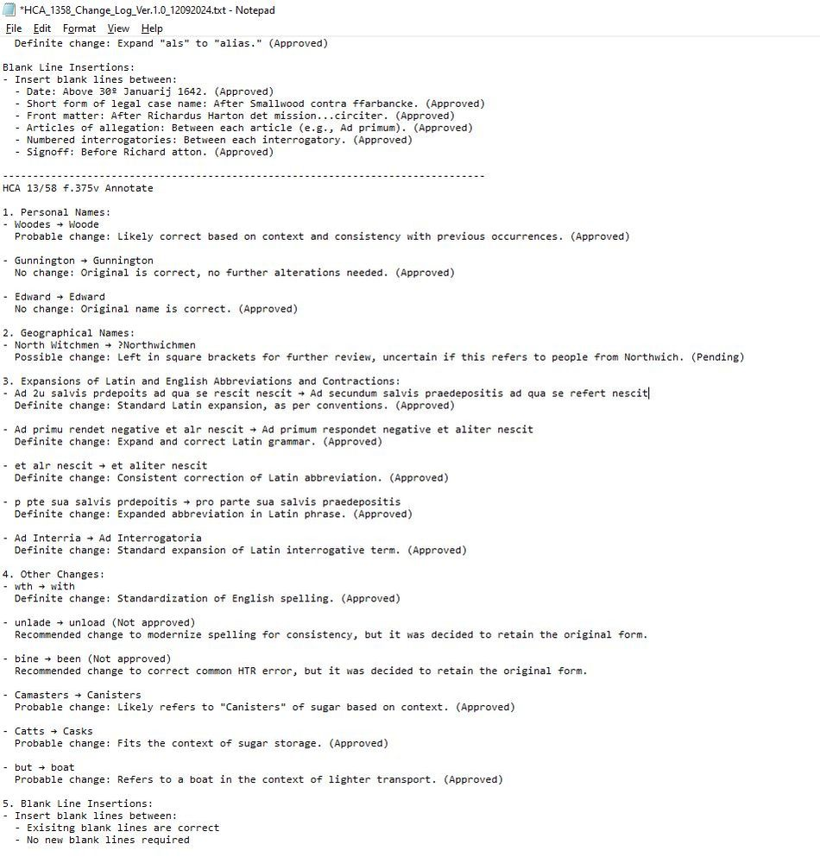

1

[[](https://bsky.app/profile/marinelives.bsky.social)](https://bsky.app/profile/marinelives.bsky.social)

[· 12/09/2024](https://bsky.app/profile/marinelives.bsky.social/post/3l3xiwcjjao2n)

8/ The MarineLives manual 'Working with Aurelius-HTR' has been updated to recommend a specific page by page process for volunteers to work collaboratively with Aurelius. See new section 10. Here is the URL to the revised manual [raw.githubusercontent.com/Addaci/HCA/m...](https://raw.githubusercontent.com/Addaci/HCA/main/Working_with_Aurelius-HTR_Ch_1-5_Ver.1.0_10092024.txt)

[@thiagokrause.bsky.social](https://bsky.app/profile/did:plc:m6ub6fozxlo3gzqn2rayoiwy)

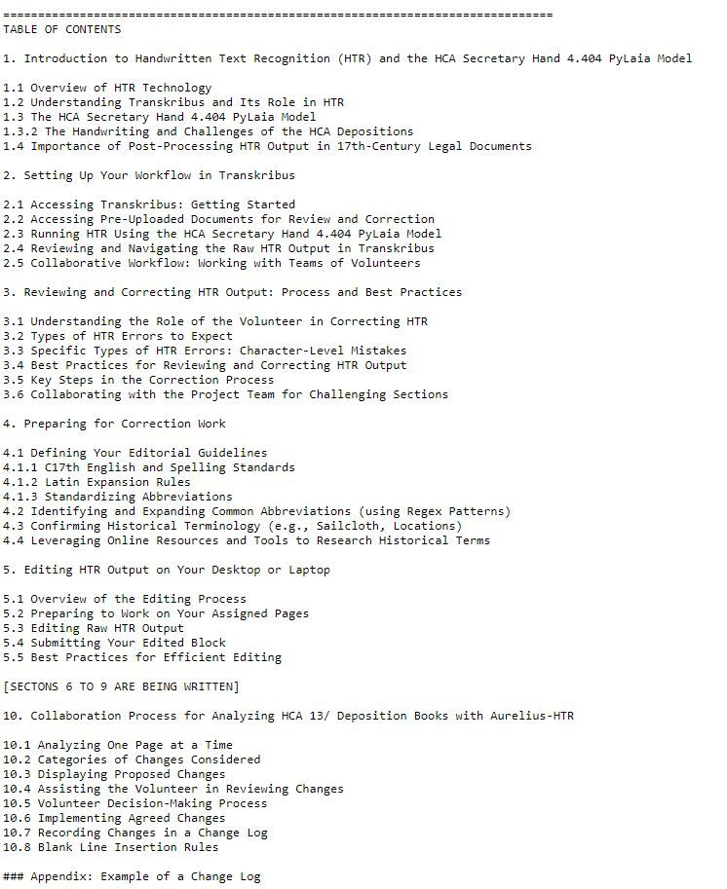

[[](https://bsky.app/profile/marinelives.bsky.social)](https://bsky.app/profile/marinelives.bsky.social)

[· 12/09/2024](https://bsky.app/profile/marinelives.bsky.social/post/3l3x4ar24ok2m)

Ping

[@thiagokrause.bsky.social](https://bsky.app/profile/did:plc:m6ub6fozxlo3gzqn2rayoiwy)

This part of the chat chain gives you the complet conversation I had this morning with Aurelius-HTR so you can see how my think developed working in collaboration with Aurelius [chatgpt.com/share/73b6a6...](https://chatgpt.com/share/73b6a6fc-69f2-4daa-9f7e-6e076e12c693)

[[](https://bsky.app/profile/marinelives.bsky.social)](https://bsky.app/profile/marinelives.bsky.social)

[· 12/09/2024](https://bsky.app/profile/marinelives.bsky.social/post/3l3x3hq3b4r2m)

5/ Here is a link to the complete interaction I had with Aurelius-HTR this morning. Starting with analyzing typical C17th English names (2) Building a process to identify and correct names (3) Two tests of process using two Admiralty Court depositions chatgpt.com/share/73b6a6... #earlymodern

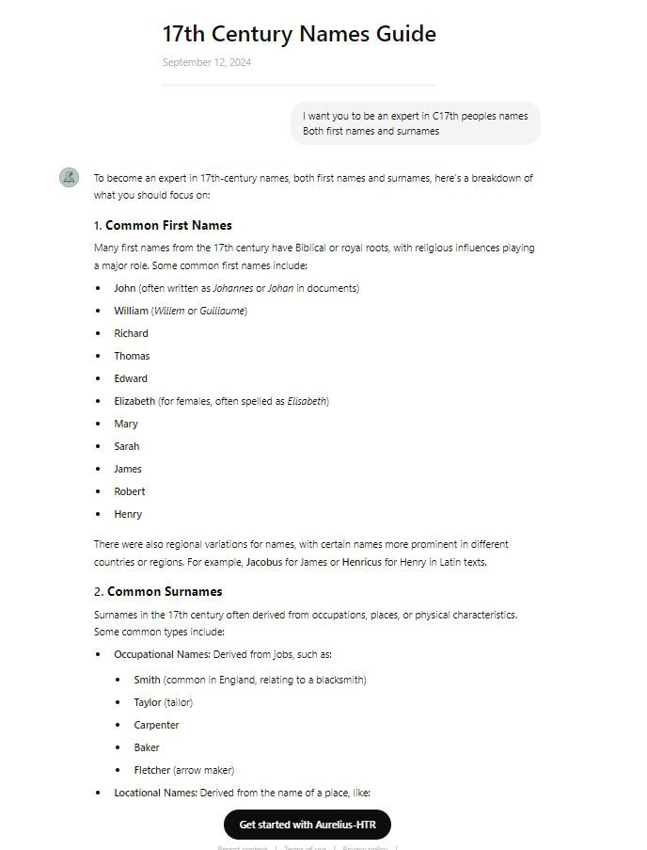

[[](https://bsky.app/profile/marinelives.bsky.social)](https://bsky.app/profile/marinelives.bsky.social)

[· 12/09/2024](https://bsky.app/profile/marinelives.bsky.social/post/3l3wy2zfice2t)

Machine transcription of C17th texts struggles with personal and geographical names. I'm testing whether Aurelius-HTR can be trained to identify all personal name variants in one raw-HTR deposition, identify the most likely spelling, then replace them in text. It can [#earlymodern](https://bsky.app/hashtag/earlymodern) [#machinelearning](https://bsky.app/hashtag/machinelearning)

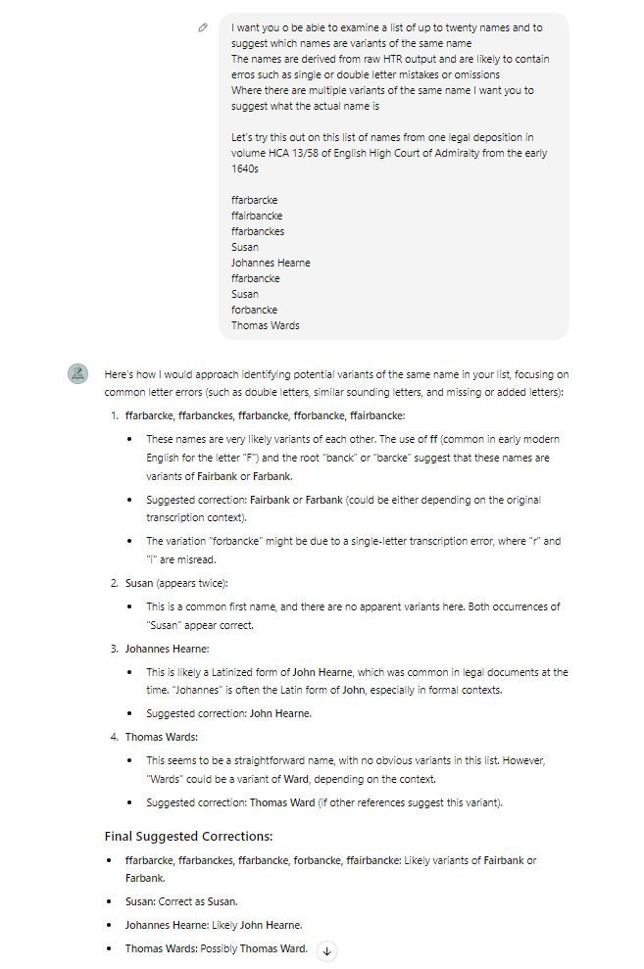

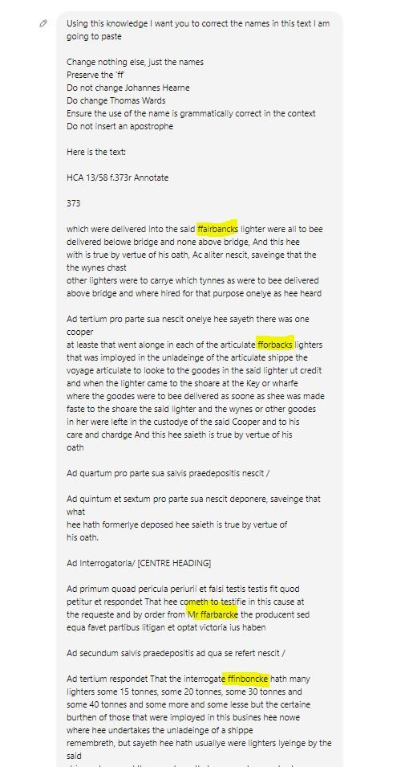

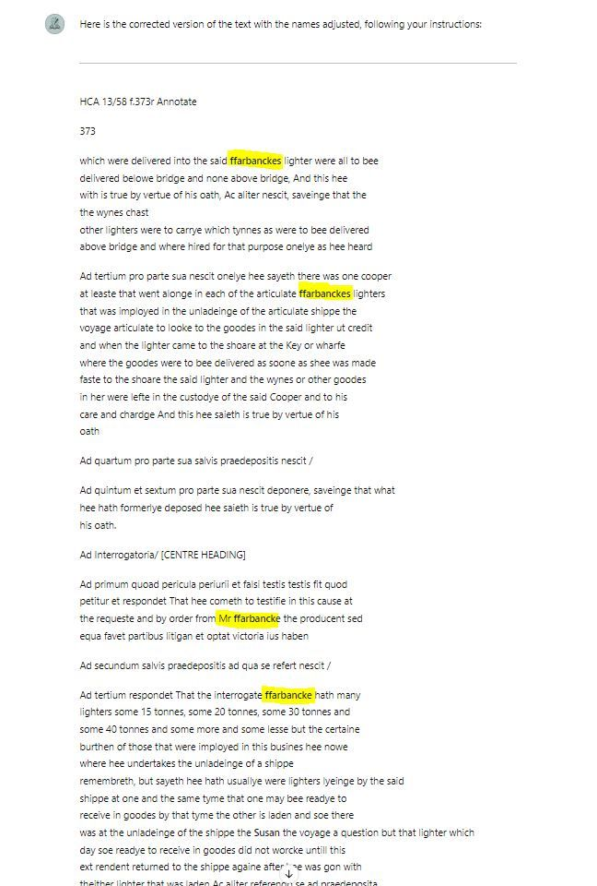

1

1

[View full thread](https://bsky.app/profile/did:plc:3haql47cl6jucf32mlqtre4p/post/3l3wy2zfice2t)

[[](https://bsky.app/profile/marinelives.bsky.social)](https://bsky.app/profile/marinelives.bsky.social)

[· 12/09/2024](https://bsky.app/profile/marinelives.bsky.social/post/3l3x3uqv3j42q)

6/ Aurelius-HTR has excellent understanding of Latin grammar and context. Here it advises me on the correct expansion of the latin abrreviation 'pvt'

[@thiagokrause.bsky.social](https://bsky.app/profile/did:plc:m6ub6fozxlo3gzqn2rayoiwy)

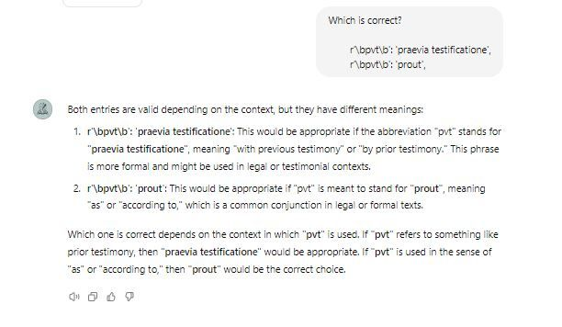

1

[[](https://bsky.app/profile/marinelives.bsky.social)](https://bsky.app/profile/marinelives.bsky.social)

[· 12/09/2024](https://bsky.app/profile/marinelives.bsky.social/post/3l3x42bovjs2m)

7/ I am planning to have volunteers each with an instance of an optimised Aurelius-HTR, with access to me as project director for edge cases. Volunteer needs to "accept" suggested changes and can override. They can refer to Aurelius-MarineLives editorial style guide, glossaries etc at any time

[[](https://bsky.app/profile/marinelives.bsky.social)](https://bsky.app/profile/marinelives.bsky.social)

[· 12/09/2024](https://bsky.app/profile/marinelives.bsky.social/post/3l3wzqavb7l2w)

Ping

[@thiagokrause.bsky.social](https://bsky.app/profile/did:plc:m6ub6fozxlo3gzqn2rayoiwy)

[@transkribus.bsky.social](https://bsky.app/profile/did:plc:adbwqqtuasa27sf4ijch4zvt)

[[](https://bsky.app/profile/marinelives.bsky.social)](https://bsky.app/profile/marinelives.bsky.social)

[· 12/09/2024](https://bsky.app/profile/marinelives.bsky.social/post/3l3wy2zfice2t)

Machine transcription of C17th texts struggles with personal and geographical names. I'm testing whether Aurelius-HTR can be trained to identify all personal name variants in one raw-HTR deposition, identify the most likely spelling, then replace them in text. It can #earlymodern #machinelearning







[[](https://bsky.app/profile/marinelives.bsky.social)](https://bsky.app/profile/marinelives.bsky.social)

[· 12/09/2024](https://bsky.app/profile/marinelives.bsky.social/post/3l3wsgitkt62p)

Versão expandida do manual "Trabalhando com Aurelius-HTR" em português O número da versão permanece o mesmo Tabela de conteúdos expandida Subsecções adicionais nas Seções 3 e 4 [raw.githubusercontent.com/Addaci/HCA/m...](https://raw.githubusercontent.com/Addaci/HCA/main/Working_with_Aurelius-HTR_Ch_1-5_PORTUGUESE_Ver.1.1_10092024.txt) [#earlymodern](https://bsky.app/hashtag/earlymodern)

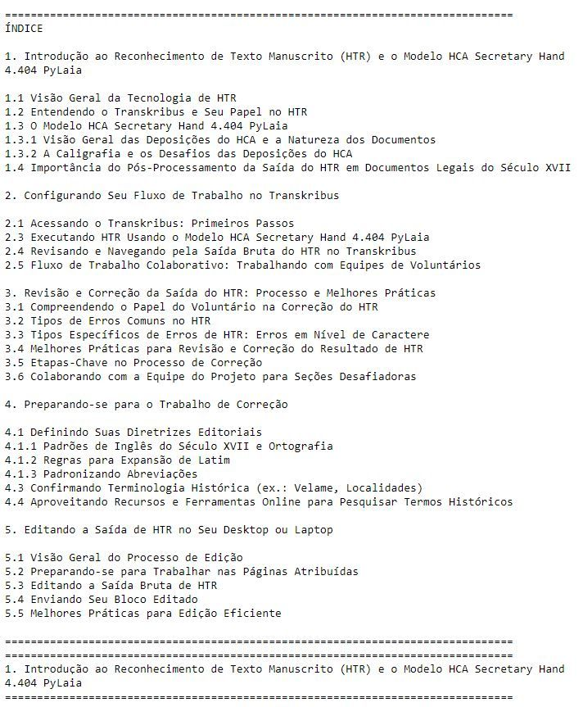

[[](https://bsky.app/profile/marinelives.bsky.social)](https://bsky.app/profile/marinelives.bsky.social)

[· 11/09/2024](https://bsky.app/profile/marinelives.bsky.social/post/3l3vjuwjgpc2e)

Ping

[@thiagokrause.bsky.social](https://bsky.app/profile/did:plc:m6ub6fozxlo3gzqn2rayoiwy)

New link with Portuguese Table of Contents added. Rest of text is unchanged. [raw.githubusercontent.com/Addaci/HCA/m...](https://raw.githubusercontent.com/Addaci/HCA/main/Working_with_Aurelius-HTR_Ch_1-5_PORTUGUESE_Ver.1.1_10092024.txt)

[[](https://bsky.app/profile/marinelives.bsky.social)](https://bsky.app/profile/marinelives.bsky.social)

[· 11/09/2024](https://bsky.app/profile/marinelives.bsky.social/post/3l3vjtbouer2r)

Temos um manual preliminar em português para apoiar voluntários interessados em trabalhar com o MarineLives na verificação e correção de transcrições automáticas em inglês/latim de documentos do Tribunal do Almirantado do século XVII. raw.githubusercontent.com/Addaci/HCA/m...

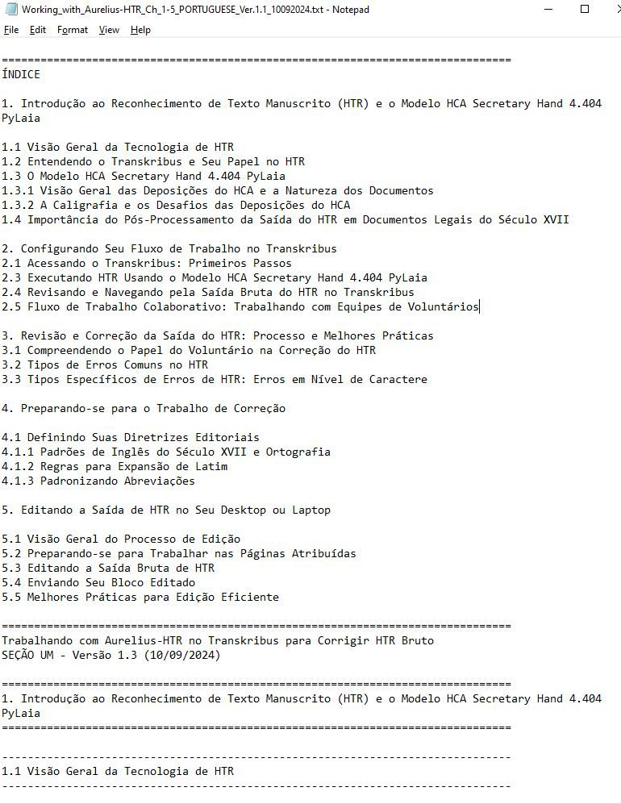

1

1